**Baskin Robbins Quick Service Restaurant App**

**QSR Mobile App**

Galadari Brothers Co. L.L.C

Submitted By:

VERBANET TECHNOLOGIES L.L.C

**CONTENTS**

1 KEY DETAILS 6

2 PROJECT SCOPE 7

3 Project Insight 7

**3.1** Introduction 7

**3.2** Benefits of Customer Loyalty Programs 8

**3.3** A Winning Loyalty Program 10

**3.4** Metrics used in our Loyalty Programs 11

**3.5** Artificial Intelligence & Machine Learning Powered Loyalty Programs 13

4 Proposed Application Features 14

**4.1** Customer Management 14

**4.2** Earning Rules 14

**4.3** Levels 14

**4.4** Rewards and Campaigns 15

**4.5** POS and Merchants 15

**4.6** Dashboards 15

5 User Interfaces and Screens 16

**5.1** Admin Interface 16

**5.2** Configuration 22

**5.3** Level downgrade settings 25

**5.4** Email Templates 28

**5.5** System Logs 29

**5.6** Customer 30

**5.7** Customer Loyalty Activity 37

**5.8** Customer Levels 43

**5.9** Points Transfer 47

**5.10** Transactions 52

**5.11** Earning Rules 58

**5.12** POS 72

**5.13** Merchants 73

**5.14** Segments 80

**5.15** Reward Campaigns 90

6 PROPOSED SOLUTION MODEL 113

**6.1** KEY STRENGTHS OF OUR SOLUTION 113

7 FUNCTIONAL REQUIREMENTS 113

**7.1** SYSTEM ADMINISTRATION/BACKEND MODULE 113

**7.2** PARTICIPATING SHOPS 114

**7.3** SYSTEM FEATURES 114

**7.4** MOBILE APPLICATION 115

**7.5** Detailed Functional Requirements 116

**7.6** NON-FUNCTIONAL REQUIREMENT (OTHERS) 125

**7.7** PROPOSED SYSTEM ENVIRONMENT 126

8 System Architecture 127

**8.1** Software Architecture 127

**8.2** Technical Architecture 133

9 TECHNICAL CONFIGURATIONS 137

**9.1** DEVELOPMENT TOOLS 137

**9.2** RECOMMENDED WEB HOSTING PACKAGE- DEDICATED HOSTING 137

**9.3** BROWSER 137

**9.4** HARDWARE 137

**9.5** TECHNICAL STANDARDS 137

**9.6** TECHNICAL GUIDELINES 138

10 PROJECT DELIVERY 139

**10.1** PROJECT MANAGEMENT 139

**10.2** ROLES & RESPONSIBILITIES 139

**10.3** PROJECT IMPLEMENTATION PLAN 139

**10.4** DELIVERABLES 139

**10.5** DELIVERY ACTIVITY SUMMARY 140

**10.6** ESTIMATED DELIVERY TIME 140

**10.7** DEPLOYMENT DETAILS (AT CLIENT’S BEHEST) 142

**10.8** RELEASE PLANNING 142

**10.9** RISK CONTINGENCY PLANNING 142

11 PROJECT ASSUMPTIONS 144

**11.1** OBJECTIVE 144

**11.2** DESIGN 144

**11.3** DEVELOPMENT 144

12 OUT OF SCOPE 146

**12.1** CHANGE MANAGEMENT 147

**12.2** MAINTENANCE & SUPPORT 149

**12.3** SERVICE LEVEL AGREEMENT (SLA) 149

13 TERMS & CONDITIONS 151

**13.1** ACCEPTANCE CRITERIA 151

**13.2** WARRANTY 151

**13.3** SOURCE CODE & INTELLECTUAL PROPERTY RIGHTS 151

**13.4** GENERAL TERMS AND CONDITIONS 152

**13.5** GENERAL ADMINISTRATIVE, TECHNICAL & FUNCTIONAL ASSUMPTIONS 153

14 FINANCIALS 155

**14.1** WEB AND MOBILE APPLICATION DEVELOPMENT 155

**14.2** WINDOWS DEDICATED HOSTING – OPTIONAL 156

15 CLIENT REFERENCES 157

16 ABOUT US 160

# KEY DETAILS

**PROJECT NAME CLIENT**

Loyalty Mobile Application Mercato & Town Center Jumeriah Group

**CLIENT CONTACT CLIENT ADDRESS**

Mr. P.O.Box 123

ABC Street

Dubai

U.A.E

**PROPOSAL SUBMISSION PROPOSAL ID NO.**

03.01.20  AD/BP/02012020/1820/2

**PROPOSAL VALID UNTIL ANTICIPATED START DATE**

03.03.20 00.00.00

**PROPOSAL SUBMITTED BY PROPOSED TECHNOLOGY**

Verbanet Technologies L.L.C ASP.NET Dubai, U.A.E **APPLICATION TYPE**

+971 4 297 3236 Web & Mobile Application

+971 50 765 2345

# PROJECT SCOPE

The Galadari Brothers Co. L.L.C (here after referred to as the client) has requested Verbat to develop a Quick Service Restaurant Mobile App (QSR) that can manage their retail business. The client already owns a desktop based delivery management solution, whereby customers can call the telephone sales representatives to place the orders. Customers can make payments using their credit / debit card through the POS system owned by the clients. Once the order is placed, the order is delivered using the clients built in delivery network. Each QSR will provide a daily update on its opening and closing hours as well as the material (ingredients) it carries so as to update their menu offerings.

The client has requested Verbat to develop a mobile app so that customers can circumvent the telephone sales system and instead order directly though the mobile app. The client have also asked Verbat to incorporate the following facilities

* Loyalty program for customer retention through points and cashback scheme
* Internationalization and localization
* Multiple payment options such as credit / debit / bank / amazon pay / Wallets etc.

Verbat being a boutique software development company with expertise in developing Quick Service Restaurant software as well as Loyalty based Application Software shall take this opportunity to present a glimpse of its take on its various implementations.

# QSR APPLICATION INSIGHTS

## INTRODUCTION

Verbat shall introduce the following features into its mobile QSR app

**Online Order Integration** – With the Order Integration feature, one can readily accept orders from multiple platforms (Credit / debit card, bank direct, amazon pay, google pay, online wallets, paytm etc.) All data is automatically synced into the central database using API’s provided by the client. Generate custom menus for individual QSR’s

**CRM Integration -** Manage customer data from a central CRM. Engage with customers by sending them regular updates about restaurant offerings and events via emails and SMSs.

**Reporting & Analytics** - View customized reports of all outlets. Access real-time reports of the restaurant business anytime, from any web-enabled device and make data-driven judgements.

**Loyalty Program Integration** - Create visit-based Loyalty Programs to encourage repeat visits. Create outlet specific or regional offers or launch offers that can be run across multiple outlets. Redeem coupons, fill digital wallets, promotions,

**Delivery Module** - Keep customers updated about their order status through SMS and track orders real-time.

**Franchise Management** – Manage multiple franchisees from one dashboard and keep track of total business generated from outlets.

**Other Features** – Customer registration, home page, notifications, Store locator, contact us, share via social media, feedback & theme based app interface

## OVERALL APPLICATION WORKFLOW

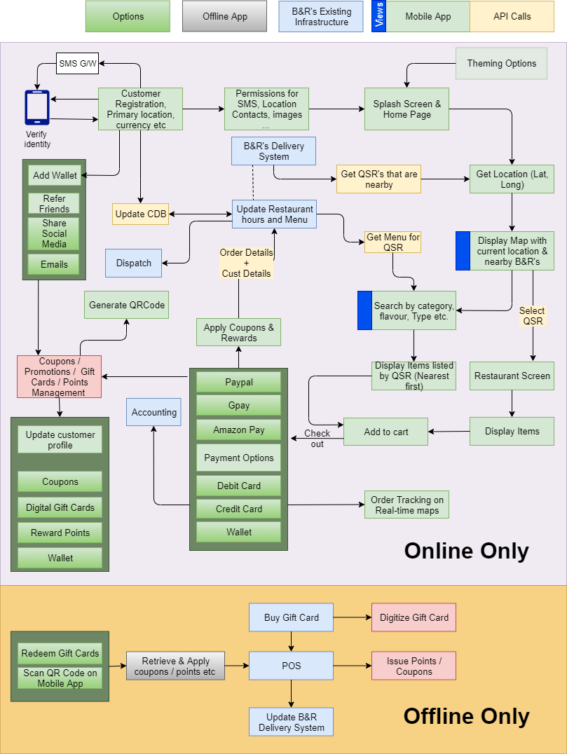

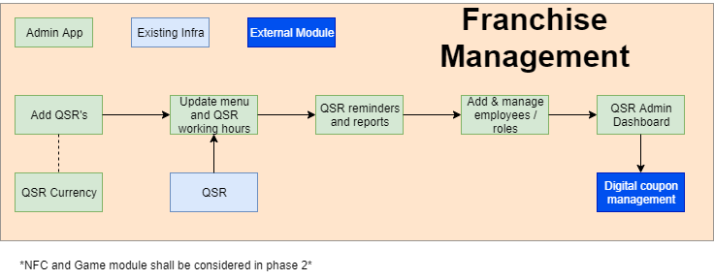

## QSR CLIENT APP ARCHITECTURE

Micro-Services based Order Management System

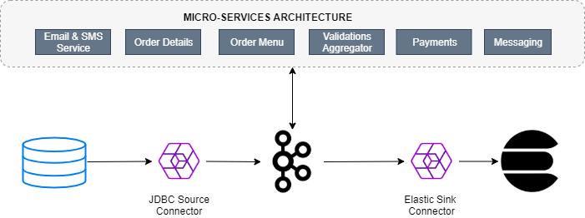

The system centers on an Orders Service which exposes a REST interface to POST and GET Orders. Posting an Order creates an event in Kafka that is recorded in the topic orders. This is picked up by different validation engines (Menu-Orders, Inventory Service, Order Details Service etc.), which validate the order in parallel, emitting a PASS or FAIL based on whether each validation succeeds.

The result of each validation is pushed through a separate topic, Order Validations, so that we retain the single writer status of the Orders Service —> Orders Topic.

The results of the various validation checks are aggregated in the Validation Aggregator Service, which then moves the order to a Validated or Failed state, based on the combined result.

To allow users to GET any order, the Orders Service creates a queryable materialized view (embedded inside the Orders Service), using a state store in each instance of the service, so that any Order can be requested historically. Note also that the Orders Service can be scaled out over a number of nodes, in which case GET requests must be routed to the correct node to get a certain key. This is handled automatically using the interactive queries functionality in Kafka Streams.

The Orders Service also includes a blocking HTTP GET so that clients can read their own writes. In this way, we bridge the synchronous, blocking paradigm of a RESTful interface with the asynchronous, non-blocking processing performed server-side.

There is a simple service that sends emails, and another that collates orders and makes them available in a search index using Elasticsearch. Finally, KSQL is running with persistent queries to enrich streams and to also check for fraudulent behavior. The diagram displayed below is the representation of a simple event driven architecture based on Apache Kafka.

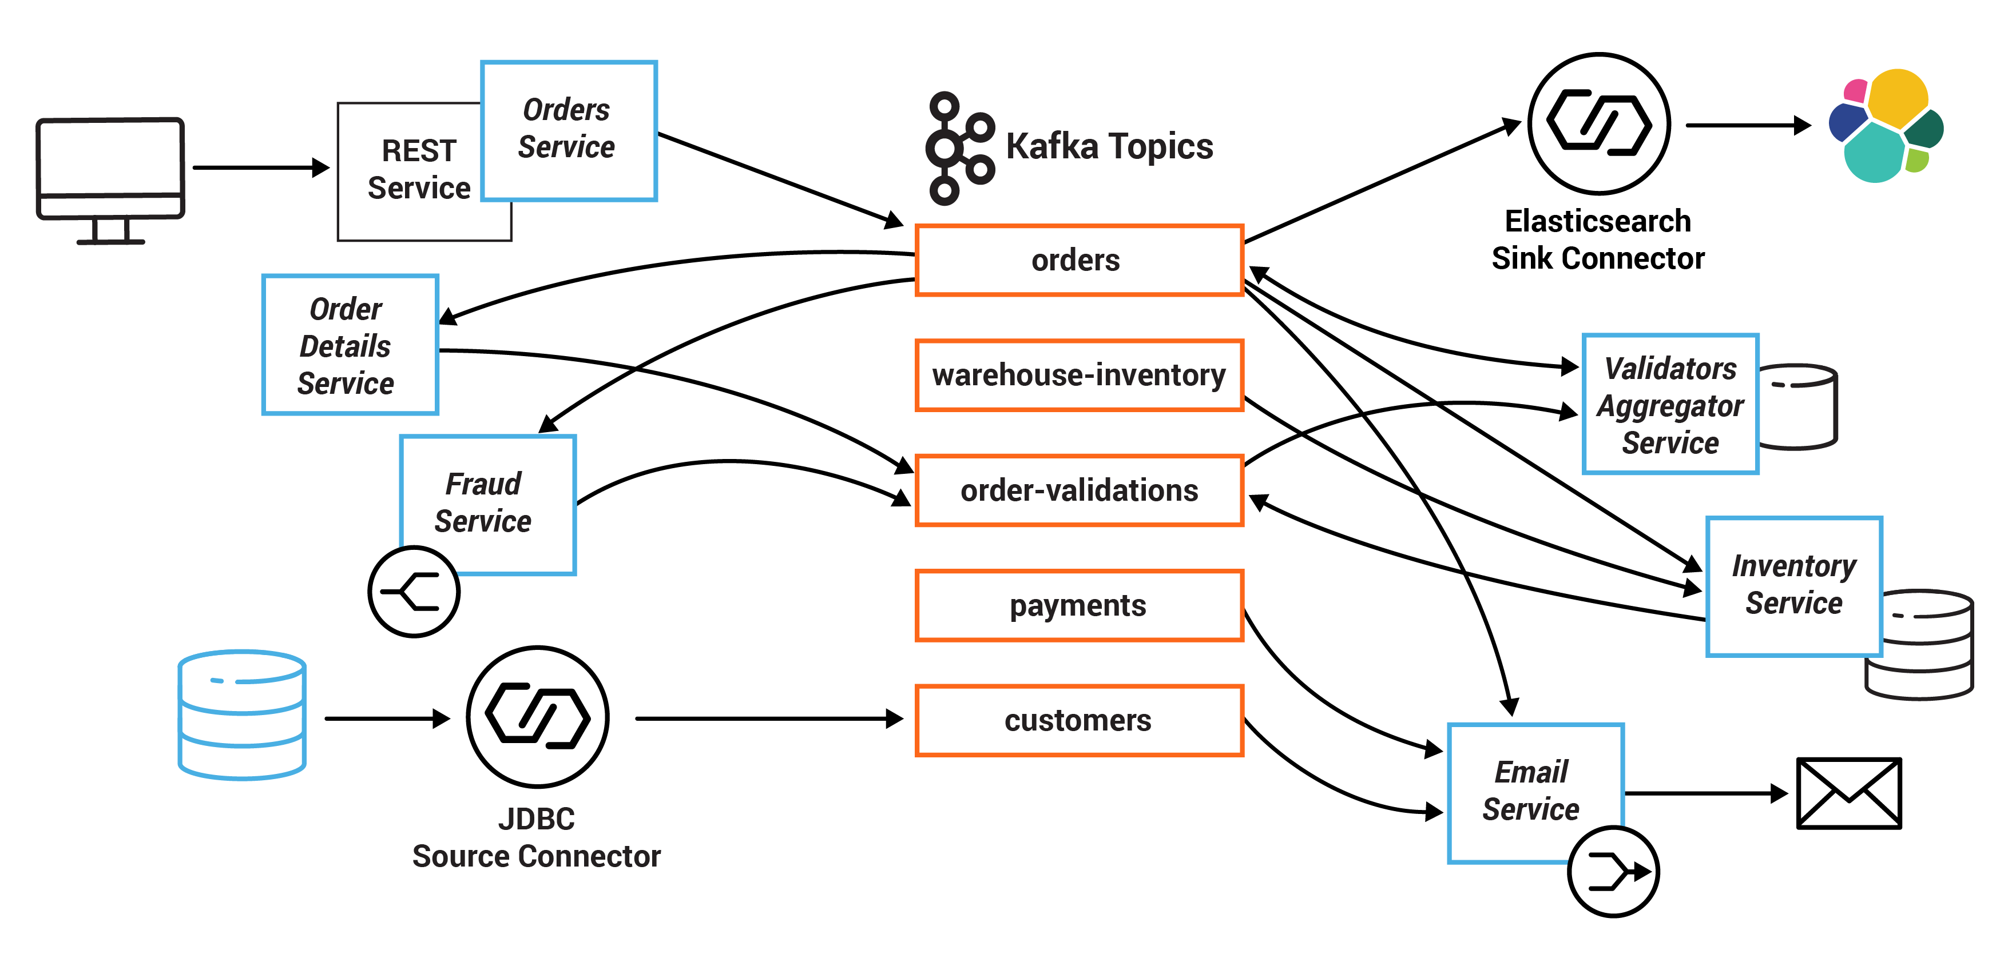

# CLIENT APP (ANDROID MOBILE)

The proposed app shall have the following features

## CUSTOMER REGISTRATION

Registration includes capturing the address, currency and country of the customer. Customer verifies using their phone number and / or email.

## GENERIC FEATURES

Generic features include the following

* Home page / Splash screen
* Contact us
* Customer feedback / complaints
* Notifications
* Sharing on social media

## GENERATE MENU

While the menu for all restaurants shall remain the same, based on the availability of certain ingredients, some menu items may be disabled

## SEARCH

Customers can search by menu item or map. The application shall have 2 separate views for search. The map view shall display all B&R stores closest to the current location of the customer.

Search by menu item will display all stores that sell the searched item by closest location.

## ADD TO CART

Each menu item displayed shall have the price associated with it. When customers add the items to the cart the total prices along with taxes and delivery charges shall be calculated. In cases where the customer is outside of their domicile equivalent price after currency conversion will be displayed.

Customer has the choice to pick up the items from store or have it delivered to the location of choice.

## DELIVERY LOCATION BOUNDRY

The app shall only display restaurants that are capable of delivering to the customer’s location

## APPLY DISCOUNTS

Customer shall be able to apply online discounts available in the app as coupons that were availed from magazines

Customer shall also avail discount coupons by sharing the app on social media or by email

## PAY FOR PURCHASE

Customers shall have multiple options to pay for the purchase namely

* Google pay
* Amazon pay
* Paypal
* Credit card / Debit card
* In app wallet
* Direct through bank

It shall be noted that these options may or may not be available in all countries. The app admin shall note these in the admin app

## PURCHASE E-GIFT CARDS

Customers shall be able to purchase electronic gift cards for themselves or for friends. The gift cards denominations shall be determined during requirements gathering phase. Gift cards may be send by email or shared by social media apps like skype or whzatsapp.

Electronic copies of the gift card and its validity can be checked through the app

## MEMBERSHIP with QR CODE

Any customer that uses the app is automatically considered to be member of B&R. The app shall generate a QR code or Barcode which can be scanned physically at the store.

## POINT ACCUMULATION THROUGH PURCHASE

Customers can accumulate points when they purchase products from B&R stores online or instore. The value of the points (Seasonal or cash amount) shall be configured thorough the loyalty App (Separate app). Points earned shall have a cash value attached as defined in the loyalty app.

## THEME BASED APPLICATION INTERFACE

The application administrator can setup custom date intervals so that the application can be updated with different themes. These themes are pre-defined and developed during application design

## MESSAGING

Customers shall receive periodical promotional offers. Offers may be in-app or via sms or email

# FRANCHISEE APP (WEB)

## UPDATE STORE OPENING

The Franchisee store shall update the system indicating its store closing and opening hours

## UPDATE INGREDIENTS

The store shall give a daily update on the ingredients that are unavailable in the store. This will help decide the menu offerings for the store

## Scan QR-CODES or BAR-CODES

Customers who have downloaded the app will have QR codes on their phone app. The franchisee shall scan the QR Code to avail discounts or points for their purchases

## PURCHASE GIFT CARDS

Customers shall be able to purchase gift cards from the store. When the customer’s information is captured along with the purchase, the gift cards shall appear in their app. These cards may be re-gifted to other patrons

## PURCHASE e-WALLET

Electronic wallets can be replenished and reused both in-app or in the store

## UPDATE STORE INFORMATION

The store admin can add employees to the store as well as update information about the store

# SUPER ADMIN (WEB)

## STORE SETUP

Franchisees may be setup in multiple countries across the gulf region. Therefore each store has to be associated with a country as well as its currency.

## COUNTRY ADMINS

Country admin(s) shall be created for each country. These country admins may then assign store admins to manage the store.

## FRANCHISEE ADMINS

As mentioned before each franchisee shall have at least one admin

## PAYMENT OPTIONS

The Country admin shall be able to setup all the available means of payment for the country.

# LOYALTY PROGRAM OVERVIEW

Since the client has also expressed great interest in customer engagement with built in features such as Loyalty & Rewards Management, Retail Campaign Management, Social Relationship Management and Retail Gift cards management. Verbat being an expert in the online retail management domain with specific experience in Quick Service Restaurant Management and Loyalty Program Management, would like to elucidate our experience.

## BENEFITS of CUSTOMER LOYALTY PROGRAM

The primary objective of a loyalty program is to retain existing customers and encourage repeat purchases. An Accenture Report found that 66% of US consumers spent more on brands that they were emotionally connected or loyal to.

Some interesting insights about the power of Loyalty Programs:

* 70% of members consider Loyalty Programs to be part of their relationship with a company
* An effective loyalty program can increase a brand's market share by 20%
* 84% of consumers said they are more likely to visit an online website with a loyalty program

Some of the benefits of using Verbat's Loyalty program are –

**Increase in Repeat Sales:** When implemented correctly, our loyalty program capable of contributing up to 30% of the total revenue

**Build A Healthy Relationship With Your Customers**: Verbat incorporates personalization and experiential rewards into its loyalty program. The loyalty program is overlaid into the CRM system to offer highly personalized rewards to customers

**Increase AOV (Average Order Value):** Our system include the AOV which is a simple but vital metric that reveals how much a customer typically spends every time they shop. Convincing an existing customer to spend more is easier with zero acquisition costs. Our loyalty program has been shown to increase the AOV from 13% to 35%

**Increase customer retention:** Verbat understands the importance of customer retention. Without a good customer retention rate, the cost of doing business will skyrocket with businesses ending up spending a fortune on acquisition costs. New customers often produce a smaller AOV (new customers typically test the waters of a new brand with small value purchases). However retention is much easier since valuable data about customer affinities, purchase journeys and demographics can be used to offer personalized offers and rewards to nudge the customer.

**Improved Brand Perception:** Our Loyalty program offers great insights about a customer (demographic, purchase patterns, product preferences etc.) compared to an invoice. The ability to combine our loyalty program with CRM platforms allows brands to combine data from multiple sources like social media, in-store and mobile applications to create a rich persona for every customer.

**Increase customer lifetime value (CLV):** CLV is the total revenue a customer will generate over the course of their lifetime. It is a critical metric that needs to be taken into account. It is also closely related to Customer Loyalty (CL)

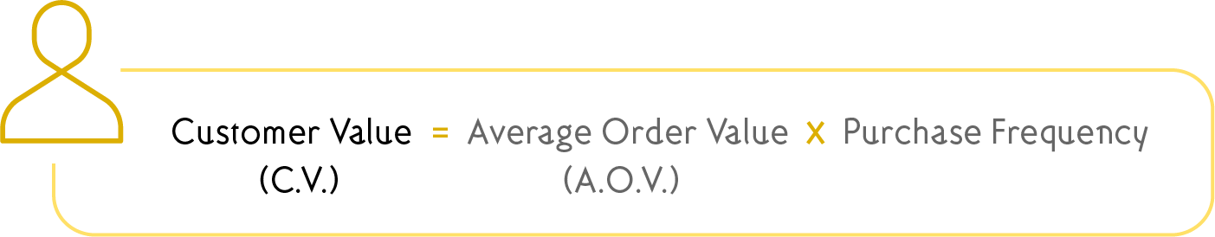



We normally recommend our clients to consider the following features in the QSR application being developed for them (More metrics shall be discussed later on)

Companies can increase their CLV by

* Increasing the customer base
* Increasing the # of repeat purchases per customer
* Increasing the retention age of customer
* Increasing profits per sale

Fortunately the points discussed above falls into a customer loyalty segment namely: Retention Loyalty, Advocacy Loyalty & Purchasing Loyalty. These Customer Loyalty attributes are directly proportional to CLV's. By increasing CL one can increase CLV's.

Our loyalty program aids you to increase

**Retention Loyalty,** thereby ensuring the customer interacts with the brand for a longer period of time

**Purchase Loyalty**, thereby increasing the frequency of sales from a customer

**Advocacy Loyalty**, thereby it makes it easier to acquire more customers

## A WINNING LOYALTY PROGRAM

A good customer loyalty program can generate significant gains in recurring revenue for the business through higher AOV and repeat sales. Since our loyalty programs are purpose built to match the unique requirements of our clients, we recommend the following supplemental features.

* Give customer the choice of opting for a physical card or an app-based loyalty solution
* Keep the loyalty program unique to the brand instead of partnering with other brands or businesses
* Keep it simple - offer points for X currency spend and make it easy for people to track the points. Also, avoid long list of exclusions and fine print
* Include a sign up bonus for new members that offers free points of up to 50% of points of the next reward
* Implement achievable reward thresholds based on the average spend of the customers
* Offer a wider redemption choice which gives customers the freedom to redeem points on what they like
* Offer special 2X or 3X rewards on non-peak times of the week or month on slow moving products
* Make sure the rewards can be redeemed from the day a customer reaches a certain reward threshold. This will encourage repeat visits
* Offer special points with limited validity to encourage repeat business
* Communicate the benefits of the loyalty program across all customer touch points (e.g.:-app, in store, desktop etc.)
* Don’t limit point earns only to purchases; reward them for social sharing, brand promotions, reviews etc.
* Design loyalty programs around customers and what they value most - is it discounts? Is it personalized experiences? Or is it exclusivity?
* Always set a grace period on the expiry date of points so customers who may have missed a deadline can still save their points
* Always set goals for the loyalty program and measure them with a CRM
* Use personalization to understand what type of rewards resonate best with each customer personas
* Assess current customer satisfaction levels before implementing the loyalty program. This will help gauge its benefits much better.
* Customization of loyalty programs based on points, tiers, fee, cashback and rewards

## METRICS USED in our LOYALTY PROGRAMS

**Customer Lifetime Value (CLV)**

Customer Lifetime Value (CLV) is simply the overall revenue contribution you can expect from a customer during his/her engagement with your brand. To calculate CLV, you need to first calculate the Customer Value





**Redemption Rate**



Redemption Rate is a percentage which indicates at what rate are your customers are redeeming their loyalty points. A high redemption rate indicates that your customers are highly engaged with your loyalty program. A healthy benchmark is a 25% redemption rate; anything less than that and it indicates an issue with the redemption process of your loyalty program, i.e., your customers are earning loyalty points and are not spending them. Here's how you calculate the redemption rate of your loyalty program.

**Active Engagement Rate**



This ties in with Redemption Rate in that it measures the number of customers who are actively engaged with your loyalty program (through points earned and redeemed).

**Repeat Purchase Rate (RPR)**

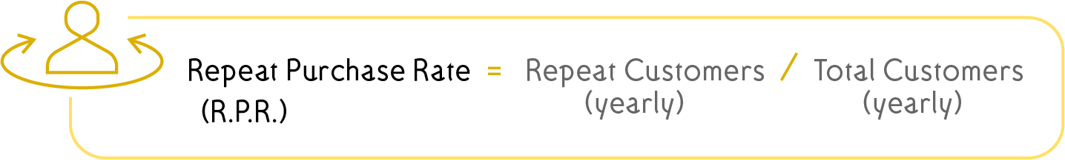

While CLV is a great way to measure the long term impact of your loyalty program, the Repeat Purchase Rate (RPR) gives you an overview of the short-midterm impact. The Repeat Purchase Rate (RPR) basically gives you the percentage of customers who have made more than one purchase for a period of 1 year. One of the primary objective of a loyalty program is to increase repeat purchases and thus measuring the RPR is critical for gauging the effectiveness of a reward program. Also, remember that the RPR has a major impact in increasing the Customer Lifetime Value (CLV)

## AI & MACHINE LEARNING POWERED LOYALTY PROGRAMS

Verbat realized that AI and Machine Learning can potentially revolutionized the retail and loyalty industry. Loyalty is closely linked to customer experience and AI is becoming impressively accurate in predicting human behavior and purchase patterns. Our next generation Loyalty programs are currently focusing on the following aspects (This is a work in progress)

**Predictive Insights**

Historically, customer data collected through loyalty programs have been used to target customers with relevant messages. However, with the help of AI and Machine Learning; brands can take this several notches up to predict customer behavior and influence purchase patterns. Imagine getting real-time information of every customer who walks in to your store along with insights on what they are most likely to purchase. Advanced AI algorithms is capable of predicting human actions long before the thought even starts taking shape in the subject's mind.

**Prescriptive Analytics**

AI-powered insights can instantly give you a segment of customers who are more likely to spend more once they move into the next tier of your reward program. Now all you have to do is offer them 3X points on their next purchase as a special gift. Prescriptive analytics can be applied to a wide range of retail scenarios to reduce churn, increase conversion rates and improve overall customer experience.

# LOYALTY APP FEATURES (ANDROID MOBILE)

## CUSTOMER MANAGEMENT & CUSTOMER REGISTRATION

**360 Customer View –** The app shall offer one **consistent loyalty profile** with a single view of the customer. Match the online and offline data under one profile. Use mobile phone, email, loyalty card number or any other identifier to connect data from multiple sources.

**Customer Segmentation -** based on their **purchase history, profile qualities** or custom events that represent **customer behavior**. Use static or dynamic segmentation in targeting your loyalty campaigns.

**Omni Channel Tracking -** Use Omni channel tracking. Use data from any kind of transaction — e-commerce and retail stores. Merge purchase operations from **one or multiple merchants** or **brands**.

## EARNING RULES

**Transactional Rules -** Use **transactional Earning rules** to define how many points can be earned based on details from the transaction. Combine rules with time, segment, location and more. Work with predefined rules or add a custom one that suits your loyalty strategy.

**Reward Behavior -** Reward customers with **behavioral Earning rules**, based on what the customer did. Nudge customers to perform specific actions like **referring** a new customer, joining a newsletter, making the first purchase and much more. Give points for any custom event you want.

## LEVELS

**Levels Management** – Define and manage multiple levels based on spending or points accumulated

**Levels Gamification** – configure advanced gamification of levels like resetting levels or renewal of levels

**Special reward on Level –** Match levels with targeting for earning rules or reward campaigns

## REWARDS AND CAMPAIGNS

**Rewards Management –** Define and manage various types of rewards like: discount coupons, value codes, physical rewards, special offers or cashback. Set limitations suitable for your campaign e.g. a coupon can be used only once per customer.

**Advanced Targeting -** Define and set limitations and conditions on who can receive rewards, when and how.

**Instant Rewards -** Rewards available under Reward campaigns can be purchased with points or redeemed instantly when specific conditions are met. You can set different redeeming rules for different Segments or Levels.

## POS and MERCHANTS

Use multi-tenancy loyalty features to define and manage reward programs for multiple stores or brands.

Use the data for Omni channel segmentation. Collect and process transactions from online and offline points of sales. Any interaction can be matched with a customer’s profile..

Introduce various user roles in the loyalty software. Define rights for browsing, modifying or adding data to the loyalty program.

## DASHBOARDS

**Admin dashboard** – to manage the Loyalty App

**Client or Customer dashboard** – Dedicated web portal for customers

**Customer management** – to manage customers registered in the loyalty app

**POS dashboard** – Manage points, rules, reward campaigns, levels & segments

**API & integrations** – integrations with other platforms

# USER INTERFACES and SCREENS

## ADMIN INTERFACE

**Admin Dashboard**

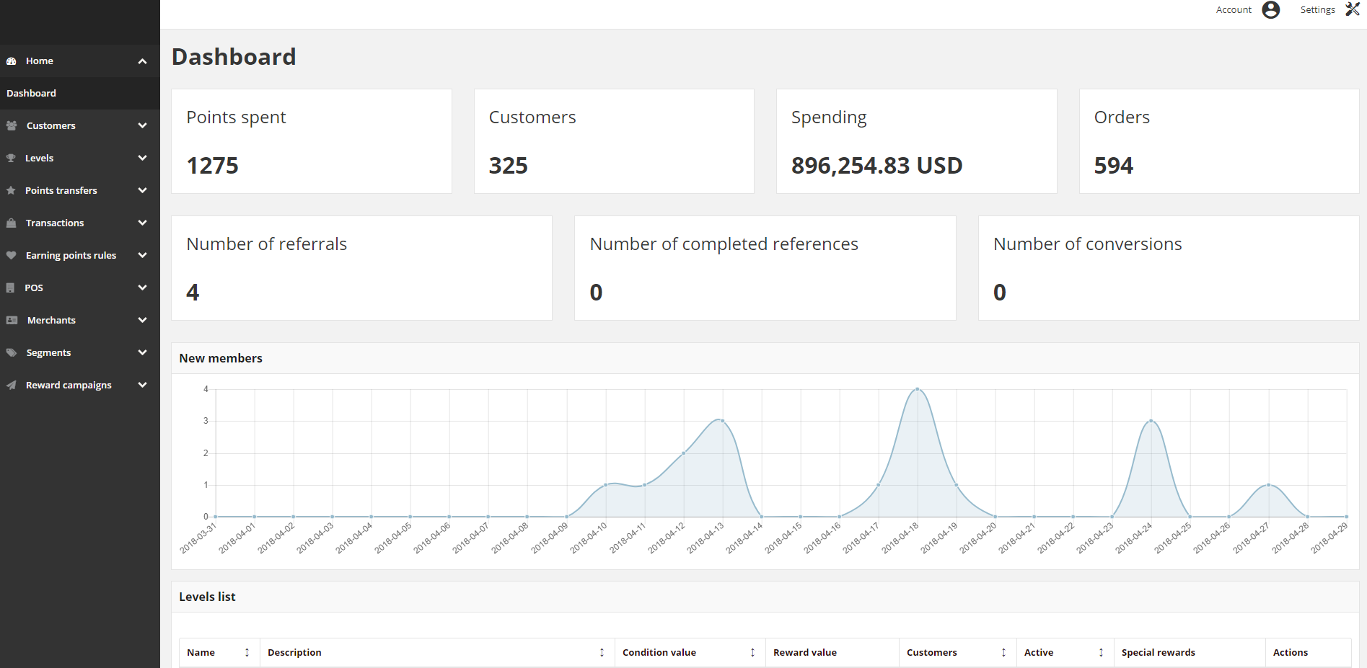

The dashboard is the default startup page for the Admin – the first page that appears when you log in to the Admin. The dashboard gives an overview of the customer’s activity in your loyalty programs.

The blocks at the top of the page provide a snapshot of:

* **# of all spent points**
* **# of all customer accounts**
* **Total amount of all registered transaction**
* **# of all registered transactions**

Blocks below, show some factors describing the current state of referral program:

* **# of all invitations sent by customers**
* **# of all customers that register an account from invitation link**
* **# of all customers that make a purchase after register an account from invitation link**

The chart shows the number of new customer accounts within last 30 days in the timeline.

The tabs at the bottom provide a quick overview of your Customer Levels list, associated to various benefits such as discounted fees and credentials for the customer to reach this value.

**Admin Login**

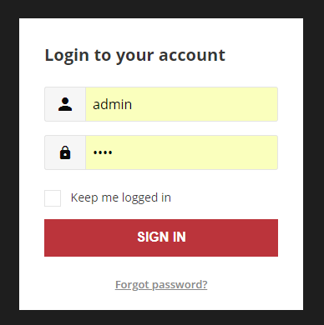

**Admin Forgot Password**

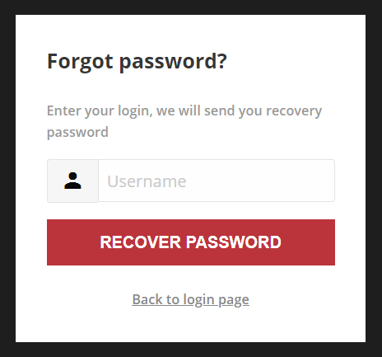

**Admin Logout**

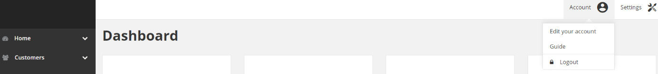

**Admin Profile Edit**

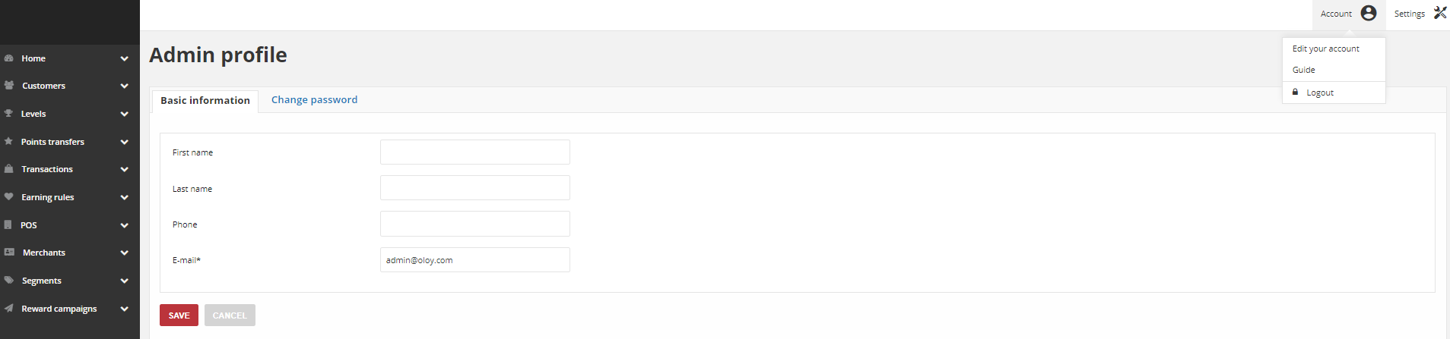

**Admin Workspace**

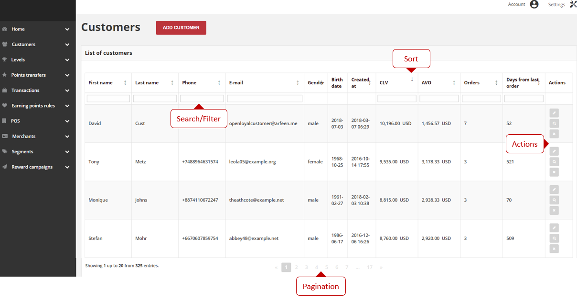

**Workspace Controls**

| **Control** | **Description** |
| --- | --- |
| Search / Filter | The filters in the header of each column can be used to limit the list to Specific values. You can simply type the value you want to find and press Enter |
| Sort | The header of mostly column can be used to sort the list in ascending or descending order |
| Paginate | The pagination controls are used to view the additional pages of results |
| Actions | The Actions control applies an operation to selected record |

**Admin Grid Controls**

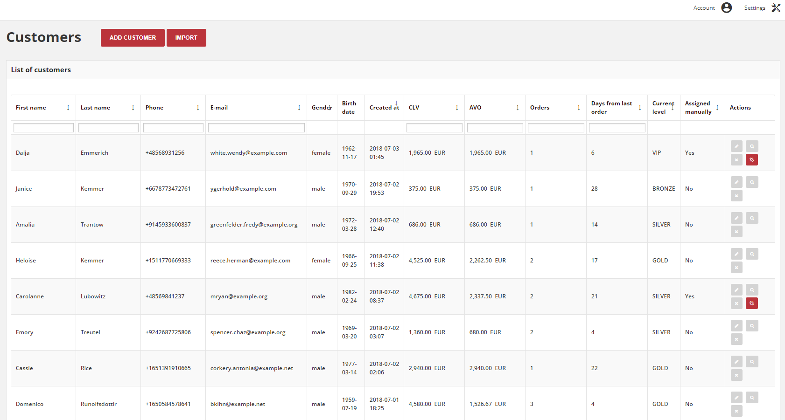

Admin pages that manage data display a collection of records in a grid. The controls at the top of each column can be used to sort the data. The current sort order is indicated by an ascending or descending arrow in the column header. The Action column lists operations that can be applied to an individual record.

**To sort the list:**

* Tap any column header. The arrow indicates the current order as either ascending or descending
* Use the pagination controls to view additional pages in the collection

To paginate the list:

Tap “Next” and “Previous” to page through the list, or click a specific Page Number

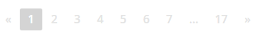

**To search the list:**

* In the selected column in the field under column header type the value you want to find
  + To find a close match, enter the few letters/signs of what you want to find
  + To find an exact match, enter the exact word/number you want to find
* You can put as many values under different columns headers as needed to describe the conditions that must be met for the search result. Search values from each column create an AND Condition rule. It means that in search results only records matching all entered values are displayed.

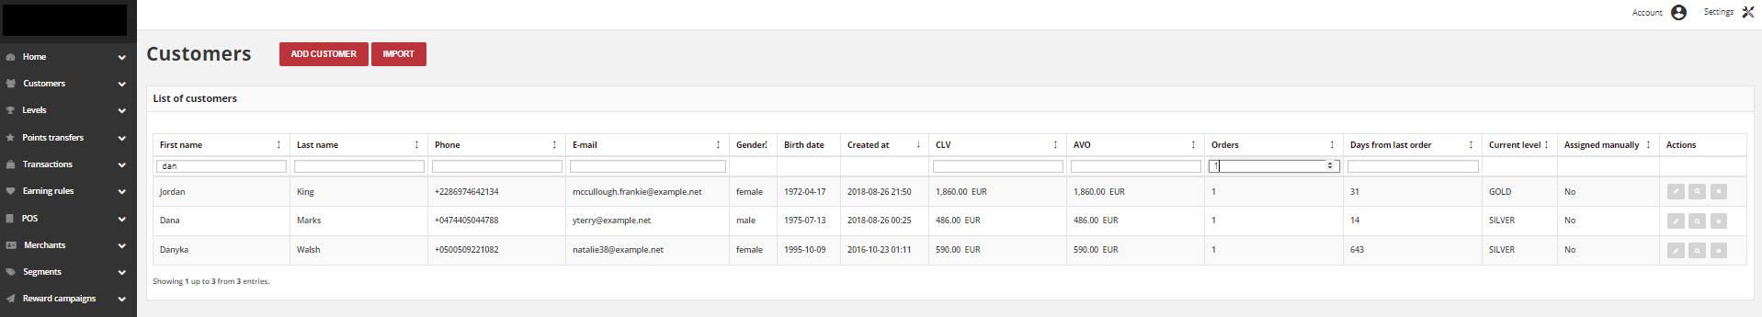

**Side Panels**

| **Menu** | **List** | **Actions** |
| --- | --- | --- |
| **Customers** | | |
|  | All Customers | * Edit customer * View Customer Account details * Deactivate/Activate customer * *Unlink manually assigned level - optional* |
| **Levels** | | |
|  | All Levels | * Edit level * Export customers to CSV |
| **Points transfers** | | |
|  | All points transfers | * View Points transfer details * Cancel transfer |
| **Transactions** | | |
|  | All transactions | * Edit transaction labels * View Transaction details |
| **Earning rules** | | |
|  | All earning rules | * Edit earning rule * View earning rule details |
| **POS** | | |
|  | All POS | * Edit POS |
| **Merchants** | | |
|  | All merchants | * Remove merchant account * Edit Merchant |
| **Segments** | | |
|  | All segments | * Delete selected segment * Edit segment * Export customers to CSV |
| **Reward campaigns** | | |
|  | All reward campaigns | * View campaign details * Edit reward campaign * Buy reward campaign for client |
| All campaign categories | * Edit campaign category |

## CONFIGURATION

**Settings**

The Configuration section determines loyalty program and point’s details, customer earning and spending statuses, account activation, identification factors of a matching transaction with a customer and other settings that are used throughout the Loyalty system.

Program URL: URL to a page with Loyalty Program description

Conditions URL: URL to page with Loyalty Program Terms & Conditions description

FAQ URL: URL to page with Loyalty Program FAQ page

Conditions File: upload Loyalty Program Terms & Conditions document in .pdf. After uploading and saving settings a link where a file is available appears.



Points Singular / Plural: A unit label of scoring in singular and plural, that you want to appear. Help e-mail: Where a customer can write to find help and support for your Loyalty Program

Expire Points Methods

After X days: Points will expire, after a provided in Points will expire after field number of days, from the date of adding Points transfer

All Time Active: Points accumulated by the participants of your loyalty program don’t expire:

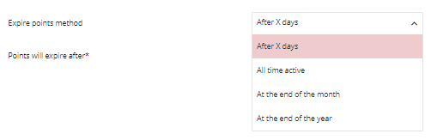At the end of the month / year: Points accumulated by the participant will expire at the end of the month / year when he got it

Points are never locked checkbox: To assign points to Active points pool and recalculate customer level instantly when his transaction will be registered in Loyalty App

Returns checkbox: After Return process completes, amount of points earned for a returned transaction will be subtracted

Days before expiring points to notify user: Webbook notification about the customer earned points expiration

SKUs excluded from levels: SKUs that will not be included in order value used for earned points calculation

Excluded SKUs of delivery cost: Available and required only when Delivery costs checkbox is selected.

Delivery Costs checkbox: If selected then delivery cost will not be included in order value used for earned points calculation

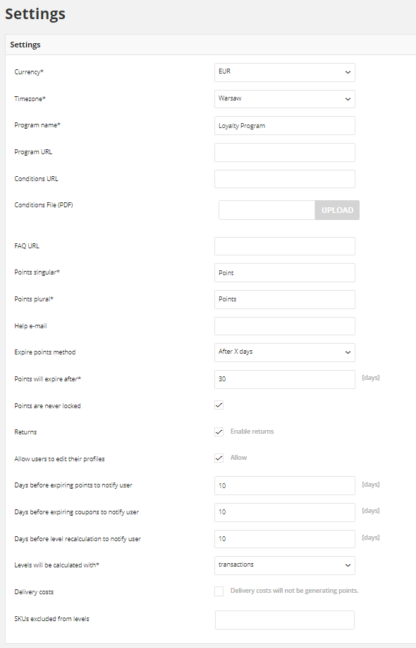

## Mode optionsLEVEL DOWNGRADE SETTINGS

| **Type** | **Description** |
| --- | --- |
| None | Customer level doesn’t decrease and his accumulated points are not reset. No additional settings to configure |
| Automatic | Default Loyalty logic.  The only scenarios when customer can return to previous level is when  transaction (order), which caused this promotion, will be returned  or his level will be changed manually by Admin.  His accumulated points are not reset – Loyalty points pool based on  Points transfers.  No additional settings to configure |
| Every x # of days | Customer level will be recalculated every provided number of days based  on accumulated points counting from registration date/last downgrade date or last level change.  If at the end of specified period  (registration date/last downgrade date/last level change + number of days  every which customer level is recalculated) customer won’t reach enough points to stay at the same level, a customer will be relegated to level  which his points determine |

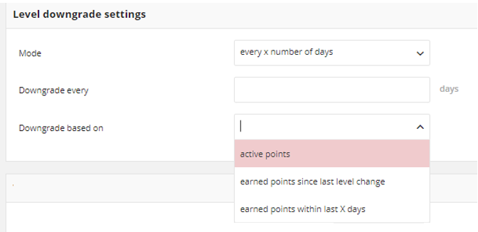

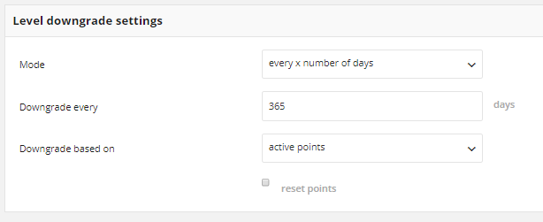

| **Type** | **Description** |
| --- | --- |
| Active points | Calculate a customer current level based on only his active points pool |
| Earned points within last X days | Calculate a customer current level based on his earned points since last  Level recalculation date (registration date/las level recalculation).  It sums up added (Active) points. Used points won’t effect on earned points.  Locked points are also excluded from earned points and will be added after unlocking them.  Currently earned points from last downgrade date are displaying in **Customer Loyalty**  Balance as a **Total points earned since last level recalculation**.  At the of every defined period amount of collected within points is reset |
| Earned points since  last level change | Calculate a customer current level based on his earned points since last  Level change date (base on his activity within loyalty program).  **For example**, after registration customer is assigned to the basic level and from the  Registration date, days till level recalculation is counted. If in the middle time,  customer will earn points that implicate promotion to the next level days are  Counted from the beginning starting from the date of promotion.  Currently earned points from last change are displaying in **Customer Loyalty**  Points balance as a **Total points earned since last level recalculation**.  At the end of every defined period, amount of collected within points is reset |

## EMAIL TEMPLATES

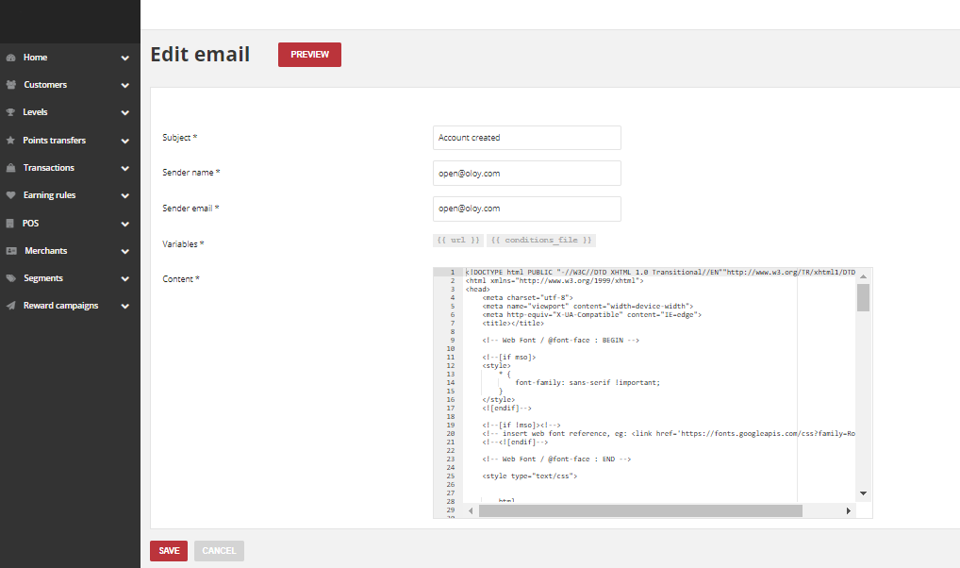

| **Event** | **Description** |
| --- | --- |
| **Account created** | |
| E-mail send when Customer  register to program using Customer dashboard | Email with link to activate account (password is entered  by customer during filling out registration form)  and link to download Terms & Conditions file (.PDF) |
| **Account created** | |
| E-mail send after registering new Customer  Account using Admin dashboard, POS dashboard and API | It contains temporary password to activate an account and link to download Terms & Conditions file (.PDF) |
| **Password reset requested** | |
| Send when user click on Forgot password  and provide email address | E-mail with reset password link |
| **New reward** | |
| Send after Customer reward redemption | It contains coupon code and reward campaign name |
| **New points** | |
| Send after Customer earn points | It contains new points value and current amount of  all active points |
| **New level** | |
| Send after Customer reach next level | It contains information about customer new level and  new discount |
| **Invitation** | |
| Send after Customer invite his friend to  loyalty program (refer a friend) | It contains referrer customer name and registration  link for his friend |

## SYSTEM LOGS

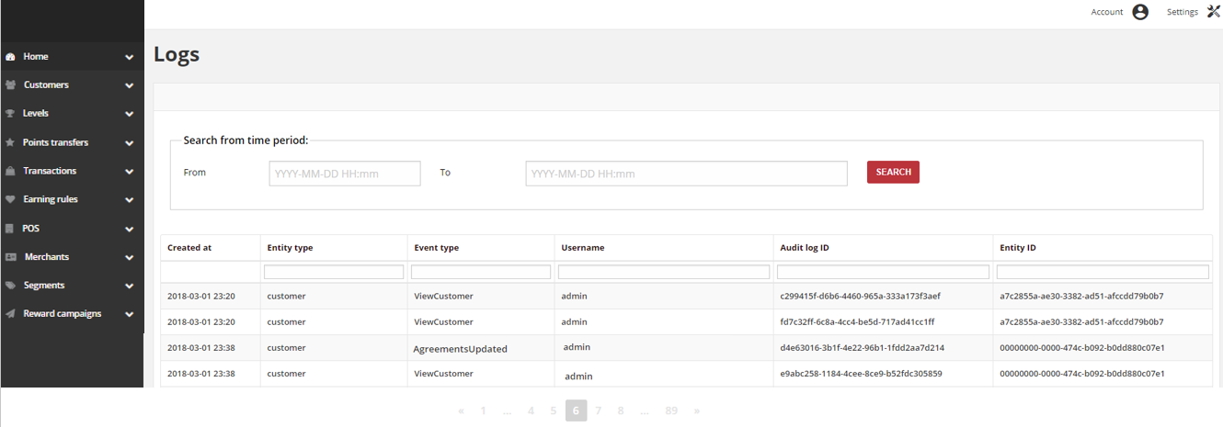

Logs grid allows monitoring every change on the customer data. The log file is accessible only to Admin users throughout the Admin dashboard. Logs view allows you to check the date and time that change was made, type and unique ID of change and user name and his unique ID associated with this change. Logs monitor Create / Delete / Update and Read actions for sensitive data.

## CUSTOMER

View Customers

**Add Customer**

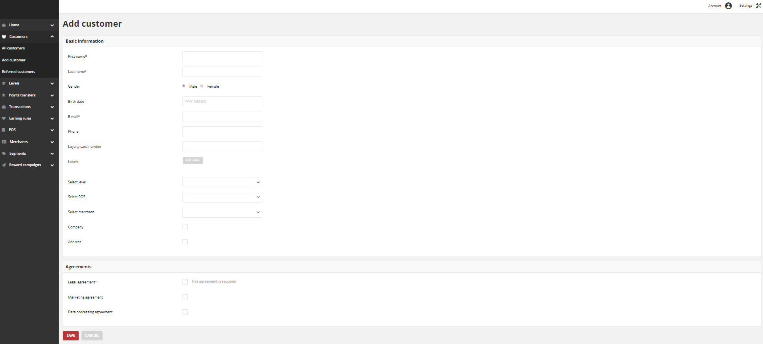

**Referred Customers**

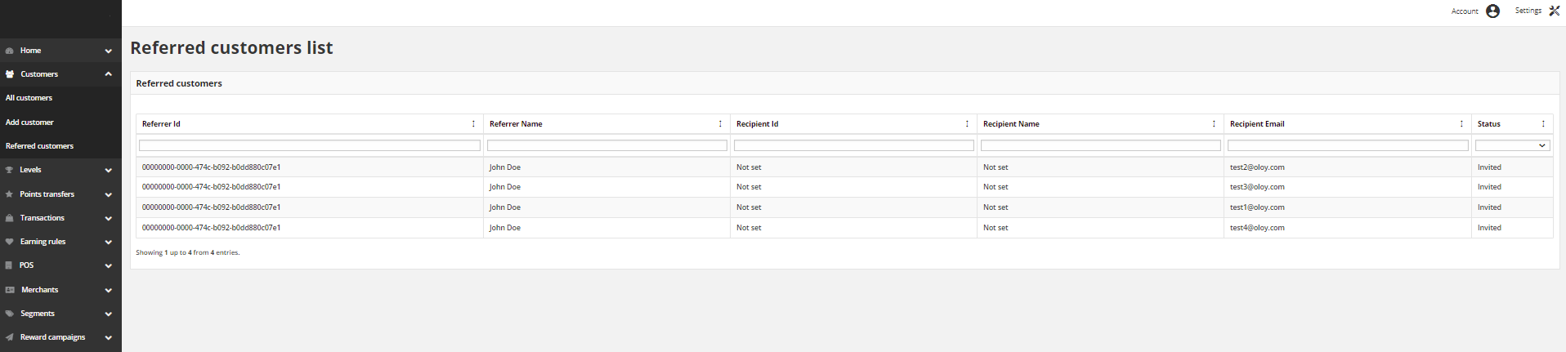

**Creating customer account from admin**



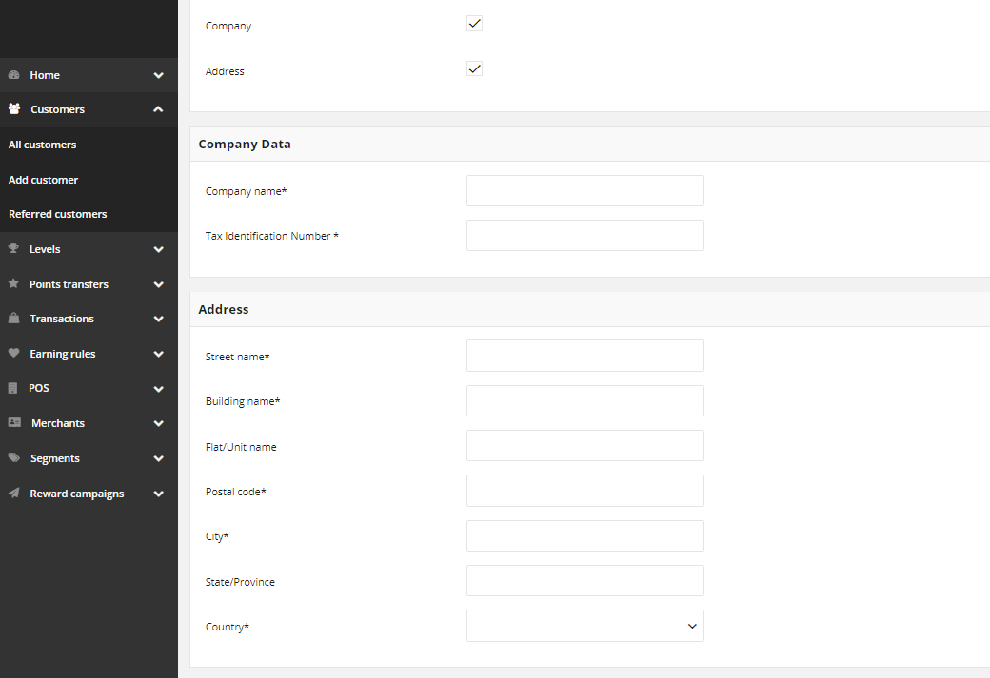

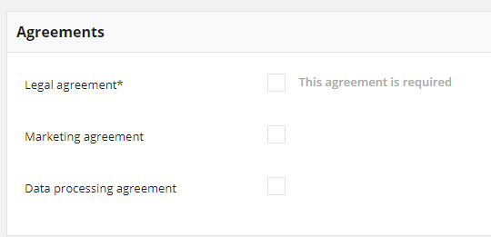

**Import Customer List**

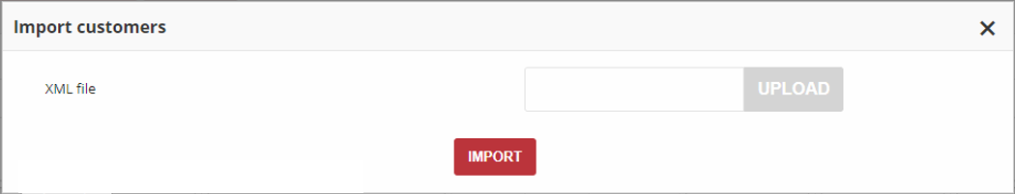

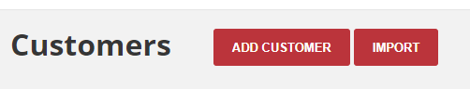

**Customer XML file structure**

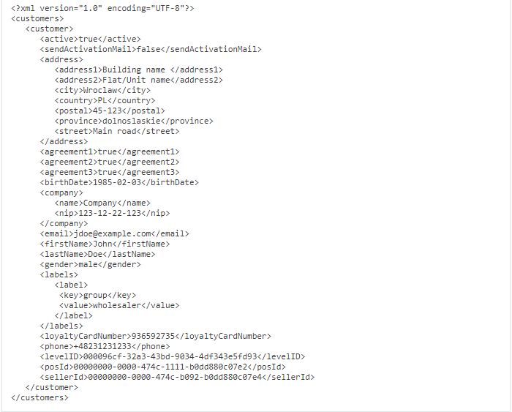

**Deactivate Customer**

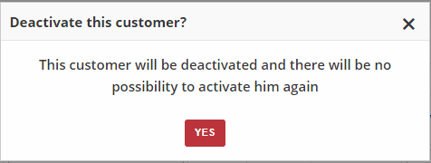

**Customer Profile Details**

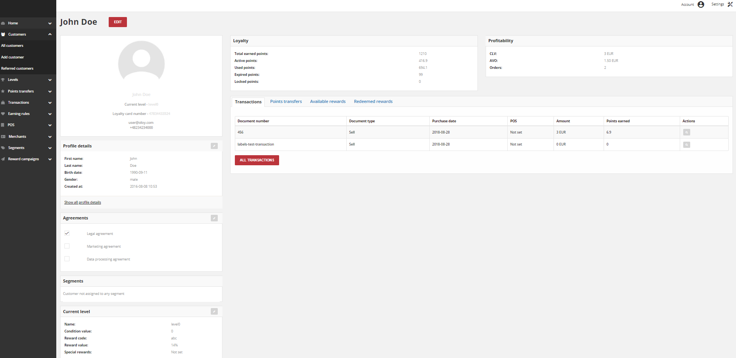

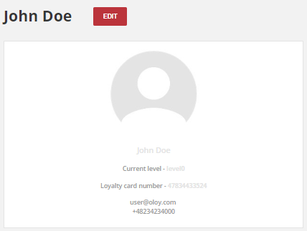

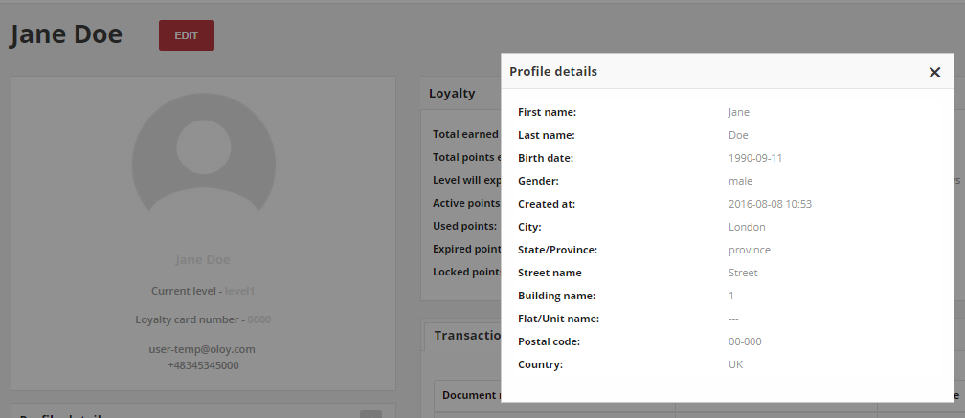

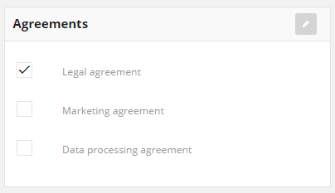

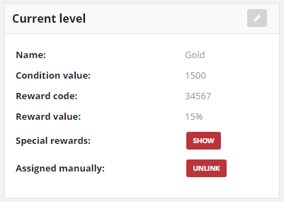

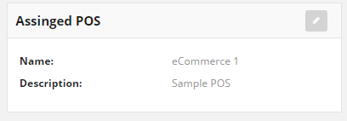

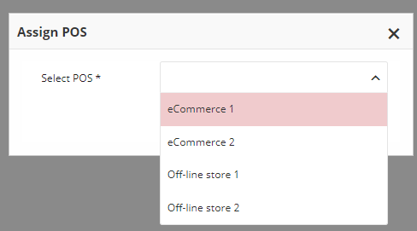

## http://docs.openloyalty.io/en/stable/_images/customer_activity.pngCUSTOMER LOYALTY ACTIVITY

**Loyalty**

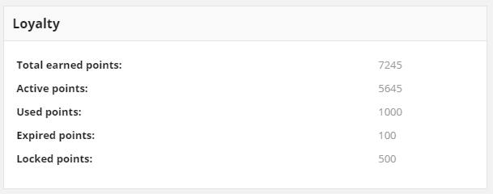

**Total earned points:** Total accumulated points assigned to the customer account thought various activity within the loyalty program based on Earning Rules.

Sum of active, locked, used and expired points.

**Active Points:** Points that may be used to redeem a reward campaigns. Depending on the Configuration, this value can be used to level recalculation instead Total points earned since last level recalculation amount.

**Used Points:** Points redeemed by the Customer thought various Reward Campaigns within the loyalty program.

**Expired Points:** Points expired due to non-redemption of assigned active points. Points will expire after number of days from date of adding Point transfer. Points lifetime is set in Loyalty Configuration

**Locked Points:** Points earned through various activity within the loyalty program that cannot be used after passing selected locked time. Points will be locked for number of days set in Loyalty App Configuration, as a customer may return whole transaction or selected products. Locked points are not used to calculate customer level. After passing selected locked time, points automatically get active. When points get active, a customer level will be recalculated.

**Profitability**

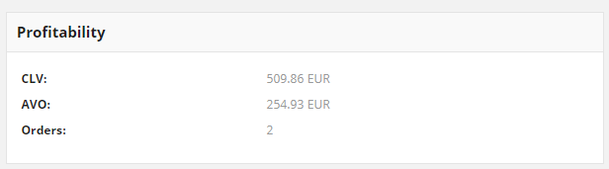

CLV (Customer Lifetime Value): Total amount of customer all registered transactions

AVO (Average Value of Order): Average amount of customer all registered transactions

Orders: Total number of customer registered transactions (orders) within the Loyalty Program

**Transactions**

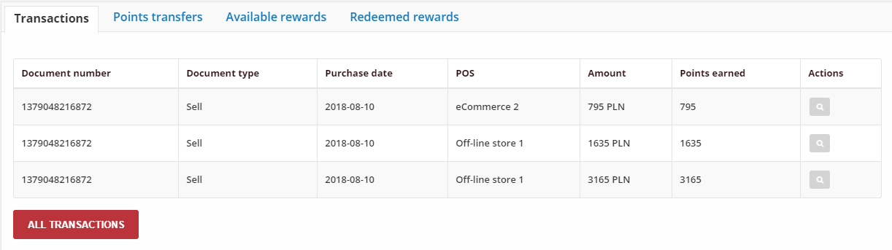

| **Field** | **Description** |
| --- | --- |
| Document number | Unique transaction ID |
| Document type | **Transaction type:**   * Sell * Return |
| Purchase date | Date of transaction |
| POS | POS where transaction was made |
| Amount | All transaction amount |
| Points earned | How many points Customer earned/lose for this transaction (order).  Transaction with the type “Sell” adds points, and “Return” subtracts |
| Actions | Open transaction record in view mode to see customers and purchased items details |

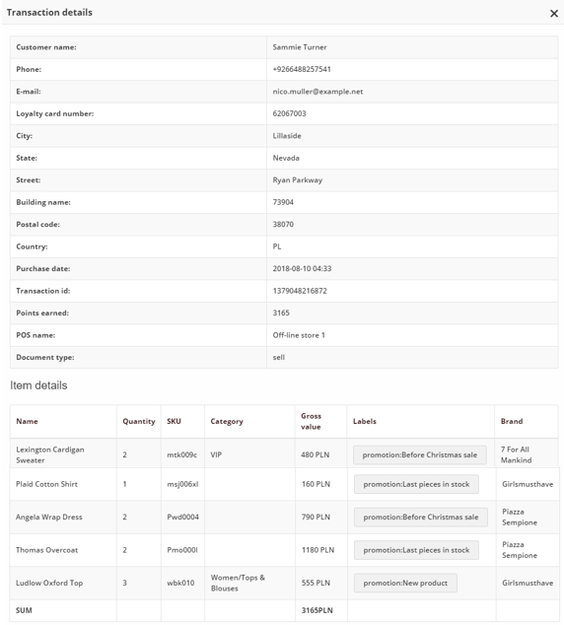

**Points Transfer**

**Points transfers** tab provide a view of latest points which customer gain or spend. Moreover, list contains information whether points are the result of Earning Rules (system) or they have been manually set by the Admin user (admin) and date until they will be locked.

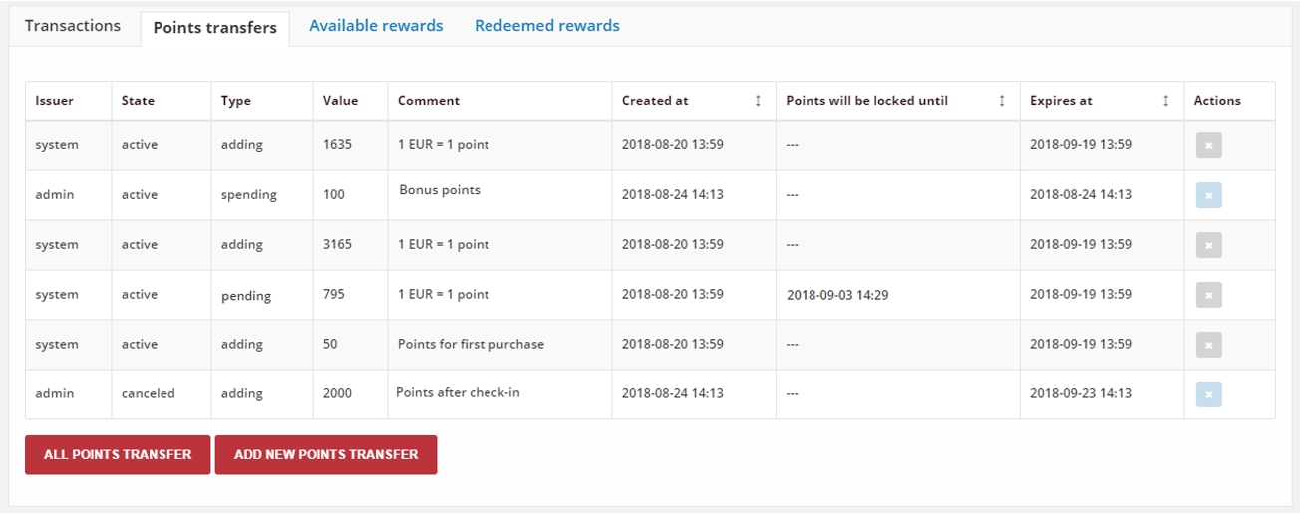

**Available Rewards**

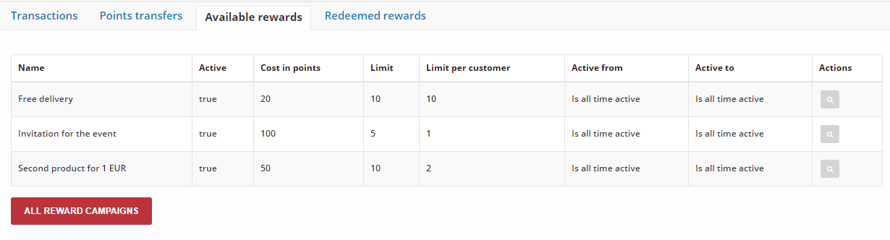

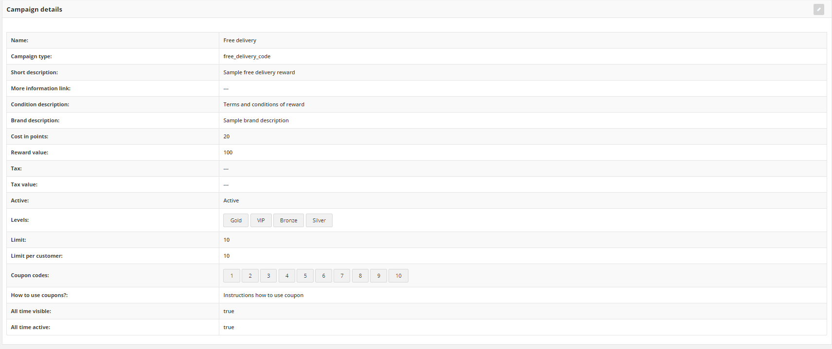

**Redeemed Rewards**

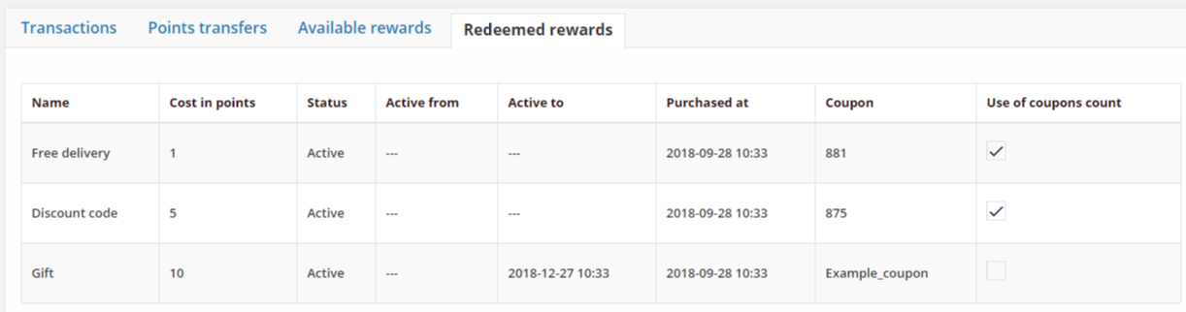

| **Field** | **Description** |
| --- | --- |
| Name | Reward name, that is display to customer |
| Cost in points | Define how much points customer spent to redeem reward |
| Status | Reward campaign status.  **Option include: Active/Inactive** |
| Active from | Reward campaign start date from which customer can used reward, define during reward campaign creation in Activity section |
| Active to | Reward campaign end date until which customer can used reward, define during reward campaign creation in Activity section |
| Purchased at | The date when reward was redeemed |
| Coupon | Discount code that was used |
| Use of coupon count | Define whether customer already used the reward or it’s only delivered and can be used by him |

## CJUSTOMER LEVELS

Levels are used to categorize customers based on the value of their transactions (orders) - The higher value/amount of transaction, the more points they will get and the higher level they’ll reach.

Customer is assigned to only one level at a time. **Customers are placed into a levels based either on their total amount of transaction or points they have earned**. If customer has spent enough money or earned enough points to move up a level, his level will automatically move up and he will be informed about it via email.

Depending on the Configuration, customer can also return to previous level e.g. when order, which caused this promotion, will be returned by him or his accumulated points will be not enough to stay at the current level at the end of specified period.

Customer level can be also changed to higher or lower manually by the Admin user. If you move a customer to a level manually, they are excluded from any automatic levels upgrades or downgrades

Each level can provide fixed discounts and also have exclusive rewards that can only be claimed when a customer is on that level.

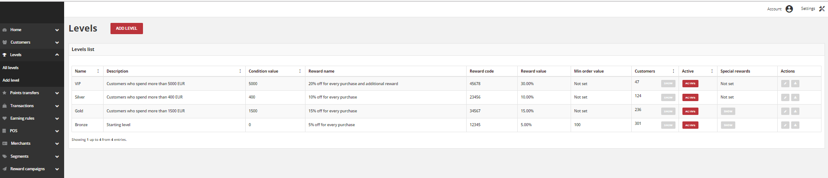

**Add Level**

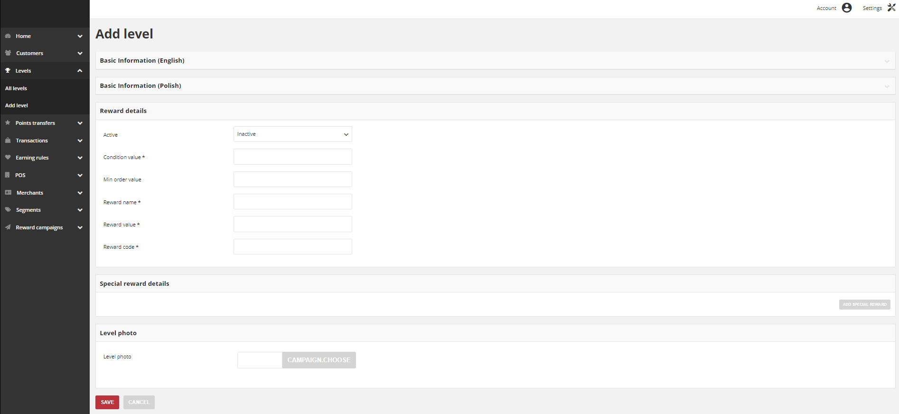

**Customers assigned to levels**

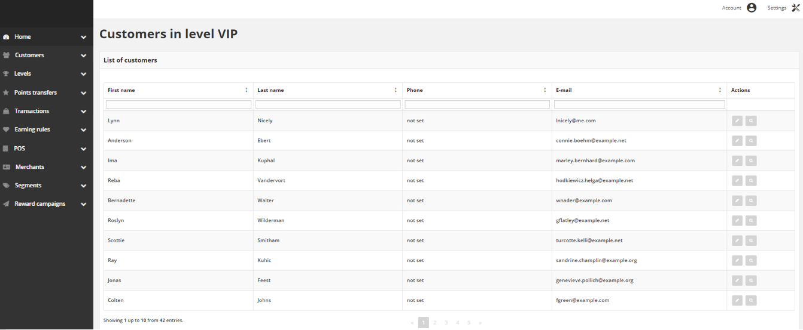

**Add / Update Level**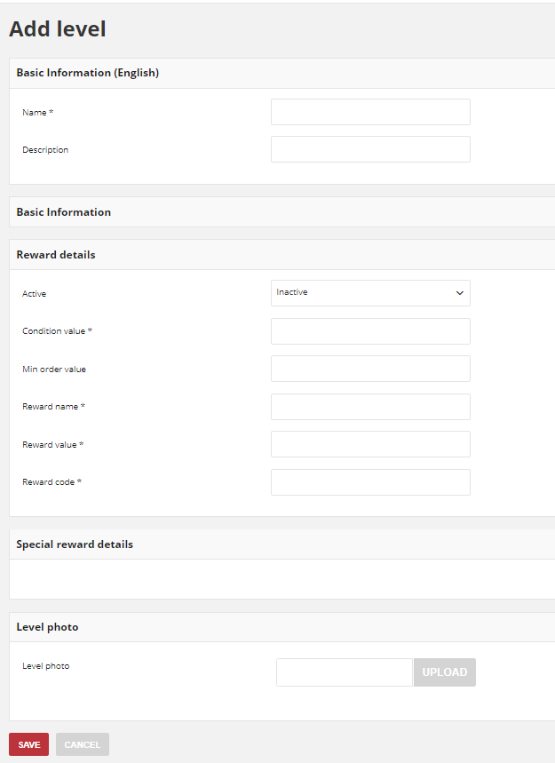

**Activate / Deactivate Level**

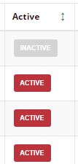

**Special Rewards**

Special reward shall be set if you want to give special discount for customer but only limited in time.

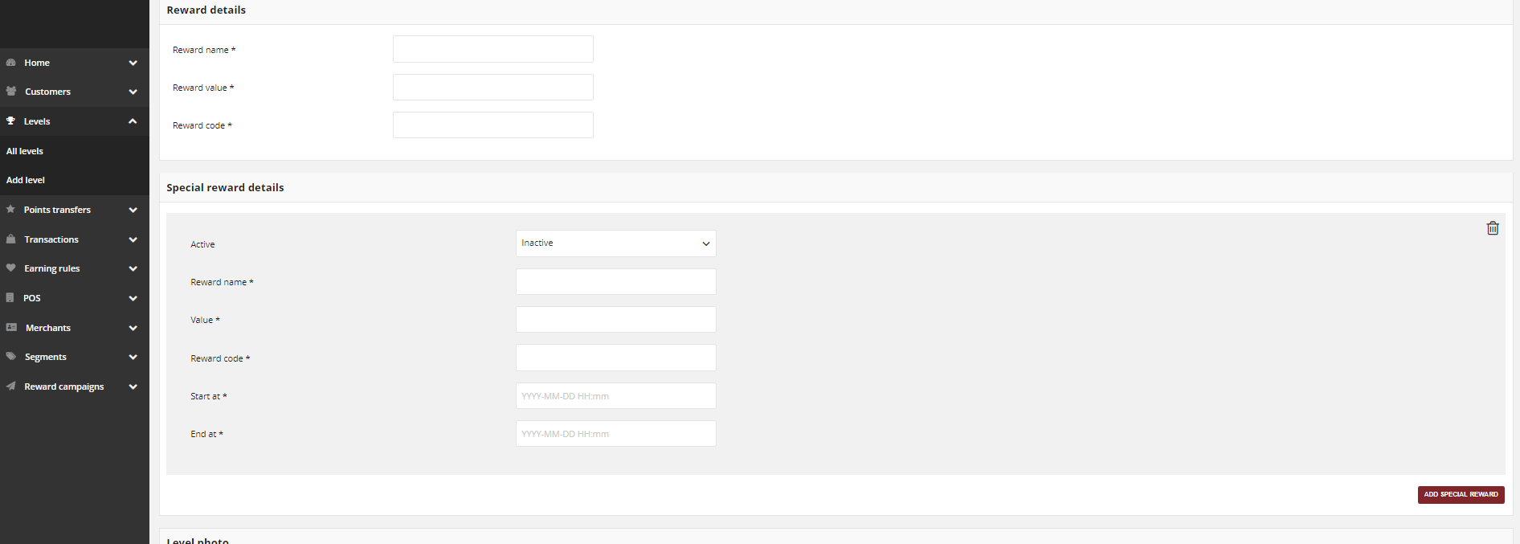

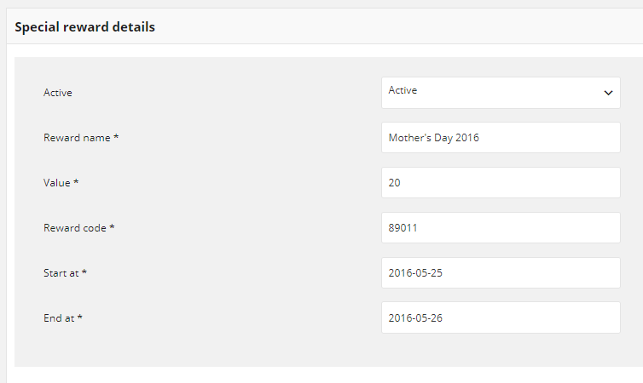

## POINTS TRANSFER

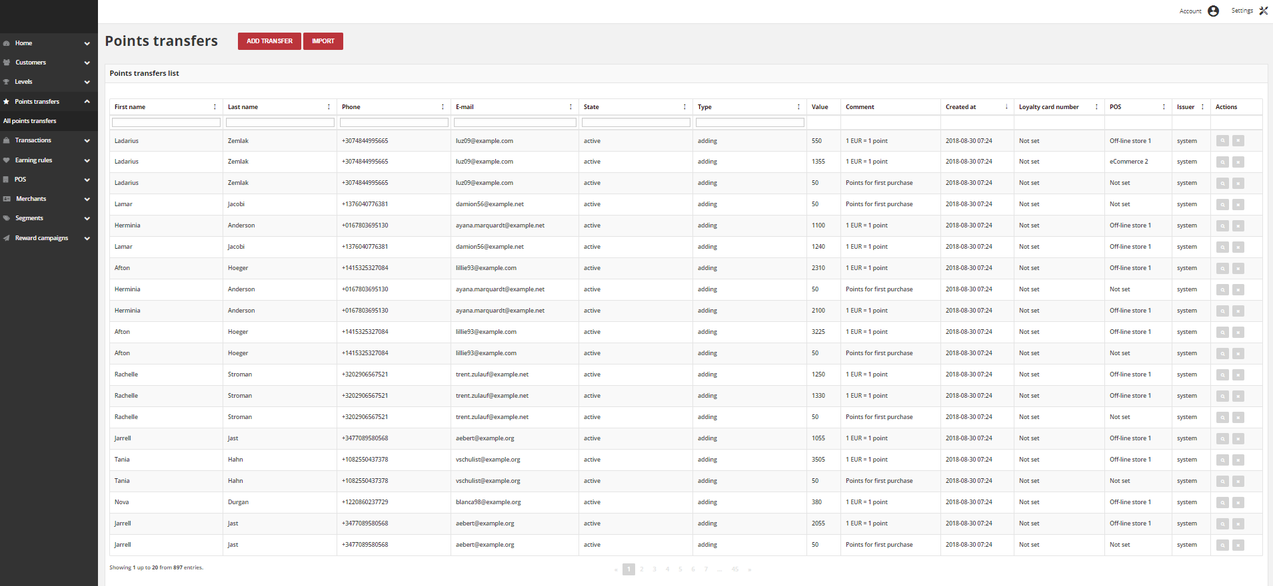

The Points Transfers section lists all – system and imported, increasing and decreasing sum of loyalty points assigned to customer account points transfers that has taken place between customer’s account and Loyalty App, and provides access to more detailed information.

| **Field** | **Description** |
| --- | --- |
| First name | The first name of customer referred to transfer |
| Last name | The last name of customer referred to transfer |
| Phone | The customers referred to transfer phone number |
| Email | The customers referred to transfer email address |
| State | Transferred points state:   * **Active**   points are available to spend   * **Expired**   points expired and cannot be used to redeem reward   * **Pending**   points are locked and cannot be used to redeem reward until locked time will be passing.   * **Canceled**   points are subtracted from the pool of Active Points as a result of canceling the points transfer |
| Type | Transfer operation type:   * **Adding**   customer earn point for transaction or other activity   * **Spending**   customer spent points for campaign reward |
| Value | Amount of points earned/spent within the transfer |
| Comment | Show details about transfer, e.g. for what Customer gets points, for what Customer spend points.  Field is automatically filled in with the **reward campaign name** when the customer *spends points* for the reward using his account.  Field is automatically filled in with the **earning rule name**, used to *earn points* by customer.  If transfer is created manually by Admin user, field is filled in with information provided by the Admin during transfer creation. |
| Created at | Date when points transfer was made |
| Loyalty card number | Customer loyalty card number linked with transfer.  If there is no value assign “Not set” is displayed |
| POS | Which of POS processed transaction upon which points were calculated.  If there is no assignment “Not set” is displayed |
| Issuer | Define who create Transfer operation.  **Options include**: system/admin |
| Actions | The operations that can be applied to selected transfer record.  **Options include**:   * cancel points transfer * view points transfer details |

**Cancel Points Transfer**

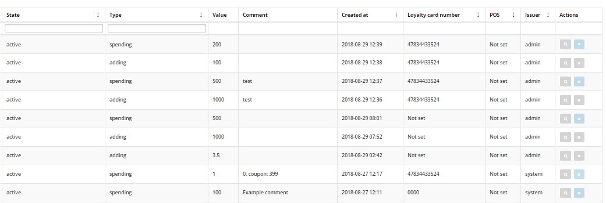

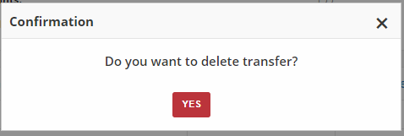

**Creating Points Transfer from Admin**

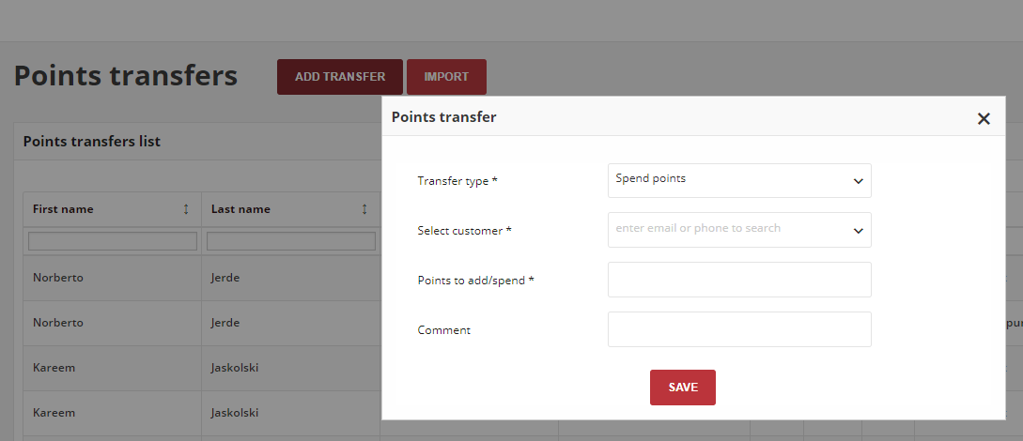

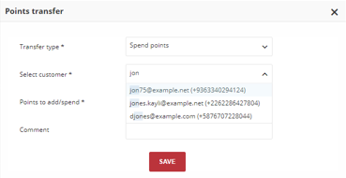

**Import Points Transfer**

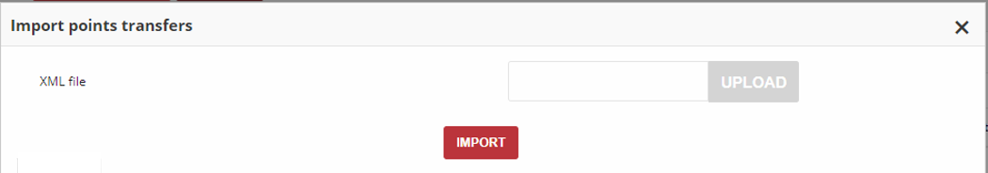

**XML File Structure**

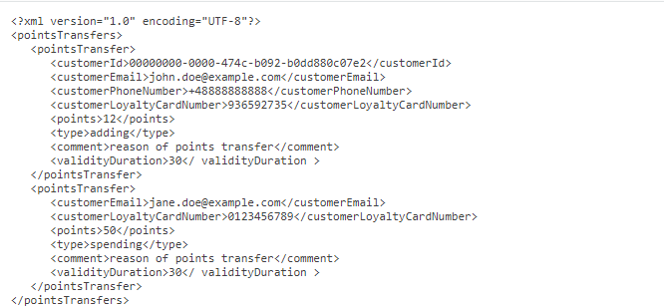

## TRANSACTIONS

The Transactions grid lists all (system and imported) payment activity that has taken place between the store system and customers, and provides access to more detailed information about purchased items and transaction itself.

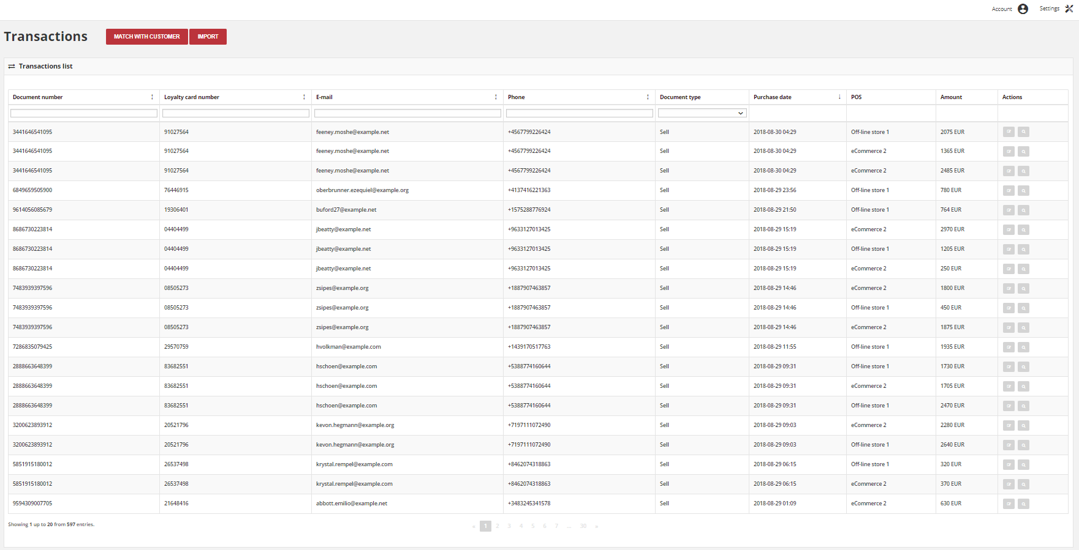

| **Field** | **Description** |
| --- | --- |
| Document number | Unique transaction ID from your store internal system (e.g. e-commerce) |
| Loyalty card number | Number of customer loyalty card related to the transaction (If transaction is linked with customer account) |
| E-mail | Email address of customer related to the transaction |
| Phone | Phone number of customer related to the transaction |
| Document type | Transaction type:   * **sell** - customer buy products * **return** - customer return bought products |
| Purchase date | Valid date of transaction |
| POS | Offline or online store where transaction was made |
| Amount | The amount of the transaction |
| Actions | The operations that can be applied to selected transaction record.  **Options include**:   * add/edit transaction labels * view transaction details |

**Transaction Details**

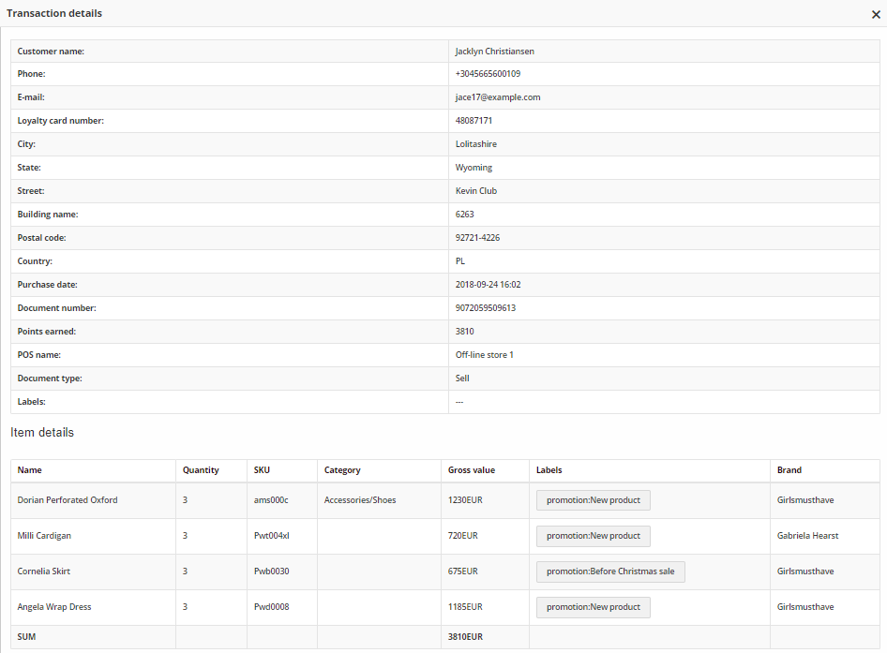

| **Field** | **Description** |
| --- | --- |
| Customer name | First and last name of customer related to the transaction |
| Phone | Phone number of customer related to the transaction |
| Email | Email address of customer related to the transaction |
| Loyalty card number | Number of customer loyalty card related to the transaction  (If transaction is linked with customer account) |
| City | The city where the customer resides at this address |
| State | The state or province of the customer at this address |
| Street | The street address of the customer |
| Building name | The name/number of a building or property where the customer resides |
| Postal code | The postal code of the customer at this address |
| Country | The country where customer resides at this address |
| Purchase date | Valid date of transaction |
| Document number | Unique transaction ID from your store internal system (e.g. e-commerce) |
| Points earned | How many points Customer earned/lose for this transaction (order).  Transaction with the type “Sell” adds points, and “Return” subtracts |
| POS name | Offline or online store where transaction was made |
| Document type | Transaction type:   * **sell** - customer buy products * **return** - customer return bought products |
| Labels | Assign transaction labels |
| **ITEM DETAILS** | |
| Name | Bought product name |
| Quantity | Bought product quantity |
| SKU | Bought product SKU |
| Category | Bought product category |
| Gross value | Gross value of bought product |
| Labels | Bought product label, if assigned |
| Brand | Bought product brand, if assigned |
| SUM | Total amount of bought products within one transaction |

**Transaction Labels**

Transaction labels are intended to be used only for the informational purpose. Transaction doesn’t have to be matched with customer to add a label. Customers from Client dashboard can also add or edit transaction labels but only this related with transaction matched with him. In that case administrator need to match transaction with a customer from Admin panel.

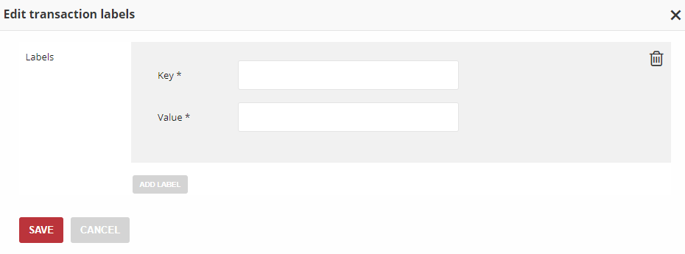

**Transaction Matching**

Usually, transaction come from your store system with information about customer. However, you can link transaction with Customer Account directly from the Admin, which is useful when you send to the Loyalty App only transactions. Depending on Matching transaction with customer identification factors priority (set up in Configuration) customer email, phone number or/and loyalty card number can be used.

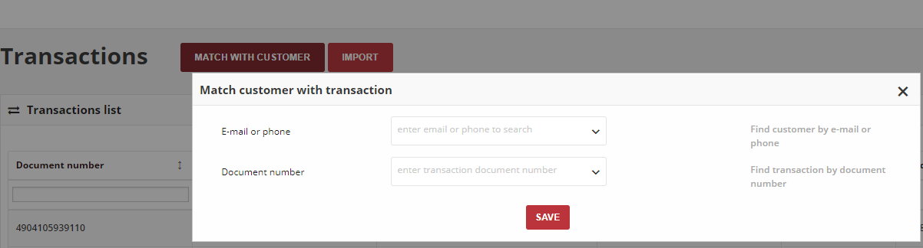

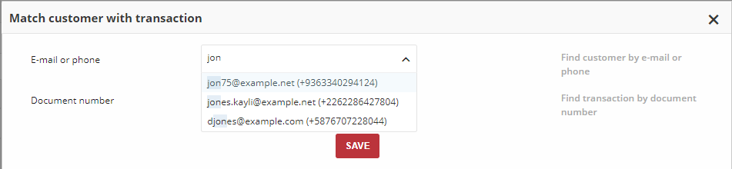

**Import Transaction via XML file**

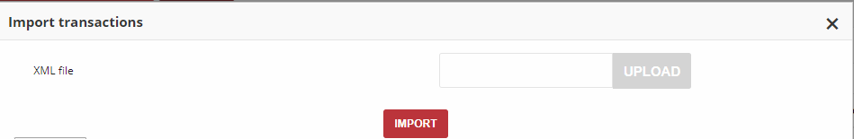

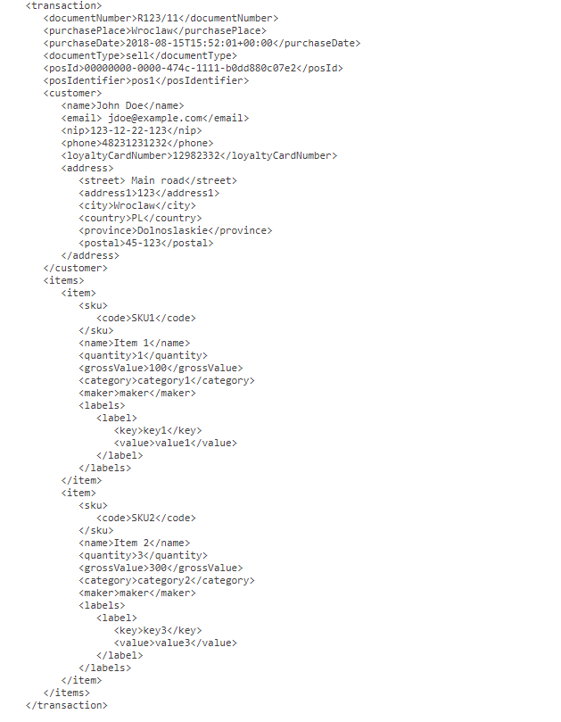

## EARNING RULES

Earning rules define ways and conditions for customers to earn points. Points can be awarded for a wide range of transaction and customer activities, and the configuration can be set to control the point allotment, balance, and expiration. You can add point multipliers, eligibility criteria and even exclude certain products or customers. Customers can redeem points toward rewards, based on the condition (points cost) that you establish.

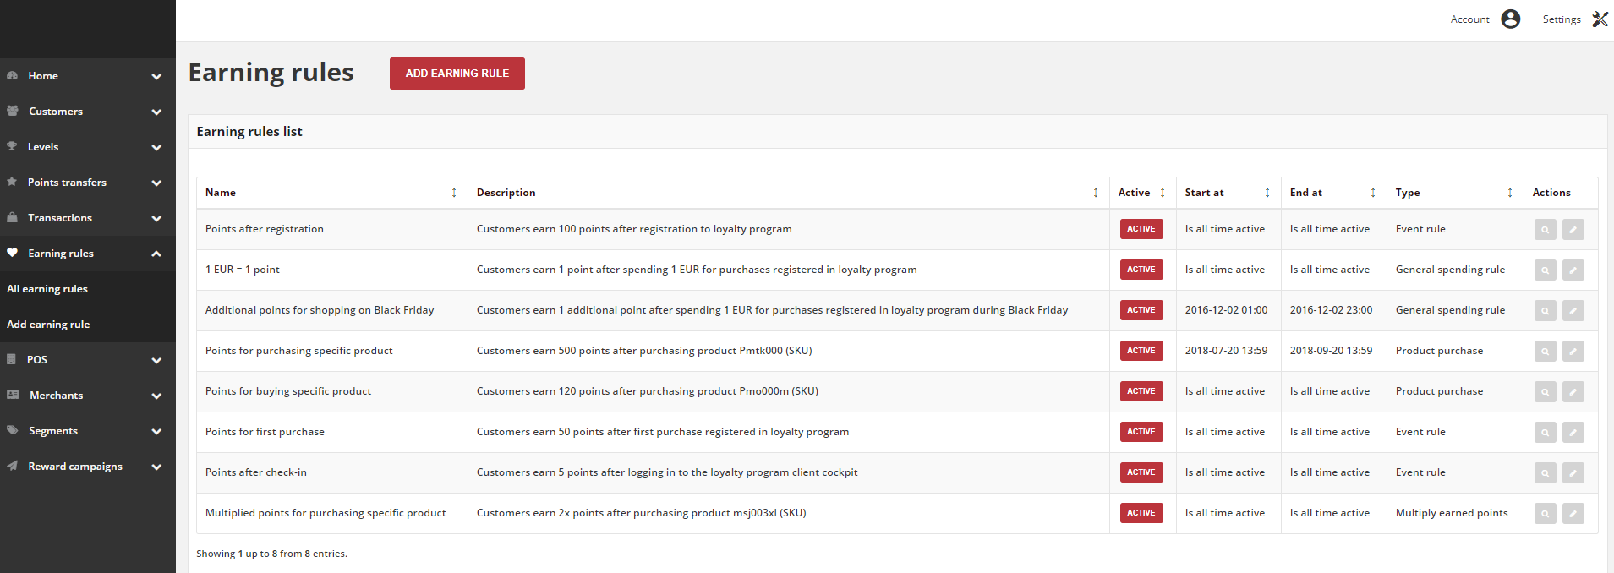

**Add Earning Rule**

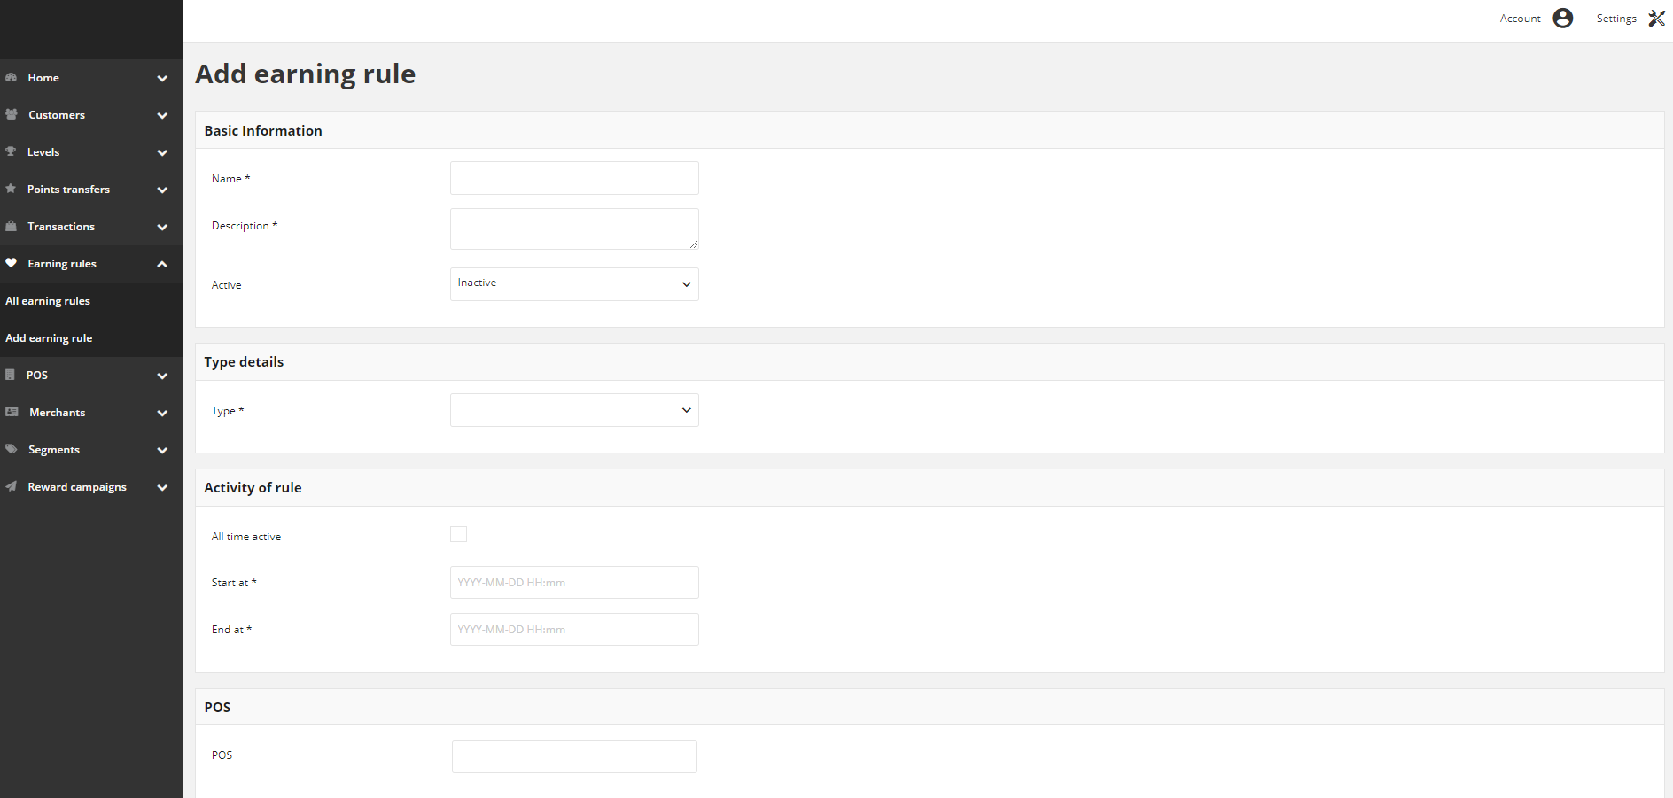

| **Field** | **Description** |
| --- | --- |
| Name | Name of the rule displayed in views |
| Description | Brief rule description |
| Active | Rule current status. **Option include: Active/Inactive**  Only Active rules are using for calculating earned points |
| Start at | Start date from which rule is active and can be used to calculate points |
| End at | End date until rule is active.  After that date rule become inactive and can’t be used to calculate points |
| Type | Rule type.  **Options include**:   * Custom event rule * Customer referral * Event rule * General spending rule * Geolocation * Instant reward * Multiply earned points * Multiply earned points by product labels * Product purchase * QRCode   To learn more about the rule types, please see Rule Types |
| Actions | The operations that can be applied to selected rule.  **Options include**:   * edit rule data * view rule details information |

**Earning Rule Type**

In general, earning rules can be divided into two types:

* **Transactional rules**

Related to transactions made by customer e.g. transaction total amount, purchased products etc.

* **Non-transactional rules**

Related to other customer data and his activity within loyalty program e.g. refer a friend, his friend registration/purchases, newsletter subscription, first purchase, account created etc.

During creation of rule you must specify its type, describing conditions for awarding points. Every rule type has its own required fields (conditions) that must be filled.

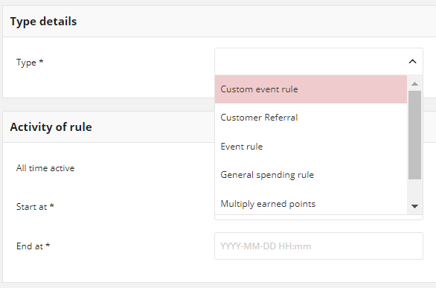

**Transactional rules**

The Loyalty App offer following standard types:

**General spending rule:** Customer could receive points for order value.

**Multiple earned points:** Customer could receive multiple points for product with specified SKU

**Multiple earned points by product labels:** Customer could receive multiple points for product with specified labels

**Instant reward:** Customer could receive any reward campaign for his transaction registered within Loyalty Program.

**Product purchase: C**ustomer could receive given amount of points for specified product

The sequence for point’s calculation is as following

* Firstly, if applicable, customer receives points from **General spending rule**
* Secondly, if applicable, points are multiplied based on **multiple earned points** rule, or based on labels multipliers from **multiple earned points by product labels**. Or reward is assigned from **Instant reward** rule
* Finally, if applicable, customer receives points from **Product purchase rule**

**Non-transactional rules**

The Loyalty App offers following standard types:

* **Custom event rule:** Customer could receive points for external actions
* **Customer referral:** Referred and/or Referrer customer receive points for his action
* **Event rule:** Customer could receive points for specified actions
* **Geolocation:** Customer could receive points for his location
* **QRcode:** Customer could receive points for scanning define QR codes

For all earning rules the following basic information is needed to create the rule. Depending on the rule additional information is captured

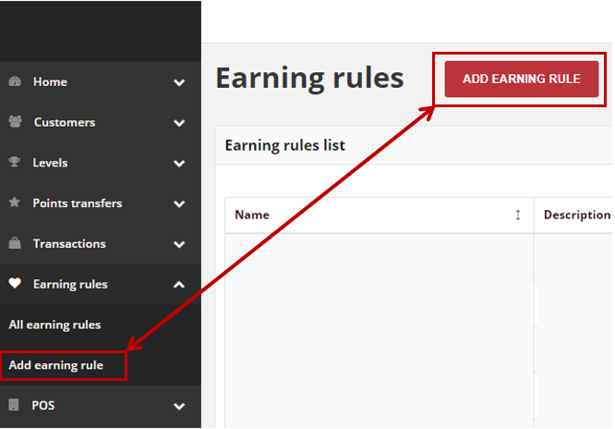

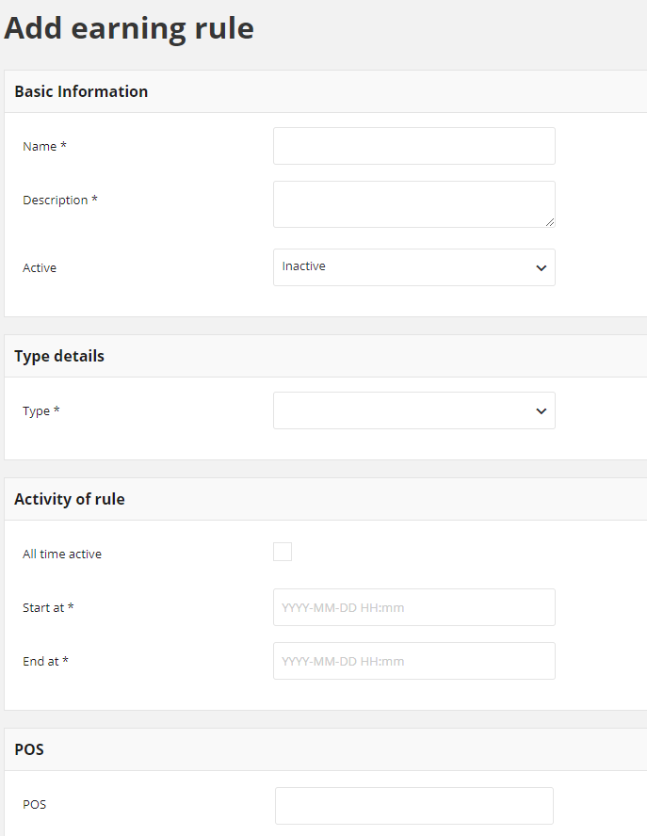

The type details define rule type. After defining the type rules can be assigned to allocation using the POS. When a transaction comes from a specific POS, only earning rules assigned to this POS will be used to calculate points.

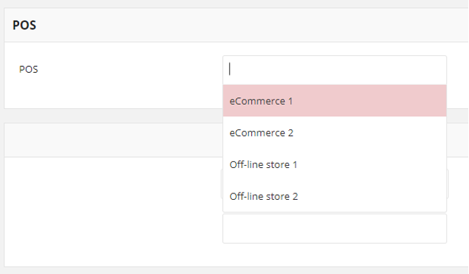

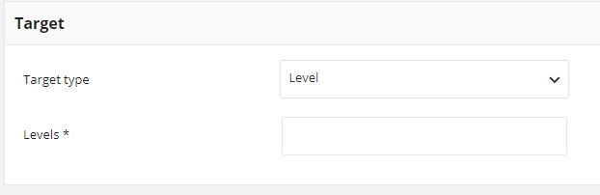

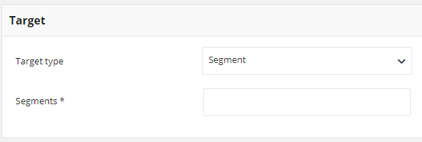

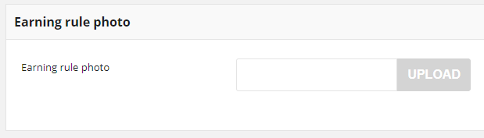

**Set Earning Rule as the last**

If there are more than one Earning Rule to be applied and one of them has a flag “stoppable”, then this rule will be applied and stops any further rules according to sequence listed above. When customer registers a transaction, the Loyalty App checks for Earning Rules that can be applied and it starts executing each Earning Rule. When executed Earning Rule has a flag “stoppable” it should be the last Earning Rule executed for that transaction which means any subsequent Earning Rules should be skipped.

**Transactional Rules**

**General spending rule**

Reward customer with defined amount of points for his order value. Allows to specify how many points customer can earn from 1 amount of currency. If needed, you can exclude certain products (Defined SKUs or labels) and delivery costs from the points calculation.

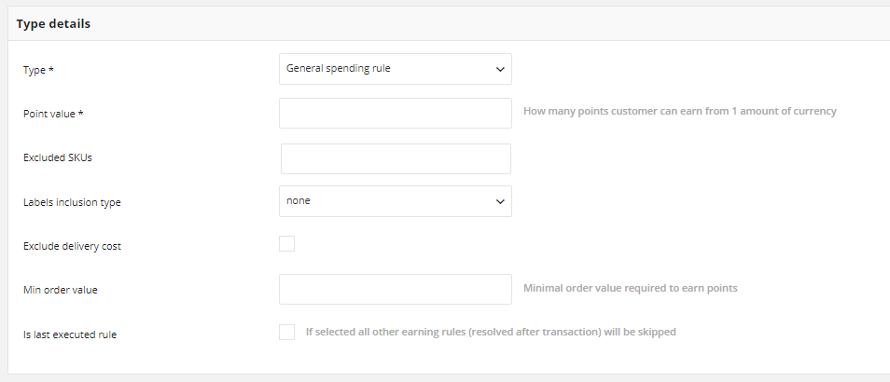

**Multiply Earned Points**

Multiply points that customer receive for purchase products with specified SKU. The rule is related to General spending rule. The rule defines for which purchase products, points (defined in General spending rule) are to be multiplied.

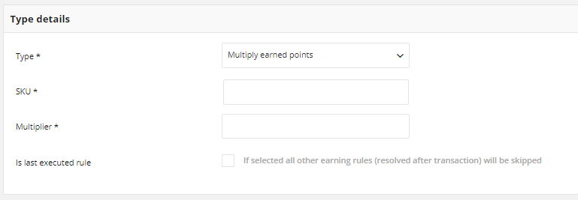

* Rule will be applied only for listed products with selected [**](http://docs.openloyalty.io/en/stable/userguide/earning_rules/creation/multiply.html#id1)SKU**s
* Points gained for purchase product will be multiplied by factor provided in **Multiplier** field
* If you marked **Is last executed rule** checkbox, then you add a “stoppable” flag to this rule.

**Multiply earned points by product labels**

Multiply points that customer receive for purchase products with specified labels. The rule is related to General spending rule. The rule defines for which purchased products, points (defined in rules above) are to be multiplied. Rule can contains more than one product label. Different **Labels** are linked with OR condition - at least one of labels linked with this rule must be true to let customer earn points. If more than one is true, points are multiply in order by all multipliers.

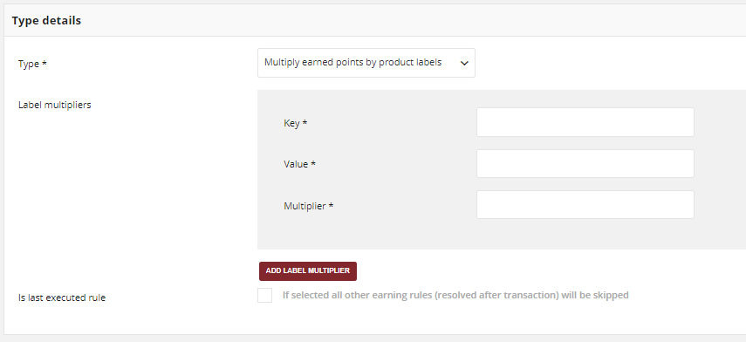

**Instant Reward**

Reward customer with defined reward campaign for his order. Rule can be related with any active Reward campaign, but only one at once.

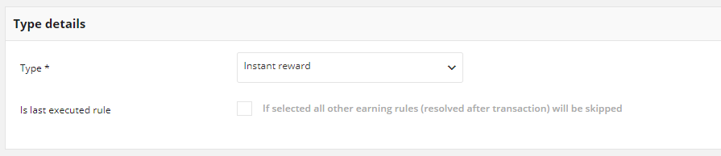

**Product Purchase**

Reward customer with defined amount of points for purchase specified products. Rule can be related to Multiply earned points rule and General spending rule.

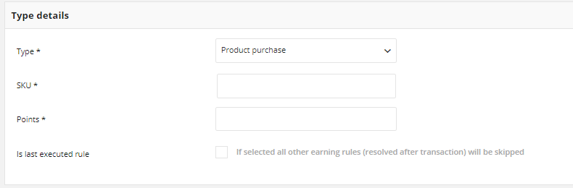

**Non Transactional Earning Rules**

**Custom Event Rule**

Reward customer with defined amount of points for his action in external system. For example, share account with Facebook, add review for a product etc. If needed, you can also add repeatability limit to this rule type.

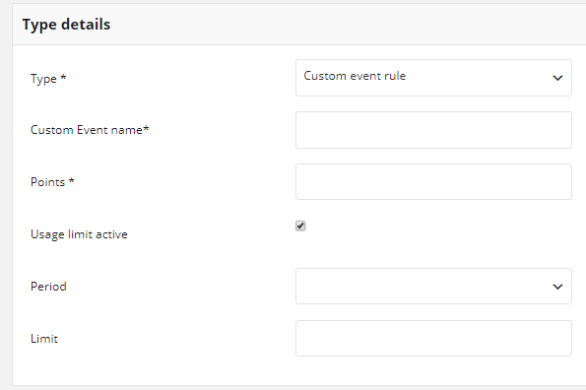

**Customer Referral**

Referral (refer a friend, member get member) functionality allows to reward Customers for invitating other Customers to the Loyalty program. It allows you to give prize to either referrer (Customer who send invitation) or referred person (Customer who respond with action to invitation).

Functionality shall allow for reward for different actions e.g.:

* Referred Customer register new account in OL
* Referred Customer make first purchase in OL (first transaction)
* Referred Customer make purchase in OL (every transaction)

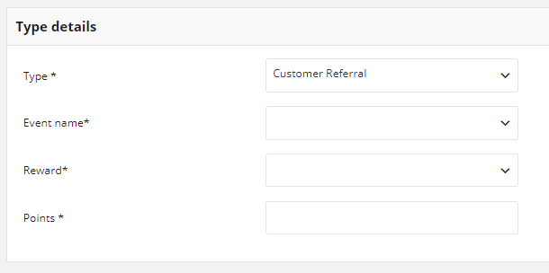

In Event name field select an event for which the customer will receive points. Options include:

* Every purchase after the first
* First purchase
* After registration and activation

In Reward field select who should receive points for this action. Options include:

* Referred
* Referrer
* Both

**Event Rule**

Reward customer with defined amount of points for his action. Actions for which customer can get points are predefined in the Loyalty App and related to events of your loyalty program.

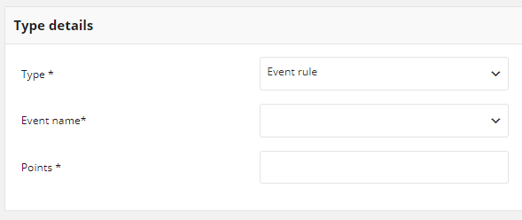

Event name options include:

* Account created
* Customer logged in
* First purchase
* Newsletter subscription

**Geolocation**

Reward customer with defined amount of points for his location. Locations for which customer can get points are defined in the Open Loyalty and related to radius. This Earning rule could be called only with API. Every run of API function will reward Customer with defined points.

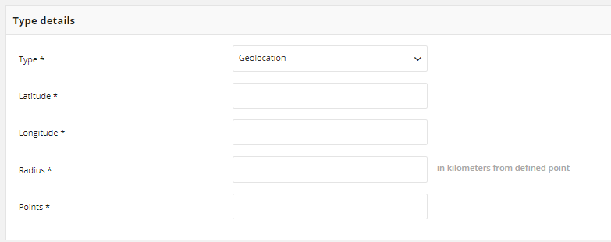

**QR Code**

Reward customer with defined amount of points for scanning QR code e.g. of product. Code for which customer can get points is defined in the Loyalty App. If needed, you can also add repeatability limit to this rule type.

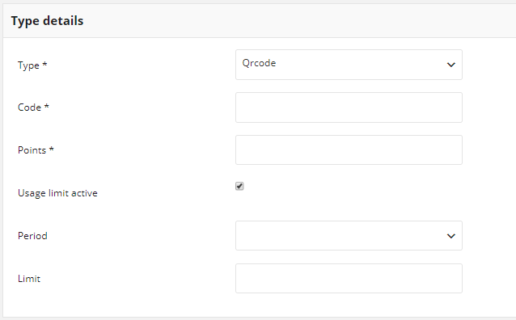

**Update Earning Rule**

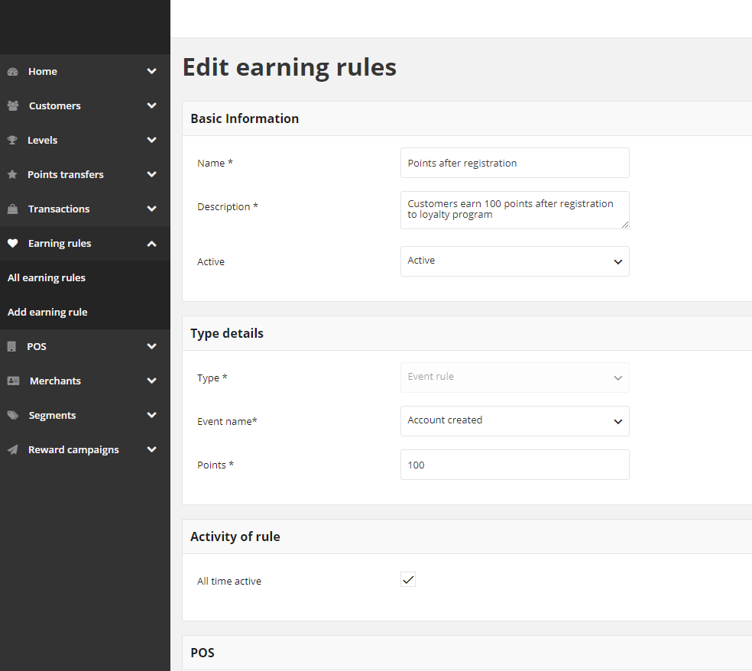

**Activate / Deactivate Earning Rule**



## POS

Customers can make transactions not only in the online store but also in offline stores. Both transactions should be counted within your Loyalty Program.

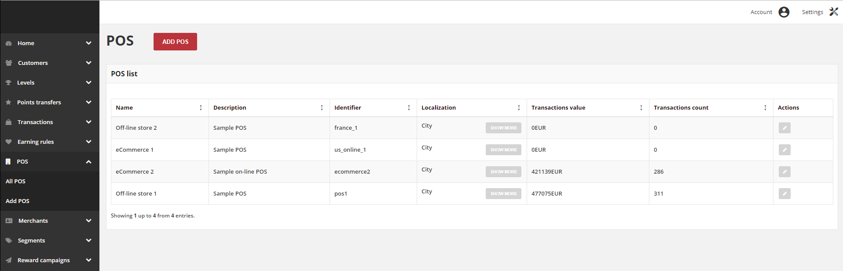**List all POS**

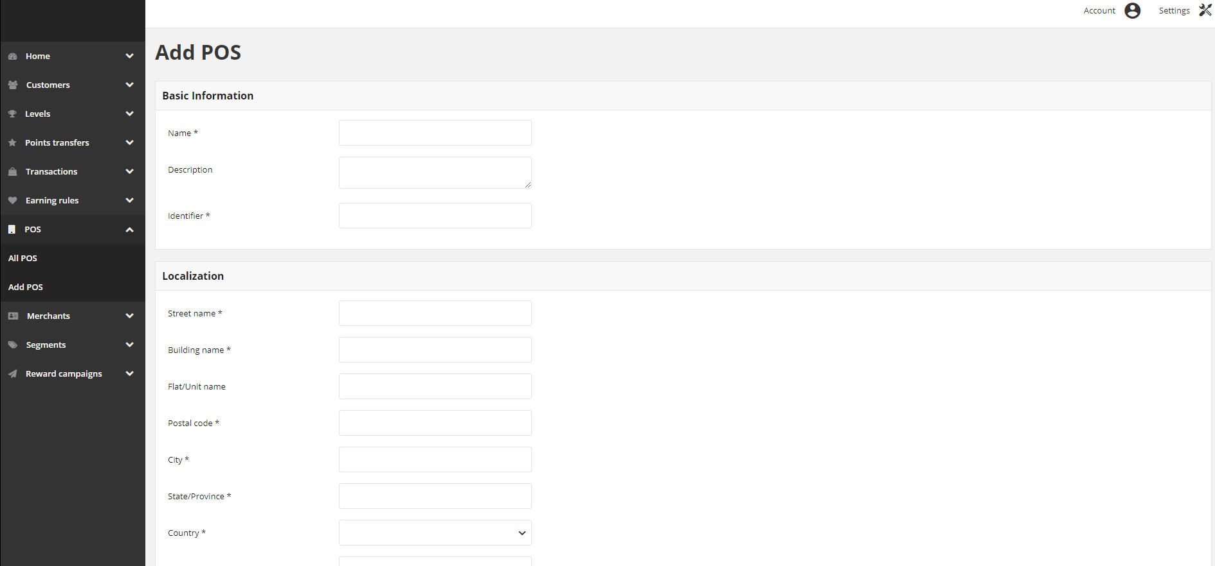**Add POS**

| **Field** | **Description** |
| --- | --- |
| Name | Name of the store |
| Description | Brief description of the store |
| Identifier | Unique POS name/code used for internal identification |
| Localization | Address details of the store. Only city is visible.  More information is available after clicking |
| Transactions value | Sum of all transactions values that were processed in POS |
| Transactions count | How many transactions were processed in POS |
| Actions | Open POS record in edit mode |

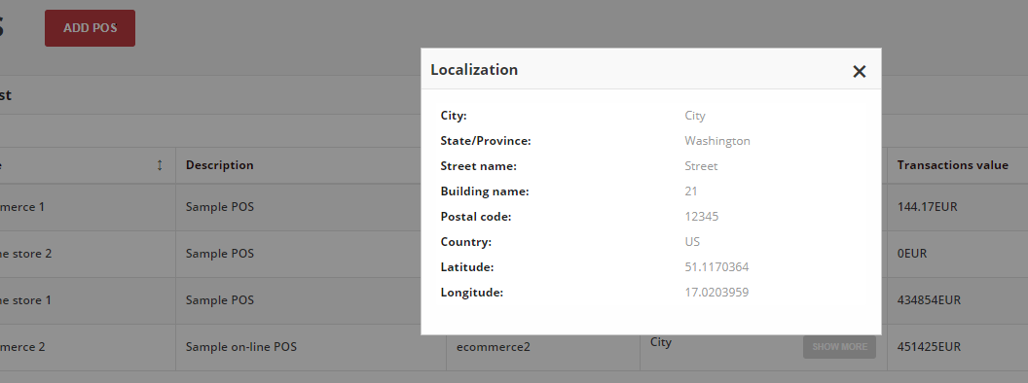**POS Localization**

## MERCHANT

The Merchant is linked to a store. In the Loyalty App store is called point-of-sale (POS). Merchants menu provide an overview of all merchants and its assignment to a particular POS. You can see the number of merchants linked to a particular store.

**All Merchants**

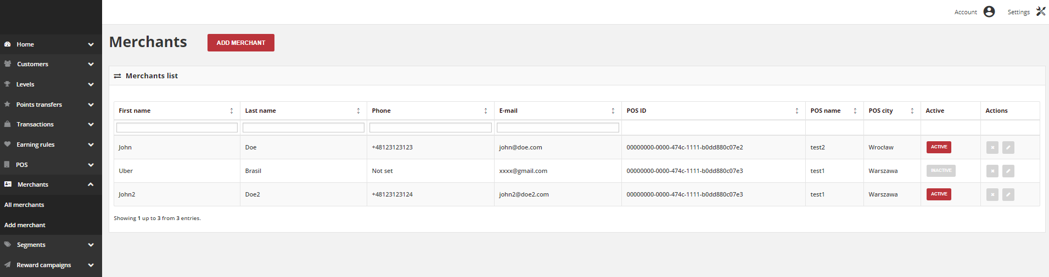

**Add Merchant**

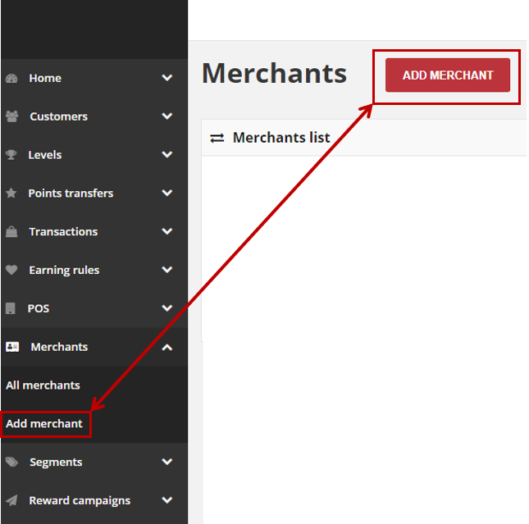

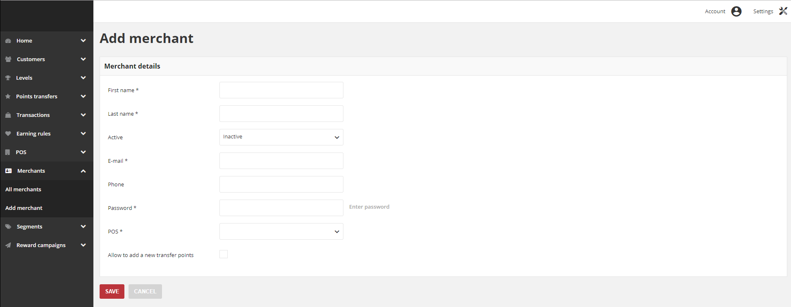

| **Field** | **Description** |
| --- | --- |
| First Name | The first name of the merchant |
| Last Name | The last name of the merchant |
| Phone | The merchant phone number. Can be used as a search/filter option.  Formatting is as on follow example:   * Country code: +48/48 * Subscriber number: 123456789 * In total: +48123456789 / 123456789 / 48123456789 |
| Email | The merchant email address.  Can be used as a login to POS Cockpit or search/filter option |
| POS ID | Unique POS ID.  Can be used in XML file to import transaction and customer |
| POS name | Name of the store |
| POS city | City where store is located |
| Active | Merchant account current status. **Option include: Active/Inactive**  Only Active merchants account are using for login to POS Cockpit |
| Actions | The operations that can be applied to selected merchant account.  Options include:   * Edit merchant data * Remove merchant account |

* Enter merchant **First name** and **Last name**
* To activate the merchant account, in **Active** field select “**Active**” from the dropdown list
* Enter merchant **E-mail** address, which will be used as a login credential to merchant account in POS Cockpit
* Provide merchant **Phone** number (in one of the acceptable format)
* Enter **Password** to merchant account, which will be used as a login credential to account in POS Cockpit. Merchant will not receive password to his account automatically via email/sms message. You have to give it to him “in person”.
* Assign **POS** to merchant by selecting from the dropdown list POS name
* Mark **Allow to add a new transfer points** checkbox to allow merchant to manage customers points transfers (add, spend, cancel, deduct points amount etc.) from the POS Cockpit

Other actions that can be performed on the Merchant include

* Updating Merchant account
* Activate / Deactivate Merchant account
* Remove Merchant account

**POS Dashboard**

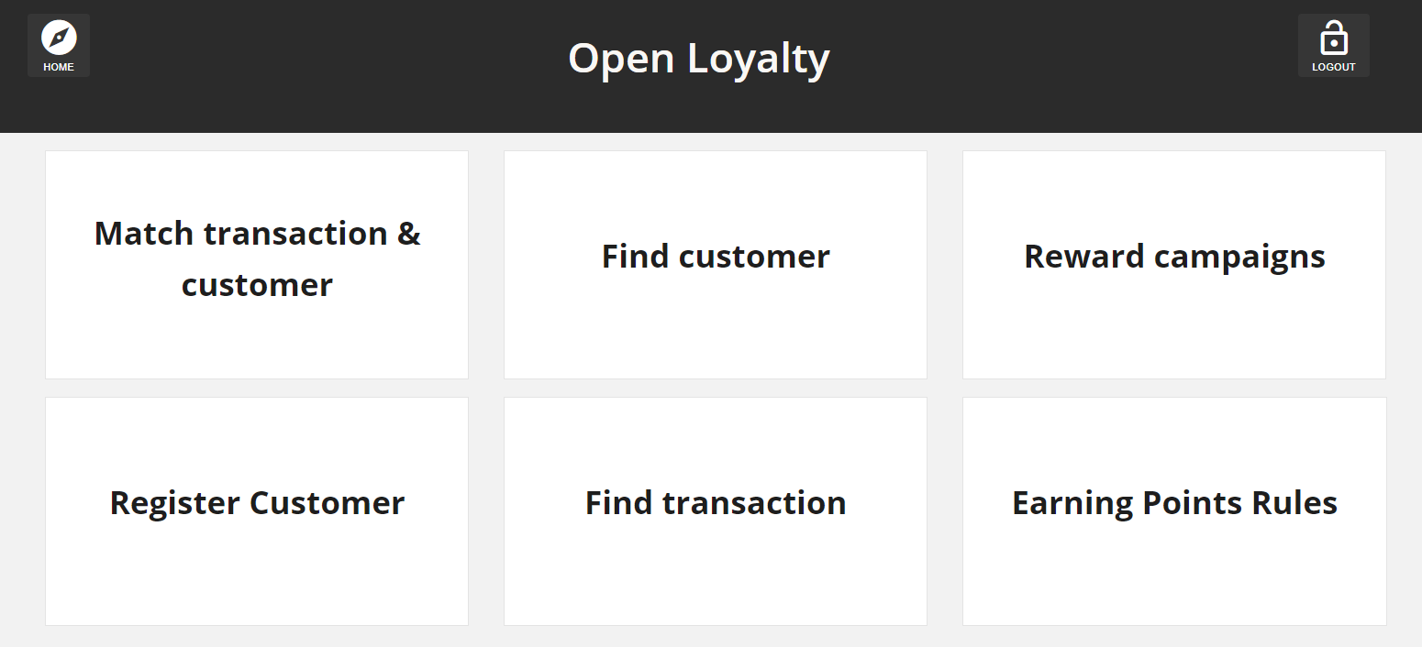

**Match Transaction and Customer**

Allows to link transaction with Customer Account directly from the POS. Based on matching transaction with customer identification factors priority (set up in Configuration). Useful when only transactions are sent to the Loyalty App***.***

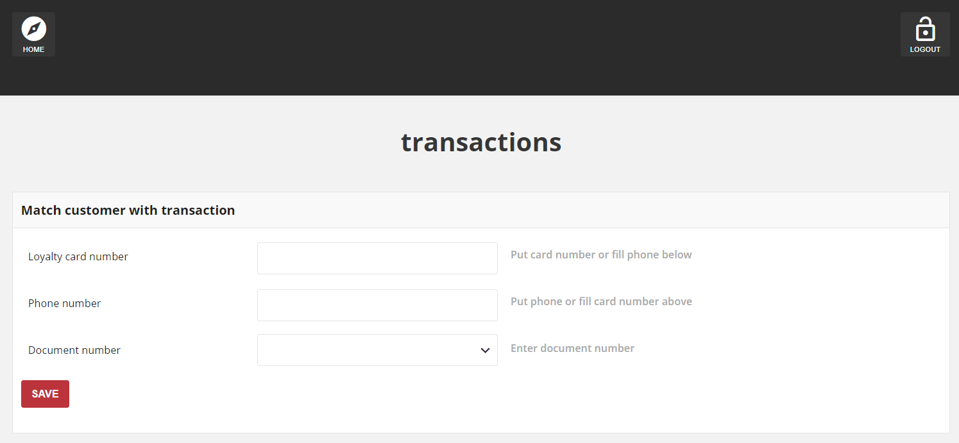

**Register Customer**

Allows to register new customer directly from the POS. Useful when new customer want to register to Loyalty Program during his shopping in a store.

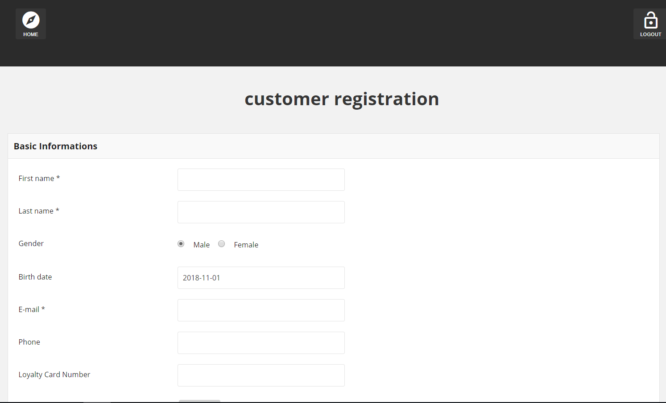

**Find Customer**

Allows to find specific customer with a link to each to preview his profile details directly from the POS

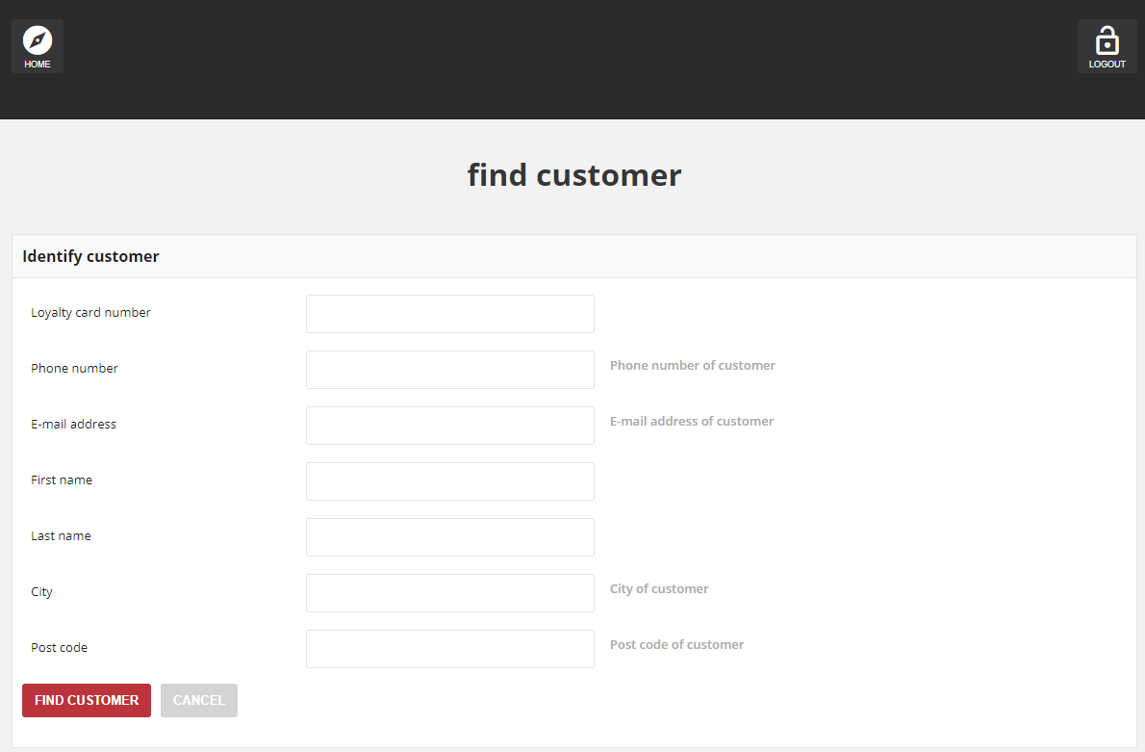

**Find Transaction**

Allows to find specific transactions and preview its details directly from the POS with a link to each to see more information**.**

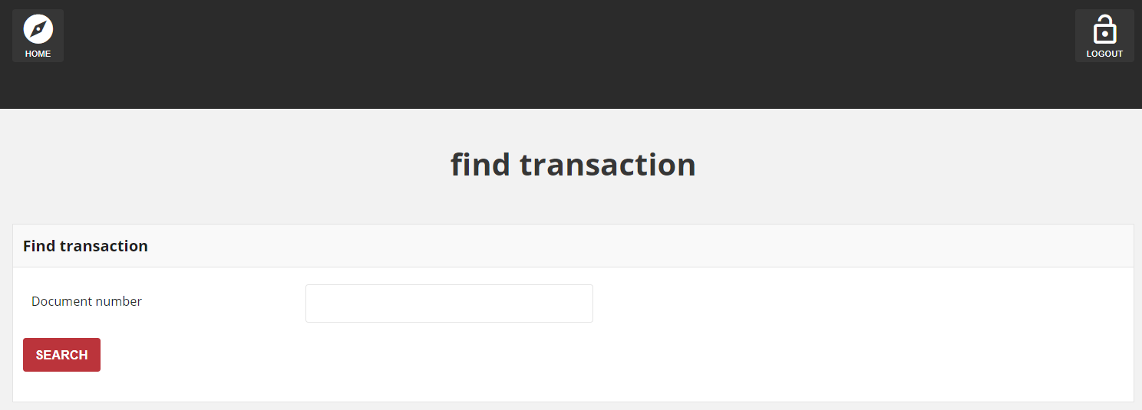

**Reward Campaigns**

Lists all available rewards with details about target, limits, cost in points and status with a link to each to see more information

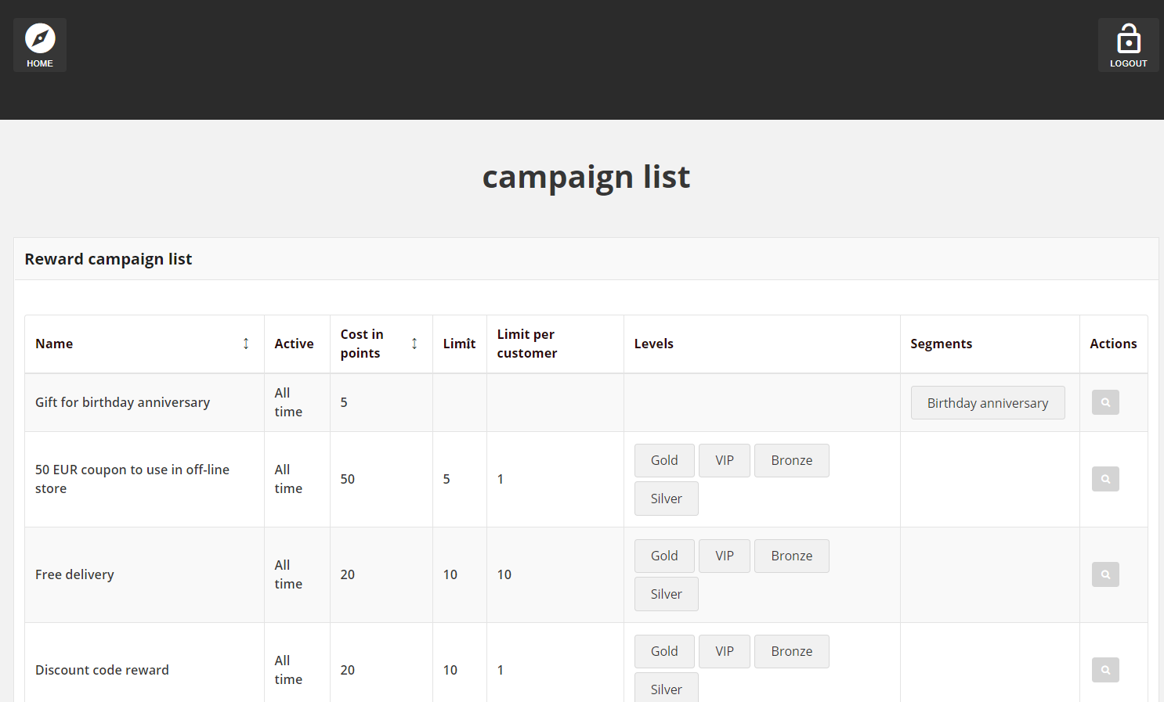

**Earning Rules**

Lists all available rewards with description and details about type, time boundaries when rule is active and status with a link to each to see more information.

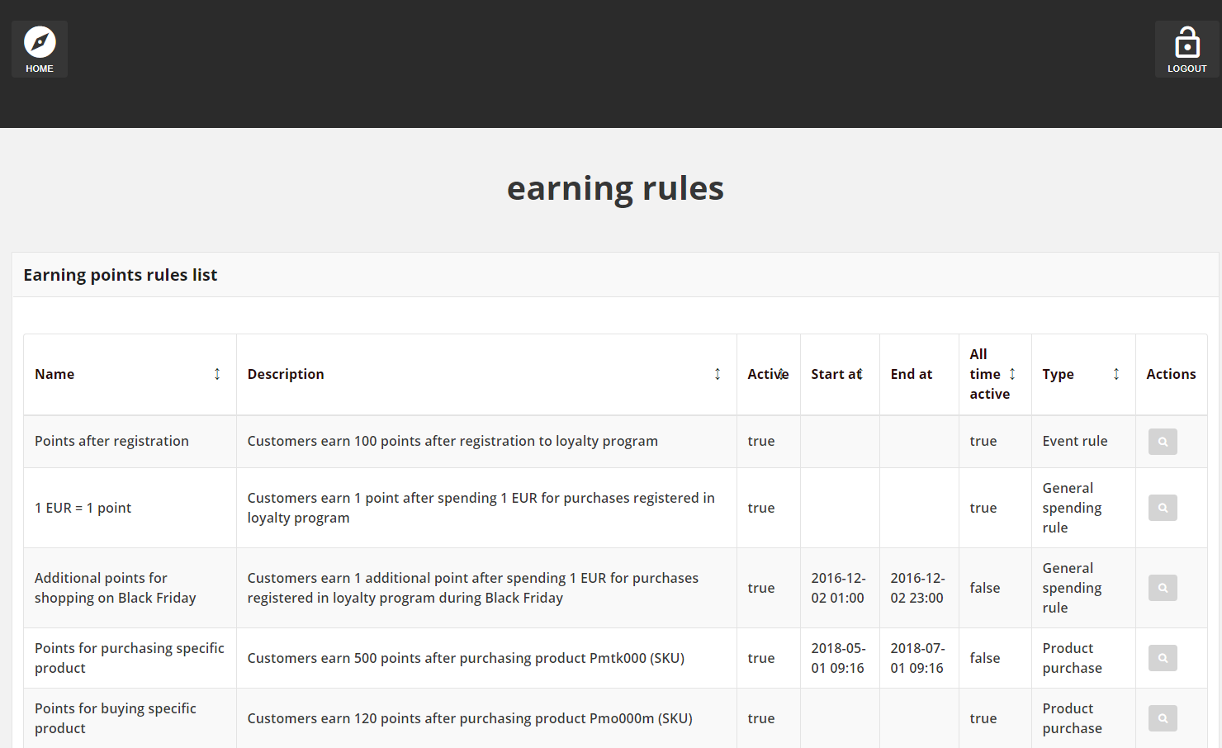

## SEGMENT

Customer segments allow you to e.g. dynamically count points, levels and display rewards to specific customers, based on properties such as system events, transactions history, purchasing activity, and so on. Customer can be assigned to several segments. You can optimize marketing initiatives based on targeted segments. You can also preview and export the list of targeted customers. Because customer segment information is constantly refreshed, customers can become associated and disassociated from a segment as they shop in your store.

**All Segments**

Lists all customer segments within your loyalty program with brief description of each and additional information regarding assigned customers

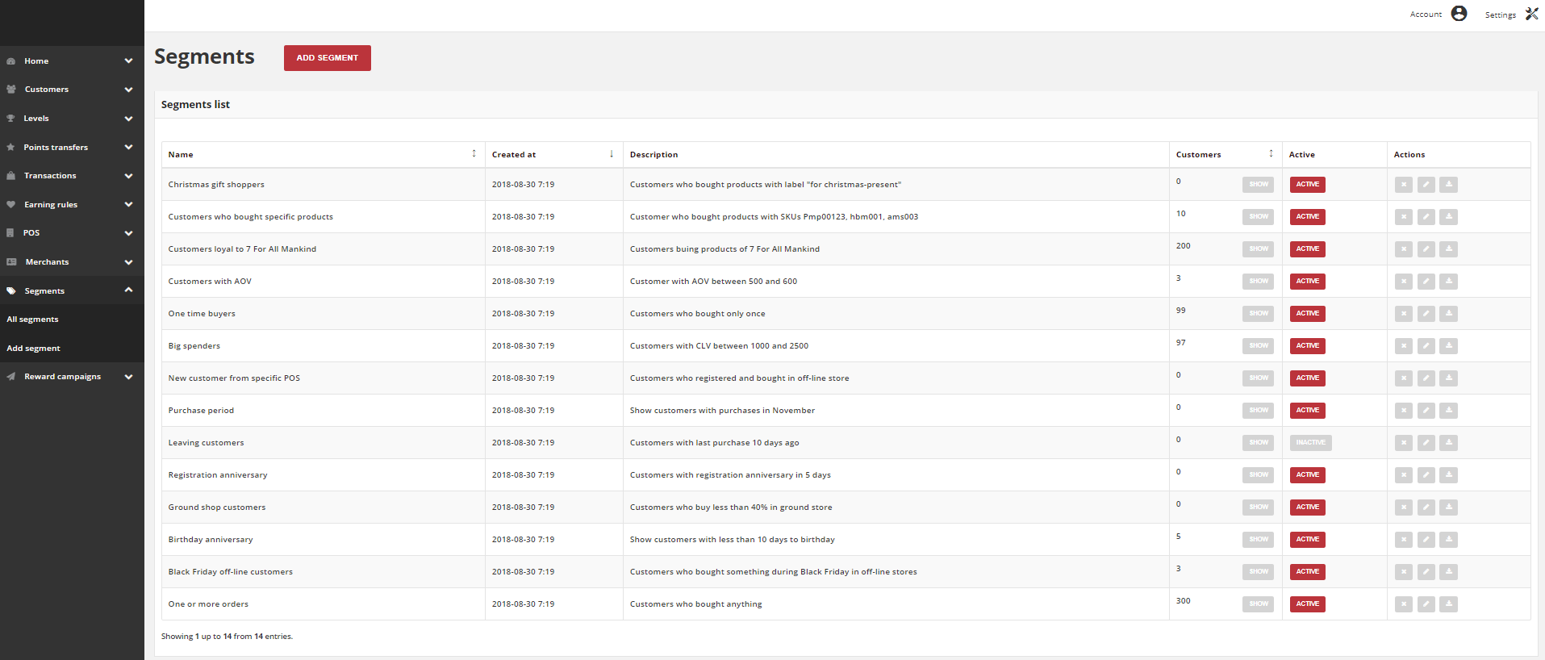

**Add a Segment**

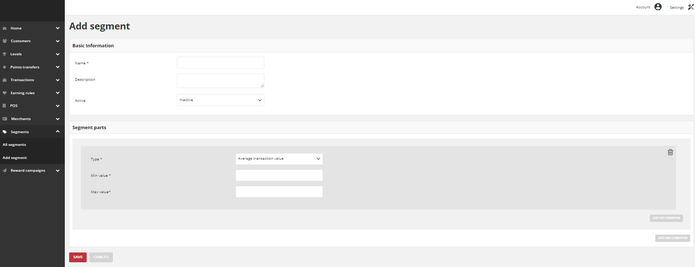

**Customers assigned to a segment list**

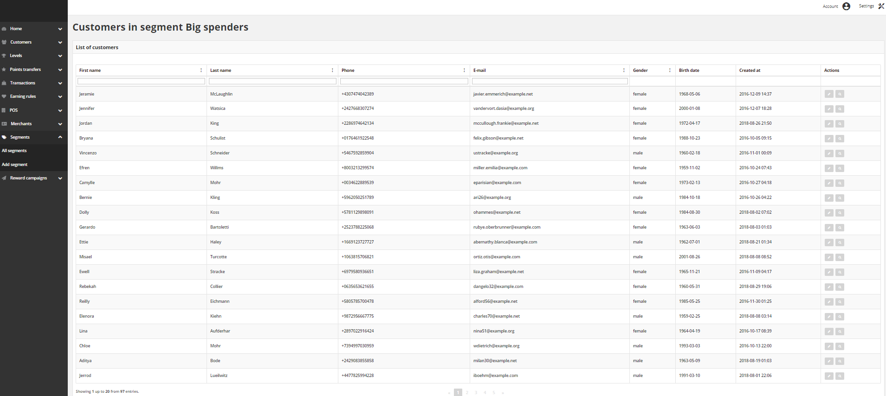You can view not only the number but also the list of customers with details assigned to particular segment.

**Segment Part Types**

The assignment process is carried out by the application based on defined rules. Customers who meet all criteria will be assigned to the segment. The criteria consist of conditions that can be combined through AND (conjuction of sets) and OR (disjunction of sets) logical operators.

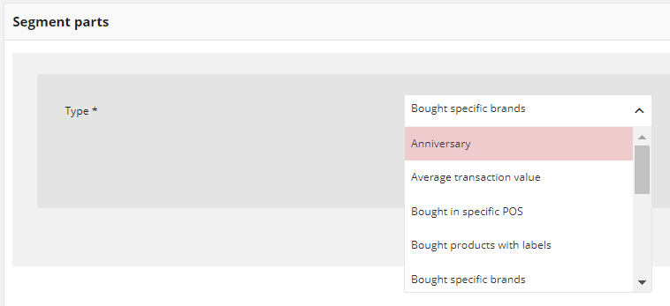During creation of Segment you must specify Segment parts type, describing conditions for assigning customer. Every type has its own required fields that must be filled, to specified condition.

**Segments types**

The Loyalty App offers the following standard segment types:

**Anniversary**: Customers who have registration/birthday anniversary in specify number of days

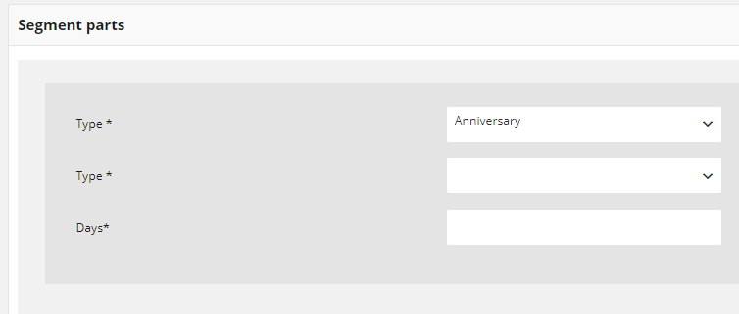

**Average transaction amount**: Customers whose average transaction value is between the limits

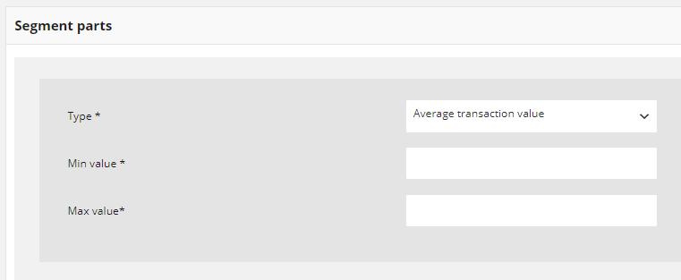

**Bought in specific POS**: Customers who made purchase in selected POS

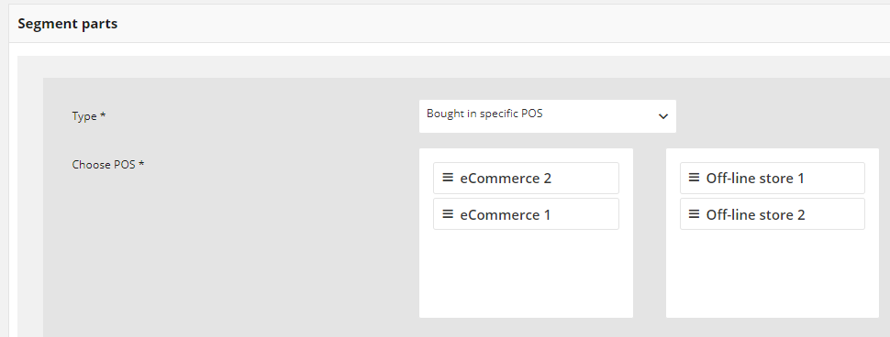

**Bought products with labels**: Customers who bought products where label on product is one of the list

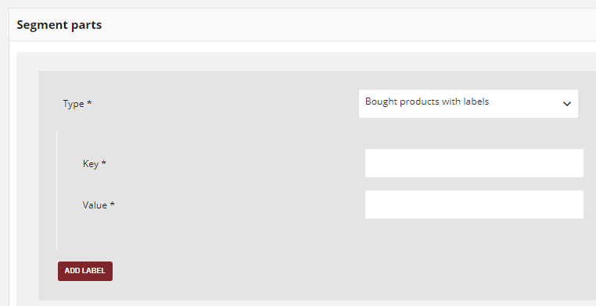

Each of list element has two values – Key, which is a label name, and Value, which is a label value. Both field need to be filled out.

Enter your key and value to add a product label. To apply additional labels, click Add label

**Bought specific brands**: Customers who bought products of a given brand

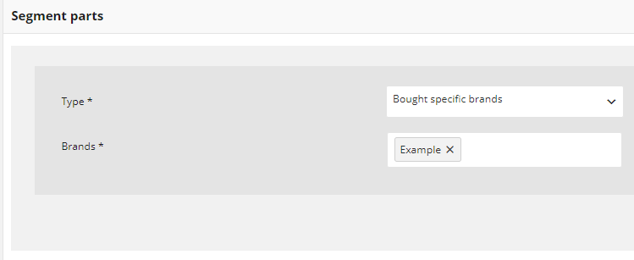

**Bought specific SKU**: Customers who bought specific products (on the basis of selected SKU)

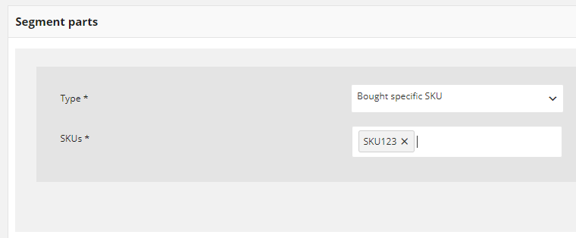

**Custom customer list**: Any Customers selected by admin

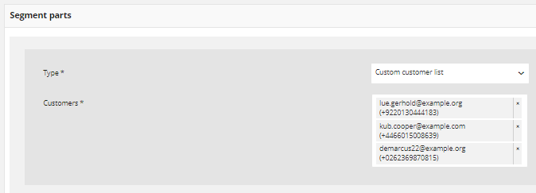

**Customer who has such labels**: Customers who made purchase in selected POS

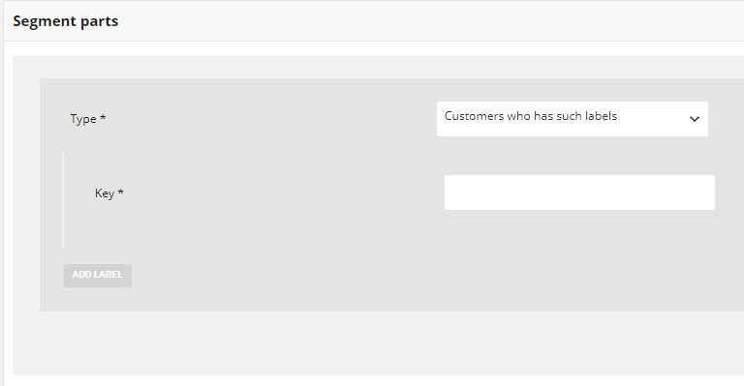

**Customers who has such labels value**: Customers whose labels value on is one of the list

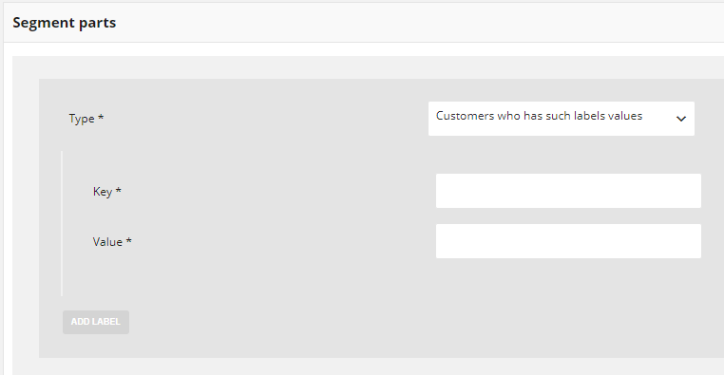

**Last purchase was n days ago**: Customers who have made their last purchase n-days ago

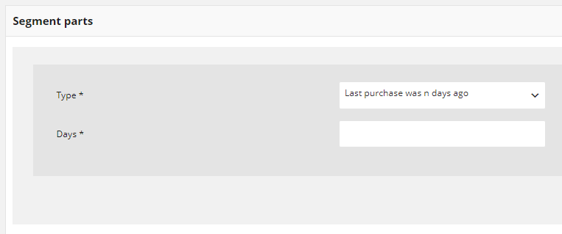

**Purchase period**: Customers who made purchase (at least one) between the specified days

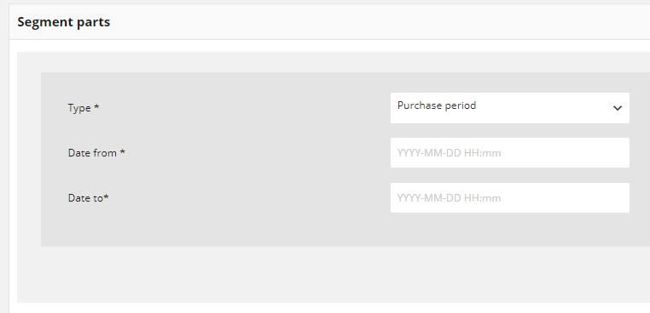

**Transaction count:** Customers whose number of purchases is within the defined range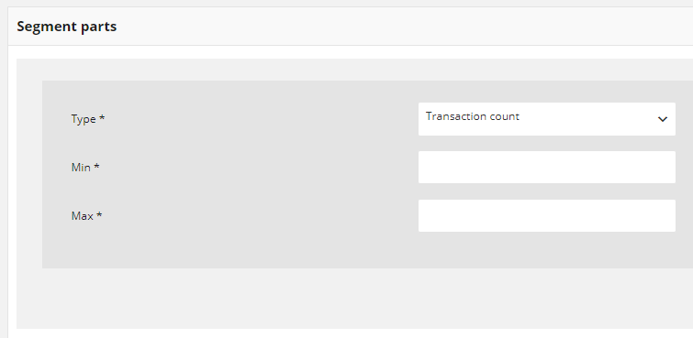

**Transaction percent in POS**: Customers whose number of purchases in a specified POS is within defined percent amount

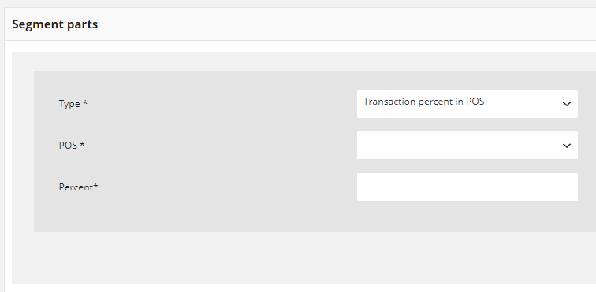

**Transaction value:** Customers whose overall amount of purchases is between the limits

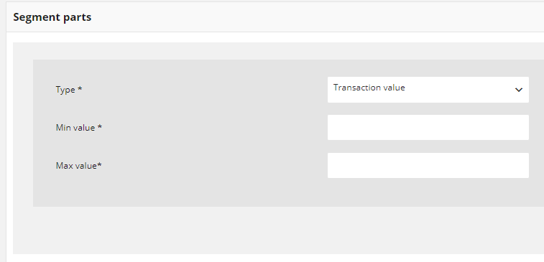

**Create a Segment**

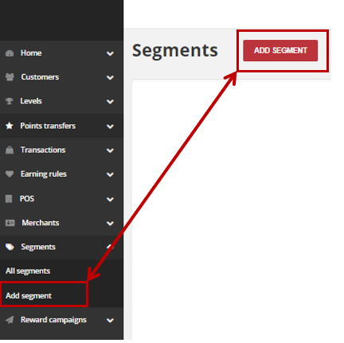

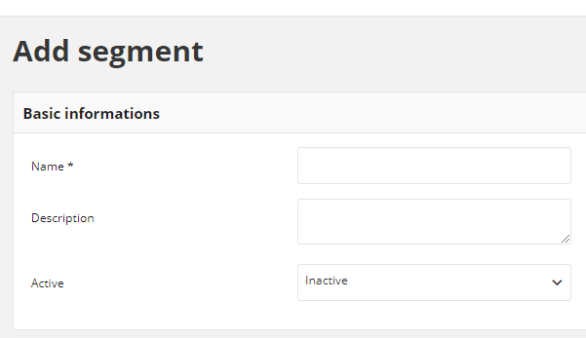

Depending on the segment type additional values would have to be filled as described in the segment types section. Additionally segments can be activated / deactivated, updated and deleted.

## REWARD CAMPAIGNS

Customers can redeem points toward various rewards, based on the cost in points of each that you establish during reward creation. When customer reaches the defined amount of points, points can be spent for a reward. Redeemed reward appears automatically in Redeemed rewards menu.

During creation you can specify for each reward e.g.:

* How many points customer need to spent to get reward
* How many times rewards can be used by one customer
* How many times reward can be used during all campaign
* To which customer reward will be visible and ready to use
* Time boundaries when reward will be active
* Reward value & taxes information
* Category to which reward belongs
* Reward brand information

**All Reward Campaigns**

Lists all rewards within your loyalty program, with additional information about its type, activity, limits, points costs and customers who can redeem each reward

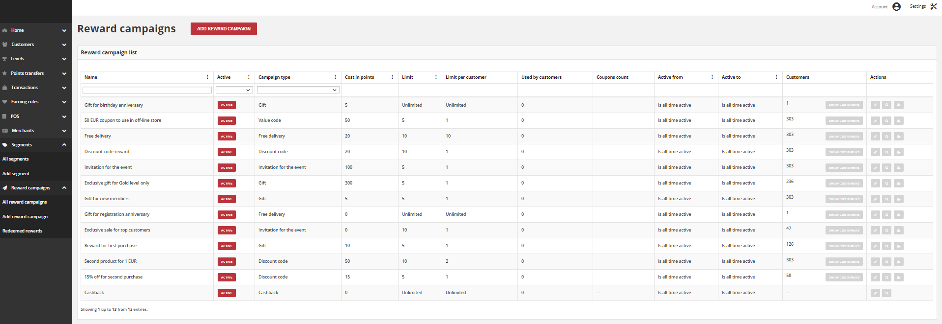

| **Field** | **Description** |
| --- | --- |
| Name | Name of the reward displayed in views |
| Active | Reward campaign current status. **Option include: Active/Inactive**  Customer can redeem only Active reward  It has higher priority than *Activity* time |
| Type | Reward type.  **Options include**:   * Percentage discount code * Cashback * Discount code * Free delivery * Gift * Invitation for the event * Value code * Custom campaign |
| Cost in points | How many points Customer must spend to redeem reward |
| Limit | Information about limit the redeem of rewards globally |
| Limit per customer | Information about limit the redeem of rewards by one customer |
| Used by customers | Information how many times reward has been redeemed |
| Coupons count | Information about number of coupons available to redeem |
| Active from | Day from which reward is active, i.e. visible and available to use for customers |
| Active to | Day until reward can be redeem.  After that day reward will not be visible for customer and unavailable to use |
| Customers | Show number of customers who could redeem reward.  After Show customers click, list of these customers details will be shown |
| Actions | The operations that can be applied to selected reward.  **Options include**:   * edit reward details * view reward details * buy reward campaign for client |

**Add Reward Campaigns**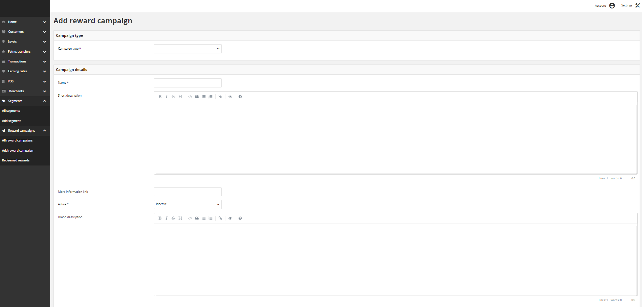

**Buy Reward Campaign for Customer**

Any active Reward campaign (except Cashback) can be assign manually by Admin user to selected customer account. Admin user can create new or use existing reward campaign from All reward campaigns list to “buy” a reward for a customer using his points or just add it for free. As an admin you can “buy” more than one coupon within one campaign at once. Note, that quantity is limited by Reward campaign limits (define during creation – Limit & Limit per customer)

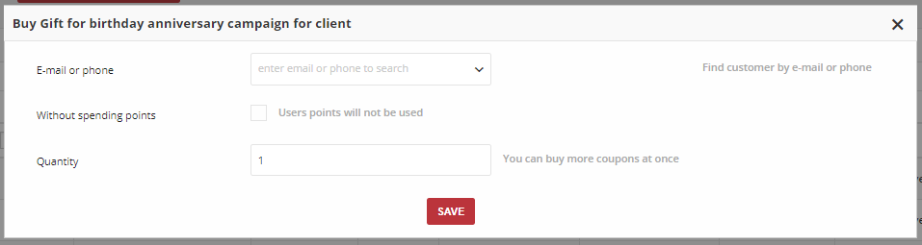

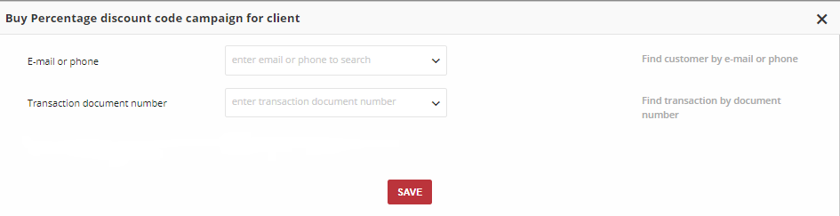

**Redeemed Rewards**

Lists all redeemed rewards with additional information who and when redeemed reward and it’s status – delivered or used

Redeemed reward is an instance of reward that Customer has bought with Points or earned for performing specified action.

There is possibility to get:

* Virtual reward - as a Discount or Value Code, free delivery
* Physical reward - which will be send to Customer, e.g. printed coupon, gift, etc.
* Cashback

**Not enough points**

If Customer does not have enough points to redeem reward then Redeem reward button will be disabled (greyed out).

**Redeemed reward from Admin perspective**

Redeemed reward management could be performed only from Administrator Dashboard by user who has Admin privileges. Redeemed rewards list grid provide an information about which customer and when redeemed given reward.

Moreover, you can check whether reward is Delivered (customer choose reward and spent points but he has not used it yet) or Used (customer used coupon code during purchase, gift was sent to customer etc.)

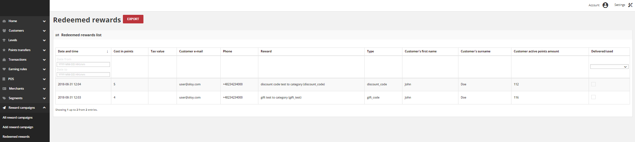

**All Campaign Categories**

Lists all reward campaign categories within your loyalty program, with additional information about its status and sort order.

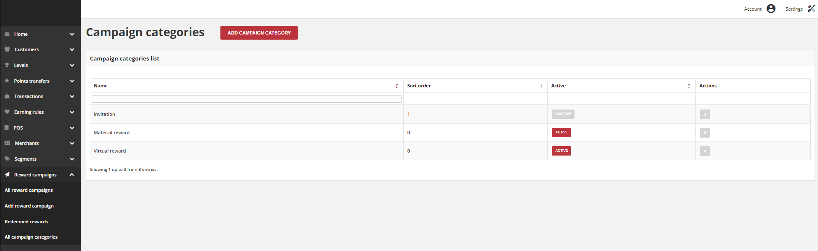

**Create Campaign**

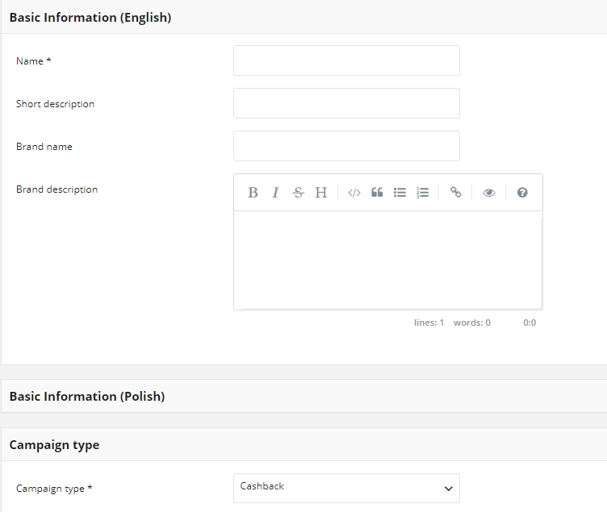

**Reward Campaign Types**

Loyalty Reward campaigns gives you the ability to create unique rewards that customer can be awarded for a wide range of transaction and activities within your loyalty program. During creation you determine time boundaries, when reward is available for customer, customers groups for whom the reward is available and defines the basic operating parameters.

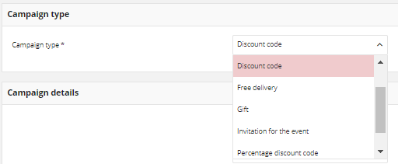

The Loyalty App offer following standard types:

**Cashback:** During purchase customer can exchange earned points for value discount and reduce order amount

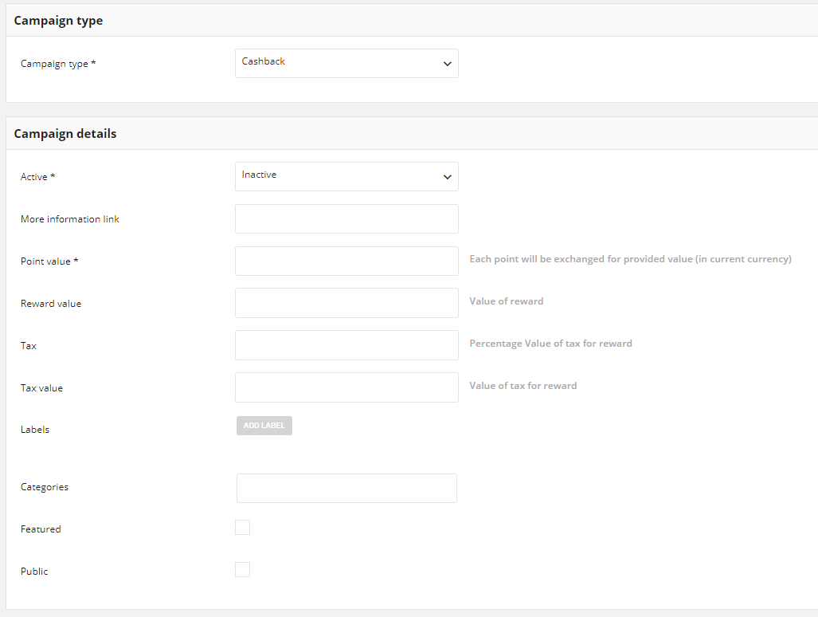

**Custom campaign:** Possibility to link with geolocation or QRcode earning rule. Information about that connection will be accessible via API and in reward details.

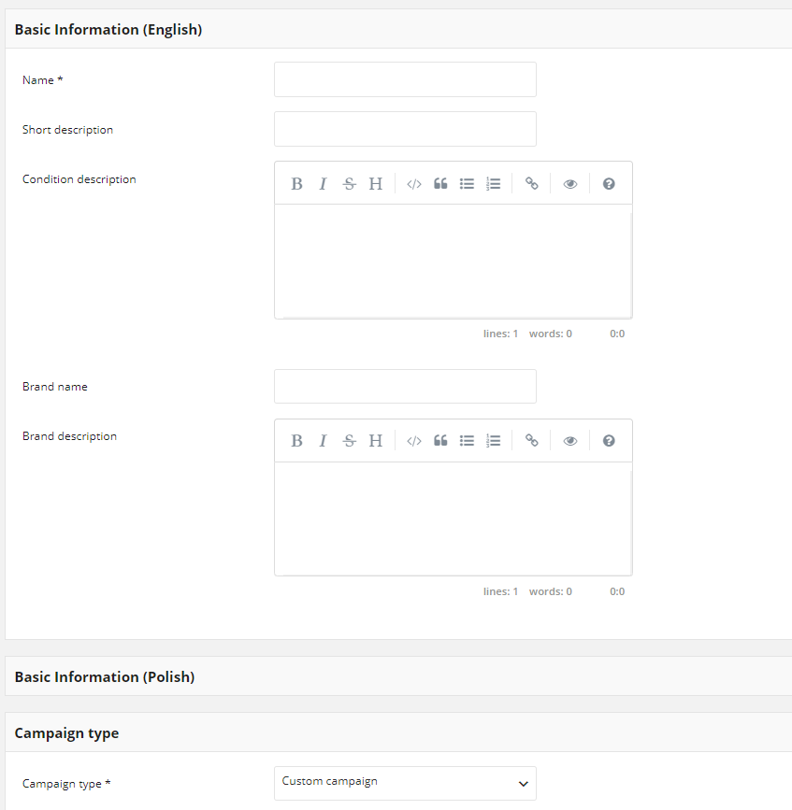

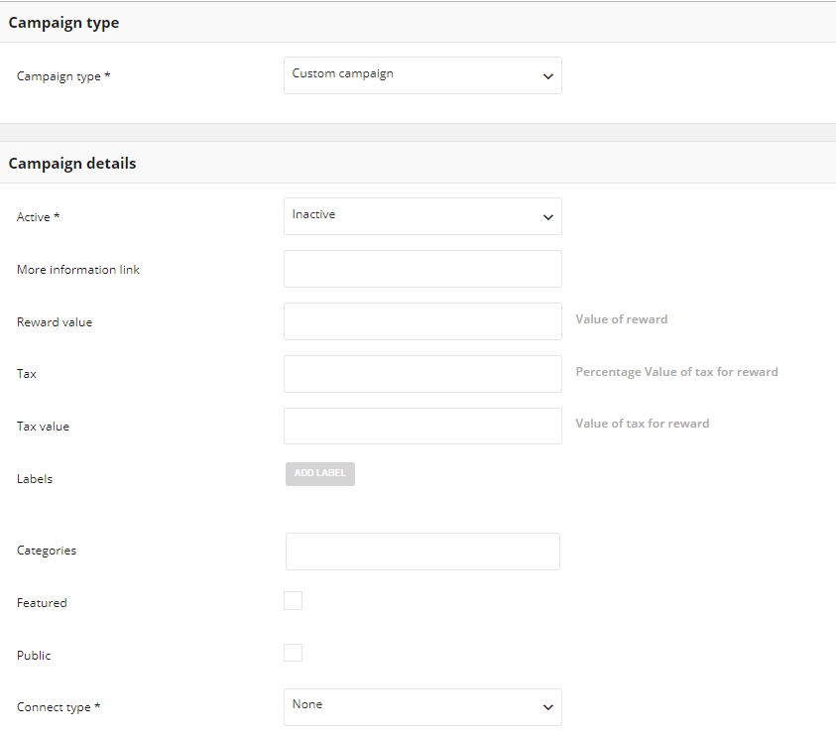

For additional labels add the key value pair

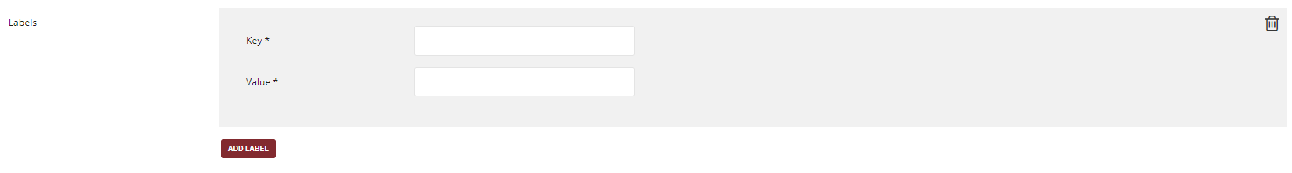

**Discount code:** percentage discount applied to reduce order amount, e.g. 25% off for next purchase

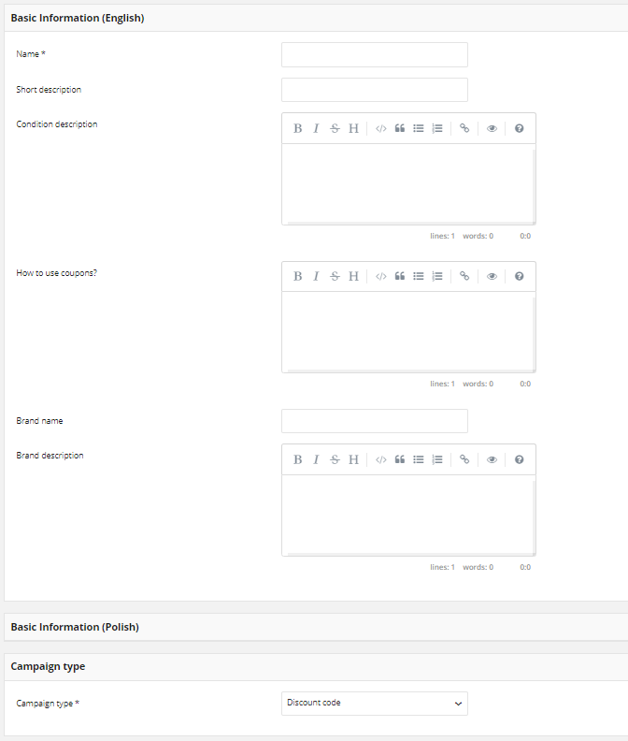

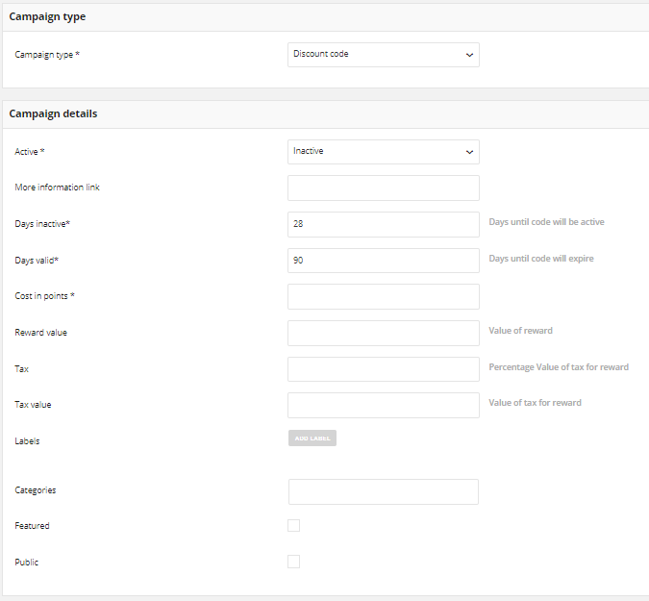

**Free delivery:** free shipping promotion

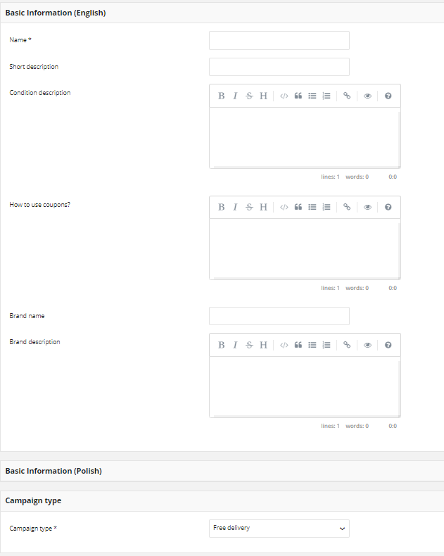

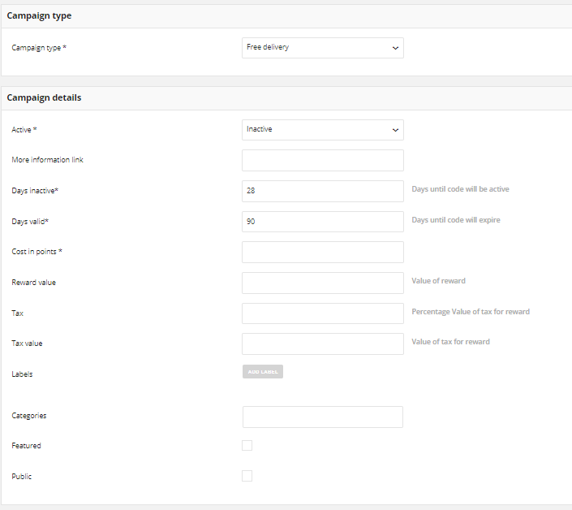

**Gift:** Material article e.g. book

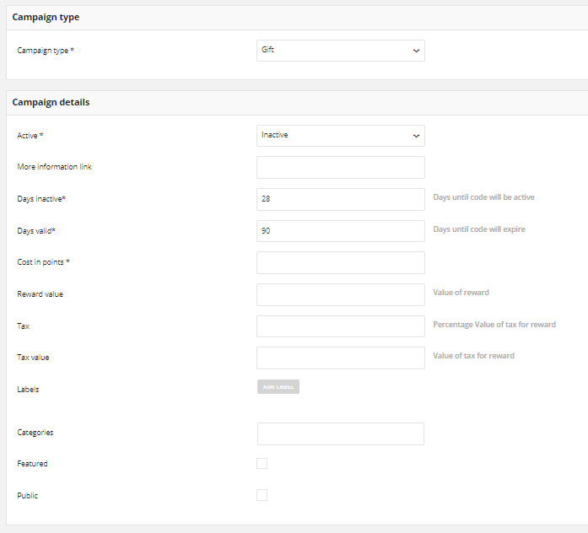

**Invitation for the event:** Invitation for business & corporate events or other depending on your business, e.g. conference

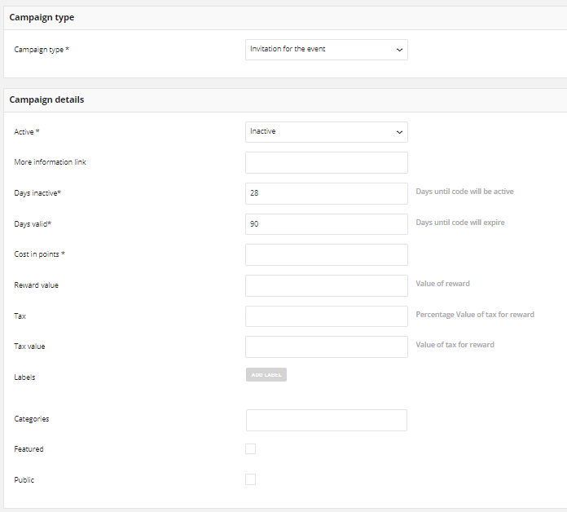

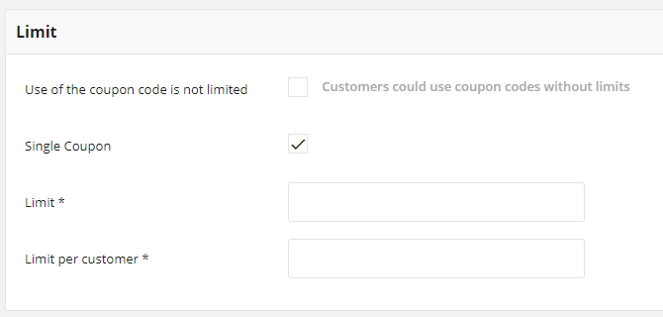

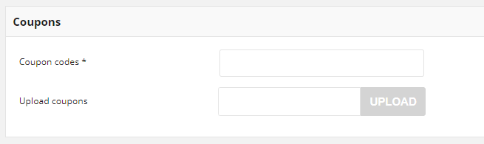

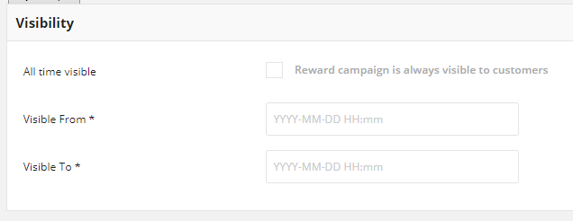

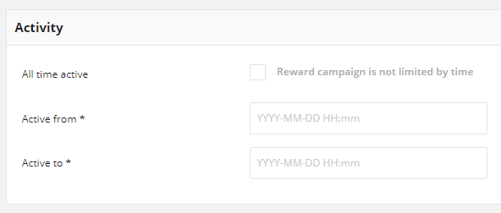

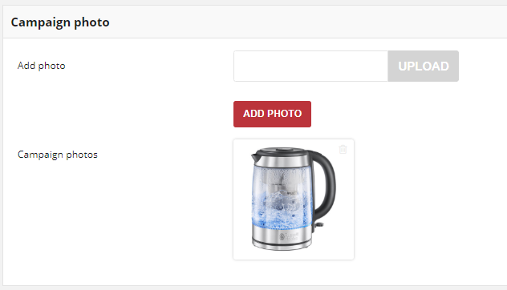

**Percentage discount code:** Percentage discount of registered order amount

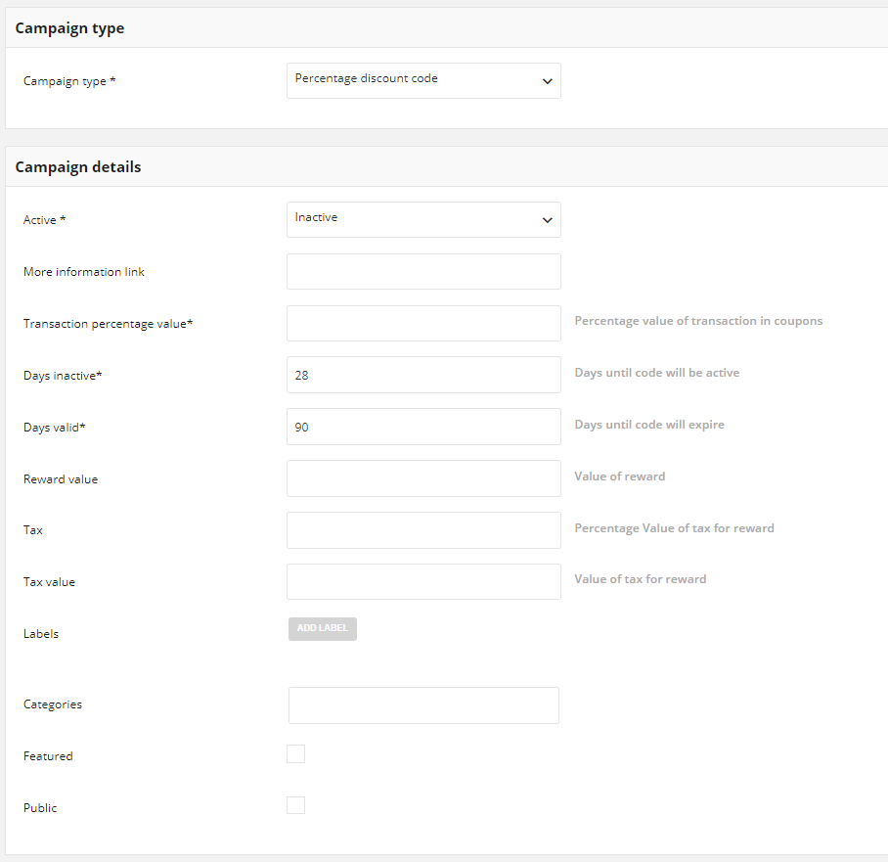

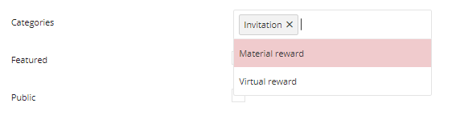

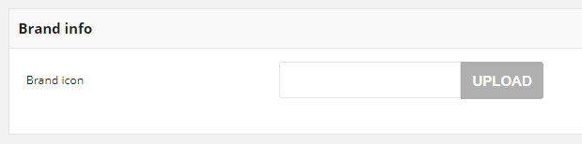

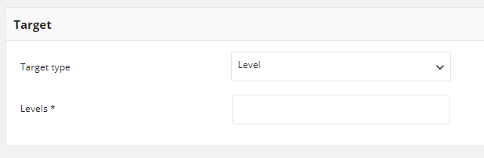



**Value code:** Value discount applied to reduce order amount, e.g. 25 USD off for next purchase. (Similar to other rewards)

**Conditions of reward availability for customers:**

* Campaign must be Active
* Campaign must be Visible (if visibility is limited in time)
* Customer is assigned to Segment/Level which are selected in Reward Campaign configuration
* There are available coupon codes (non used) for the campaign or campaign is not limited with single coupon code
* If there is option to limit coupon per campaign then reward is available when usage count is below limit
* If there is option to limit coupon per user then reward is available when usage count is be-low limit

**Campaign Reward Details**

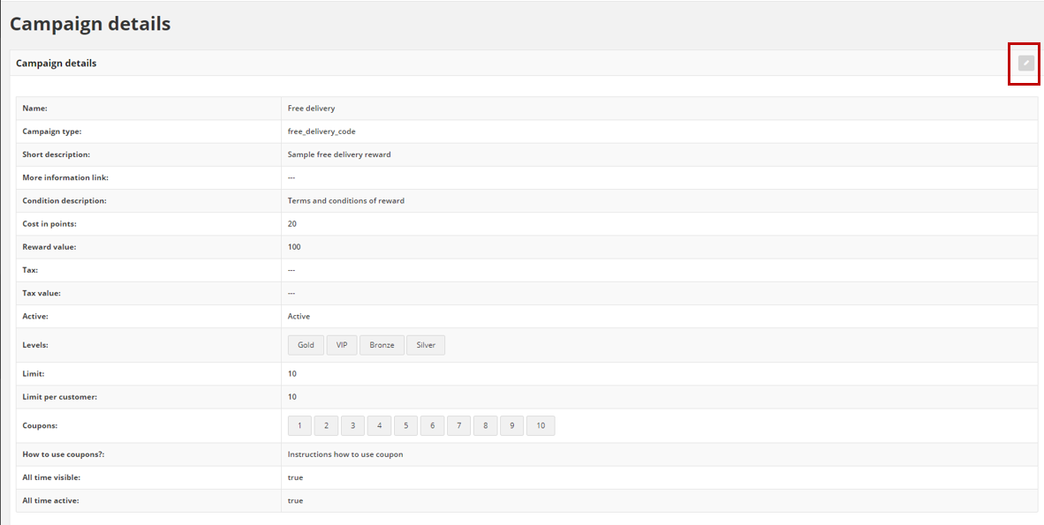

**Edit Reward Campaign**

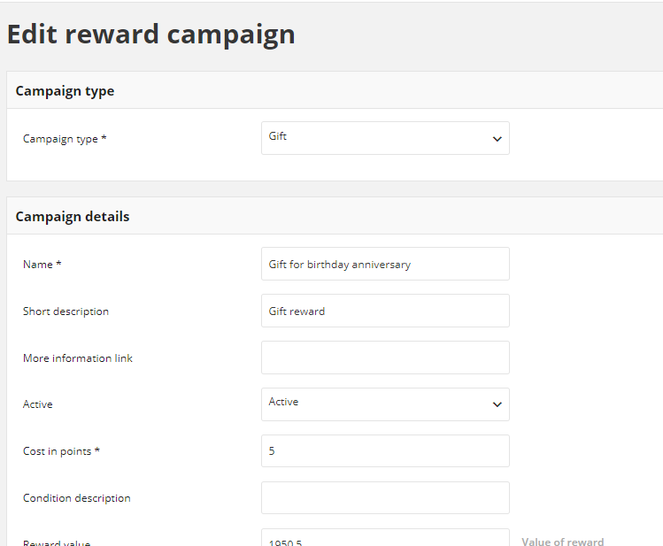

# PROPOSED SOLUTION MODEL

**STAND- ALONE FIXED BID**

Verbat will be following a stand–alone fixed bid solution delivery model wherein the required solution would be devised and a suitable pricing would be offered. Verbat’s solution architects have conducted a thorough research on the requirements and have come to the conclusion that our proposed solution, which is detailed further in this document, will meet the requirements put forth by the client.

## KEY STRENGTHS OF OUR SOLUTION

* Strong and Scalable platform accommodating to future enhancements
* A framework which acts as a solution accelerator with building blocks that can be re-used in n future for building new components and features.
* Our light weight framework used consumes fewer system resources thereby making the application perform faster.
* All security aspects are considered

# FUNCTIONAL REQUIREMENTS

The main features and functionalities of the application to be developed are presented below:

## SYSTEM ADMINISTRATION/BACKEND WEB MODULE

* Membership Master

Personal Profile details (Name, Age, Gender, Phone, Email Id, Nationality, etc.)

* Merchant Master

Details of shops in Loyalty Program (Shop Name, Shop Id, Business Type, Contact No, join date, Loyalty Scheme applied and other details, etc.)

* Mall Master

Mall details (Mall Name, address, logo, Report header and footer details, courtesy message)

* Tenant PRIVILEGEPLUS device master

Device configuration of participating shops to carryout Loyalty transactions

* Membership Type Master

Membership type details- create parameters when required, tied to loyalty schemes

* Tenant Category Master

Classifies business category and Control transaction value to comply with the limit set

* Loyalty Scheme Master

Calculate and reward points against transactions, redemption rules and timeframe of the scheme, redemption of gift cards

* System Security

User Roles Management, Master data management

* Notifications & Automations

Schedule/Automate/manually send notifications through SMS, emails, push notifications for promotions

* Reports
  + Track transactions
  + Dashboard shall visually track and generate various metrics and key data such as Total no of Active members, Gender ratio, Active merchants, Total transaction specific period, Total points rewarded, Total cash back redemption against points etc. the data shall be represented through tables, graphs such as bar, pie and line charts etc.

## PARTICIPATING QSR’s

* Scan barcode of the Gift cards
* Scan barcode of the customer mobile app/enter mobile number
* Enter transaction details manually(receipt photo)/system shall capture
* Redeem all the Gift Cards collected at the end of each calendar month
* Participating shops shall not incur any cost in redeeming the Gift Card from the mall

## SYSTEM FEATURES

* Each customer shall have a unique customer number
* Scan barcode of the customer mobile app
* An account of plus and minus shall be shown(redeemed gift cards by shops)
* Receive and store purchased amount of each customer
* Receive and store copy of the purchase receipt
* Change Dhs to points any time
* Reconciliation of each shop account and print a full data for that particular shop.
* Store the issued and redeemed Gift Card with the unique number of the customer and the unique participating shop
* Add any other report required by the management (such as total sales of all the participating shops, total gift cards redeemed (shop wise), daily, weekly, monthly or annual reports)
* The redeemed Gift Cards from the non-participating shops
* Redeem collected Gift Card at the end of each month with a percentage fee for GC’s (nonparticipating shop)

## MOBILE APPLICATION

* Customer shall Login/Logout the application
* View collected points
* Redeem gift cards
* Feature earned points and convert it into Dhs
* Scan Gift Cards
* Scan purchase receipts
* Feature mall promotions
* Feature shop promotional adverts and offers
* Scanned gift cards and purchase receipts shall be send to the system
* Customer shall approach service centers to redeem Dhs in app to gift cards
* Customers/Members can access their loyalty profile and a general section anyone can browse - Store Directory, Promotional offers, News, Services, Upcoming Events, Entertainment, Dining, About us, Contact us etc., Authenticating membership, View point balances, View transaction histories, Manage account profile, Receive push notiﬁcations.
* New customer shall signup themselves with basic mandatory fields such as Name, Mobile, Gender, email and Nationality etc.,
* System shall assign each member with unique membership ID and QR code along with the user name and password.
* Tenant Loyalty Module
  + Authenticate membership,
  + Authenticate tenant/staffs login, validate membership
  + Scan membership QR code
  + Reward points, checking available points, transaction history and redemption of points against Gift Card
  + Void / cancel / return transactions, Classify transactions, Generate sales transactions reports
* A new tenant device shall download PRIVILEGEPLUS loyalty app configure with required parameters to authorize the respective tenant to accept their login and connect to the loyalty system and make it functional

## Detailed Functional Requirements

|  |  |  |  |  |
| --- | --- | --- | --- | --- |
| **ID** | **Functional Area** | **Feature** | **User Role** | **Description** |
| F001 | API | API Transactions | System | Import or export Transactions data. |
| F002 | API | API Client Profiles | System | Import or export Client Profiles data. |
| F003 | API | API Points Transfer Operations | System | Import or export Points Transfer Operations data. |
| F004 | API | API Earning Rules | System | Import or export Earning Rules data. |
| F005 | API | API Reward Campaigns | System | Import or export Reward Campaigns and Rewards data. |
| F006 | API | API Authorization | System | Import or export all data needed for authorization od Client Profile. |
| F007 | API | API Settings | System | Import or export Settings data. |
| F008 | API | API Levels | System | Import or export Levels data. |
| F009 | API | API Client Profiles Management | System | Import or export data needed for Client Profiles Management. |
| F010 | API | API Earning Rules Calculations | System | Import or export data needed for Earning Rules Calculations. |
| F011 | API | API Reward Campaigns redeeming process | System | Import or export all data needed for redeeming Reward process. |
| F012 | API | API Segments | System | Import or export Segments data. |
| F013 | API | API Segments Management | System | Import or export data needed for Segments Management. |
| F014 | API | API Admin Users | System | Create Admin, get admin user, Admin user collection, Update admin, |
| F015 | API | API Audit |  | Get action log |
| F016 | API | API Analytics | System | Get registered customers, Get spent and transferred points, info on referrals, info on transactions, |
| F017 | API | API New Campaign | System | Create new campaign, get collection of campaigns, update campaign, get campaign details, available campaigns for customer, buy reward campaign for customer, Mark logged in customer coupons as used, Check campaign visibility for the customers, Get campaign’s photo, Remove campaign’s photo, Add a photo to the campaign, Change campaign’s status, Get campaign collection (seller), Get campaign details (seller), Get available campaigns for a customer (seller), Buy reward campaign for a specific customer (seller), Get all campaigns available for logged in customer, Change delivery status in bought campaign by customer. |
| F018 | API | API Campaign categories | System | Create new campaign category, Get the collection of campaign categories, Update a campaign, Get campaign category details |
| F019 | API | API Customer | System | Activate a customer, Deactivate a customer, Get customer status, Get customers, Activate a customer using activation token, Create a new customer, Update a customer, Customer registrations in last 30 days |
| F020 | API | API Customer campaigns | System | Get all campaigns bought by a customer, Get all campaigns available for logged in customer, Get all campaigns bought by logged in customer, Mark logged in customer coupons as used, Buy campaign by logged in customer, Get all campaigns bought by a customer (seller) |
| F021 | API | API Customer earnings | System | return all active earning rules, |
| F022 | API | API Customer points transfer | System | List of all logged in customer points transfer, |
| F023 | API | API Earning rules | System | Get a complete list of earning rules, Get earning rule details, Get a complete list of earning rules (seller), Get earning rule details (seller), Create a new earning rule, Edit existing earning rule, Change earning rule status, Use a custom event earning rule, Get earning rule’s photo, Remove earning rule’s photo, Add a photo to the earning rule, points based on Geolocation |
| F024 | API | API Invitations | System | Get a complete list of invitations, Send invitation to customer |
| F025 | API | API Levels | System | Get a complete list of levels, Add levels, get level details, Edit existing level, Activate / deactivate level, customers assigned to the level, get levels photo, Remove levels photo, Add photo |
| F026 | API | API Points Transfer | System | Get a complete list of Points transfers, Get a complete list of Points transfers (seller), Get a complete list of Points transfers (customer), Add points to customer, Spend customer points, Transfer points between customers (admin), Transfer points between customers (customer), Cancel specific points transfer |
| F027 | API | POS API | System | Create new POS, Get POS details, Update POS data, get list of POS, |
| F028 | API | API Security | System | Change logged user password, Change logged user password (customer), Change logged user password (seller), Set new password after reset password requesting, “Forgot password” functionality, Log out current user |
| F029 | API | API Seller | System | Get List of Sellers, register new seller, Get seller details, Update Seller details, Activate / Deactivate seller, Delete Seller |
| F030 | API | API Segment | System | Get Segment list, Create new segment, Delete segment, get segment details, update segment, Activate /Deactivate segment, Customers assigned to segment |
| F031 | API | API Settings | System | get available customer statuses, get / update system settings, get data for specified field, List of available email settings, Update / delete email settings, add / update / delete logo, get / add / delete named photo, Add hero image, Remove / add / delete conditions terms file |
| F032 | API | API Transactions | System | Assign a customer to a specific transaction, Assign a customer to a specific transaction (seller), Get a list of transactions (customer), Get transaction details (customer), Get a list of transactions (seller), Get customer’s transactions (seller), Get transactions with provided document number (seller), Get a list of transactions, Register a new transaction, Update transaction labels, Add new transaction labels as customer, Get available item labels, Number of points which can be obtained after registering given transaction, Get transaction details (admin) |
| F033 | API | API Utilities | System | Get CSV of customers for a particular segment or level |
| F034 | API | API ACL | System | Creating an role, Getting a single role, Collection of available roles, Updating a role, Collection of available resources, Collection of available accesses |
| F035 | Authorization | Different login data | Client Dashboard | Client can log in to account using email, phone number or loyalty card number. |
| F036 | Authorization | Login | POS Dashboard | Merchant must login to work with POS Dashboard. |
| F037 | Authorization | Password Recovery | Admin Dashboard | Administrator can recover password. |
| F038 | Authorization | Password Recovery | Client Dashboard | Client can recover password. |
| F039 | Authorization | Password Recovery | POS Dashboard | Merchant can recover password. |
| F040 | Authorization | Log in | Admin Dashboard | Administrator can use Admin Dashboard after log in. |
| F041 | Authorization | Log in | Client Dashboard | Client can use Client Dashboard after log in. |
| F042 | Authorization | Log in | POS Dashboard | Merchant can use POS Dashboard after log in. |
| F043 | Authorization | Log out | Admin Dashboard | Administrator can logout from Admin Dashboard. |
| F044 | Authorization | Log out | Client Dashboard | Client can log out from Client Dashboard. |
| F045 | Authorization | Log out | POS Dashboard | Merchant can use POS Dashboard after log in. |
| F046 | Client Profiles | Client Profile | Admin Dashboard | Client Profile gives single view of every Clients registered in Loyalty Program. Client Profile gathers information about Client including e-mail, phone, loyalty card number, personal data, address data. Client Profile collects also all the information about operations and events processed in Loyalty Program like Points balance, current Level, Point Transaction operations, transactional history of Client, Segments, etc. |
| F047 | Client Profiles | List of Agreements | Admin Dashboard | Client Profile collects 3 types of agreements for Client: general agreement, marketing agreement, data processing agreement. All collected agreements can be shared and normalized with external systems like CRM, e-commerce or marketing automation. |
| F048 | Client Profiles | Profitability Metrics | Admin Dashboard | Administrator can check lifecycle value of Client, average order value of Client and total amount of orders placed by Client. |
| F049 | Client Profiles | List of Reward Campaigns available for Client | Admin Dashboard | Administrator can see list of Reward Campaigns available for specific Client. |
| F050 | Client Profiles | List of Rewards redeemed by Client | Admin Dashboard | Administrator can see list of Rewards redeemed by Client. Administrator can change status of specific Redeemed Reward. |
| F051 | Client Profiles | Client Profile | POS Dashboard | Client Profile gives single view of every Clients registered in Loyalty Program. Client Profile gathers information about Client including e-mail, phone, loyalty card number, personal data, and address data. Client Profile collects also all the information about operations and events processed in Loyalty Program like Points balance, current Level, Point Transaction operations, transactional history of Client, Segments, etc. |
| F052 | Client Profiles | Profitability metrics | POS Dashboard | Merchant can check lifecycle value of Client, average order value of Client and total amount of orders placed by Client. |
| F053 | Client Profiles | List of Reward Campaigns available for Client | POS Dashboard | Merchant can check which Reward Campaigns are available for Client. |
| F054 | Client Profiles | List of Rewards redeemed by Client | POS Dashboard | Merchant can see list of Rewards redeemed by Client. |
| F055 | Client Profiles | Client Profiles Management | Admin Dashboard | Administrator can add new Client Profile, see details of existing Client Profile, modify existing Client Profile and suspend existing Client Profile. |
| F056 | Client Profiles | Client Profiles Management | POS Dashboard | Merchant can add new Client Profile, see details of existing Client Profile and modify existing Client Profile. |
| F057 | Client Profiles | List of Clients Profiles | Admin Dashboard | Administrator can browse, sort and filter list of Client Profiles. |
| F058 | Client Profiles | List of Clients Profiles | POS Dashboard | Merchant can browse, sort and filter list of Client Profiles selected with search query. |
| F059 | Client Profiles | POS Preferences | Admin Dashboard | Administrator can check and edit Preferred POS assigned to specific Client. |
| F060 | Client Profiles | Client Search | POS Dashboard | Merchant can search for specific Client. |
| F061 | Client Profiles | Client Profiles Management | POS Dashboard | Merchant can modify details of Client Profile or revoke Client Profile.  Merchant can change Level assigned to Client Profile. |
| F062 | Client Profiles | Segments assigned to Client | Admin Dashboard | Administrator can see list of Segments assigned to specific Client. |
| F063 | Client Profiles | Level assigned to Client | Admin Dashboard | Administrator can check and edit Level assigned to specific Client. |
| F064 | Client Profiles | List of Transactions | Admin Dashboard | Administrator can browse list of Transactions performed by specific Client. |
| F065 | Client Profiles | List of Points Transfer operations | Admin Dashboard | Administrator can browse list of Points Transfer operations performed by specific Client. |
| F066 | Dashboard | Key Metrics | Admin Dashboard | Administrator can check key metrics of Loyalty Program: number of Clients, total amount of spending, total amount of points earned in program, total amount of orders registered in Loyalty Program. |
| F067 | Dashboard | Graph of new Clients | Admin Dashboard | Administrator can check in chart how many new Clients joined Loyalty Program in last 30 days. |
| F068 | Dashboard | List of Levels | Admin Dashboard | Administrator can check number of Clients in all available Levels. |
| F069 | Earning Rules | Earning Rule | Admin Dashboard | Earning Rule tells the system how Client could get Points of Rewards and set time period when specific Earning Rule will be active. Administrator can set various types and combinations of Earning Rules. |
| F070 | Earning Rules | Earning Rules Management | Admin Dashboard | Administrator can Add Earning Rule, modify existing Earning Rule and change status of existing Earning Rule. |
| F071 | Earning Rules | List of Earning Rules | Admin Dashboard | Administrator can browse and sort list of Earning Rules. |
| F072 | Earning Rules | List of Earning Rules | Client Dashboard | Client can browse list of available Earning Rules. |
| F073 | Earning Rules | List of Earning Rules | POS Dashboard | Merchant can browse and sort list of all available Earning Rules. |
| F074 | Earning Rules | Details of Earning Rule | POS Dashboard | Merchant can see details of specific Earning Rule. |
| F075 | Earning Rules | Refer a Friend for registration | Admin Dashboard | Administrator can reward Client for referring new Client and new Client register in Loyalty Program. |
| F076 | Earning Rules | Earning Rule for Custom Events | Admin Dashboard | Administrator can reward Client for performing specific Custom Event. |
| F077 | Earning Rules | Custom Event | Admin Dashboard | Custom Event represents behavior of Client in any external system, registered by API and collected in Application.  Example Custom Events: product review, product create, Facebook like, Facebook share, survey answer, contest participation, visiting specific landing page. Custom Events need to be implemented to work. |
| F078 | Earning Rules | Limit per Custom Event | Admin Dashboard | Administrator can define limitation in day, week or month for Earning Rule for Custom Event. |
| F079 | Earning Rules | Earning Rule restricted for Levels or Segments | Admin Dashboard | Administrator can restrict specific Earning Rule to be available for specific Levels or Segments. |
| F080 | Earning Rules | Multiply Points for specific label | Admin Dashboard | Administrator can define Earning Rule which multiply earned Points for purchasing products with specific label. |
| F081 | Earning Rules | Multiply for products with specific SKU | Admin Dashboard | Administrator can define Earning Rule which multiply earned Points for purchasing products with specific SKU. |
| F082 | Earning Rules | General Spending Rule | Admin Dashboard | Administrator can define how many points Client will earn after spending one unit of currency. |
| F083 | Earning Rules | General Spending Rule exclusions | Admin Dashboard | Administrator can exclude products with specific SKU, products with specific label and delivery costs form General Spending Rule calculation. |
| F084 | Earning Rules | Minimum Order Value in General Spending Rule | Admin Dashboard | Administrator can define minimum order value for General Spending Rule to be run. |
| F085 | Earning Rules | Earning Rule for registration in Loyalty Program | Admin Dashboard | Administrator can define how many points Client will earn after registration in Loyalty Program. |
| F086 | Earning Rules | Earning Rule for login | Admin Dashboard | Administrator can define how many points Client will earn every time after login to Client Dashboard. |
| F087 | Earning Rules | Earning Rule for first purchase | Admin Dashboard | Administrator can define how many points Client will earn after performing first purchase registered in Loyalty Program. |
| F088 | Earning Rules | Earning Rule for newsletter subscription | Admin Dashboard | Administrator can define how many points Client will earn after subscribing to newsletter as a member of Loyalty Program. |
| F089 | Homepage | Homepage | Client Dashboard | CMS homepage that aggregate basic information about Loyalty Program and Client Profile. |
| F090 | Infopage | Match with on-line store | Client Dashboard | CMS page with instructions how to link Client Profile with existing account in on-line store |
| F091 | Infopage | About Loyalty Program | Client Dashboard | CMS page with basic pieces of information about Loyalty Program. |
| F092 | Infopage | Terms and conditions | Client Dashboard | CMS page with terms and conditions of Loyalty Program. |
| F093 | Infopage | Guide | Admin Dashboard | CMS page in Admin Dashboard. |
| F094 | Infopage | Terms and conditions | Client Dashboard | CMS page with terms and conditions of Loyalty Program |
| F095 | Infopage | Find store | Client Dashboard | CMS page with list of off-line stores. |
| F096 | Infopage | Match with on-line store | Client Dashboard | CMS page with instructions how to match account in on-line store with Profile in Loyalty Program. |
| F097 | Infopage | About Loyalty Program | Client Dashboard | CMS page with details about Loyalty Program. |
| F098 | Levels | Level | Admin Dashboard | Level is special kind of Segment. Client can join or be promoted to specific Level based on total spendings or total number or Points earned in Loyalty Program. |
| F099 | Levels | Special Reward in Level | Admin Dashboard | For specific Level Administrator can define additional Special Reward in form of discount. Special Reward is limited by time. |
| F100 | Levels | Levels Management | Admin Dashboard | Administrator can add new Level, modify existing Level, delete existing Level and change status of Level. |
| F101 | Levels | List of Levels | Admin Dashboard | Administrator can browse and sort list of Levels. |
| F102 | Levels | Export to CSV | Admin Dashboard | Administrator can export Clients from specific Level to CSV file. |
| F103 | Levels | List of Clients in specific Level | Admin Dashboard | Administrator can browse and sort list of Clients in specific Level. |
| F104 | Levels | Client Level | Client Dashboard | Client can check his current Level and how much he needs to spend or how many points he need to earn to get to the next level. |
| F105 | Levels | Level Downgrade | Admin Dashboard | Client can be downgraded in Level when he will return order or manually by Admin. |
| F106 | Merchants | Merchant Account | Admin Dashboard | Merchant Account allow Merchants to log in POS Dashboard and perform various operations like registering Client Profile or linking Transaction with Client Profile. In Merchant Account Administrator can define personal and contact details of Merchant, create password for Merchant Account and assign Merchant Account to specific POS. |
| F107 | Merchants | Merchant Accounts Management | Admin Dashboard | Administrator can add new Merchant Account, modify existing Merchant Account, delete existing Merchant Account and change status of Merchant Account. |
| F108 | Merchants | List of Merchant Accounts | Admin Dashboard | Administrator can browse, sort and filter list of Merchant Accounts. |
| F109 | My Level | Spending or Points to next Level | Client Dashboard | Client can see how much he needs to spend or earn Points to be promoted to next Level. |
| F110 | My points | Points Balance | Client Dashboard | Earning Rule tells the system how Client could get Points or Rewards and set time period when specific Earning Rule will be active. Administrator can set various types and combinations of Earning Rules. |
| F111 | My points | Points Transfers | Client Dashboard | Client can check all Points Transfers linked to him in Loyalty Program. |
| F112 | My Profile | Profile Details | Client Dashboard | Client can see and change personal information, address data, company data. |
| F113 | My Profile | Change Password | Client Dashboard | Client can see and change password. |
| F114 | My Profile | Agreements | Client Dashboard | Client can see and change agreements like general Loyalty Program agreement, marketing and newsletter agreement, data processing agreement. |
| F115 | My Rewards | List of rewards | Client Dashboard | Client can see all rewards that are assigned to him: available to redeem, not enough points to redeem. |
| F116 | My Rewards | List or Redeemed Rewards | Client Dashboard | Client can browse all redeemed rewards. |
| F117 | My Rewards | Redeem Reward process | Client Dashboard | Client can collect reward if he has enough Points. |
| F118 | Points Transfer | Points Transfer | Admin Dashboard | Transfer is a single operation on points gathered by Client. It may be an addition (on the basis of Earning Rule) or subtraction (on the basis of using Reward Campaign). Administrator can add or subtract amount of points. |
| F119 | Points Transfer | List of Points Transfer operations | Admin Dashboard | Administrator can browse and sort list of Points Transfer operations. |
| F120 | Points Transfer | Points Transfer operations Management | Admin Dashboard | Administrator can add and subtract amount of points for specific Client or remove specific Points Transfer operation. |
| F121 | POS | POS | Admin Dashboard | POS represents the on-line or offline store to which Merchant or Transaction can be linked. Administrator can define detailed localization and contact data for specific POS. |
| F122 | POS | POS Management | Admin Dashboard | Administrator can add new POS and modify existing POS. |
| F123 | POS | List of POS | Admin Dashboard | Administrator can browse and sort list of POS. Administrator can check how much Clients spent in specific POS and how much orders were made in specific POS. |
| F124 | Register Client | Register | Client Dashboard | Client can register in Loyalty Program in Client Dashboard. |
| F125 | Register Client | Register confirmation | Client Dashboard | Client needs to confirm e-mail address. |
| F126 | Register Client | Register new Client Profile | POS Dashboard | Merchant can register new Client Profile. |
| F127 | Reward Campaigns | Reward Campaign | Admin Dashboard | Reward Campaigns are representing Rewards that Client can redeem. Administrator can define details of Reward Campaign like name, type, cost in points, instructions how to redeem Reward, terms and conditions for specific Reward, limit of Rewards in Reward Campaign, visibility of Reward Campaign or assign Reward Campaign to specific Level or Segment. |
| F128 | Reward Campaigns | Reward Campaigns Management | Admin Dashboard | Administrator can Add Reward Campaign, modify existing Reward Campaign and change status of existing Reward Campaign. |
| F129 | Reward Campaigns | List of Reward Campaigns | Admin Dashboard | Administrator can browse and sort list of Reward Campaigns. |
| F130 | Reward Campaigns | Image of Reward Campaign | Admin Dashboard | Administrator can upload image for specific Reward Campaign. |
| F131 | Reward Campaigns | Redeemed Rewards Basic Status Management | Admin Dashboard | Administrator can set Redeemed Reward as used or not yet used. |
| F132 | Reward Campaigns | Redeemed Rewards Basic Status Management | Client Dashboard | Client can set Redeemed Reward as used or not yet used. |
| F133 | Reward Campaigns | List of Reward Campaigns | POS Dashboard | Merchant can browse, sort list of Reward Campaigns. |
| F134 | Reward Campaigns | Details of Reward Campaign | POS Dashboard | Merchant can see details of specific Reward Campaign. |
| F135 | Reward Campaigns | Code Reward | Admin Dashboard | Administrator can define Reward based on code which can be used in external system or as identifier. Available types of coupon based Rewards: free delivery code, discount code, value code, gift code, invitation for the event code. |
| F136 | Reward Campaigns | Unlimited Reward Code | Admin Dashboard | Administrator can define Reward Campaign with one code and unlimited usage of the code. |
| F137 | Reward Campaigns | Upload many Reward Codes | Admin Dashboard | Administrator can upload many codes with CSV file. |
| F138 | Segments | Segment | Admin Dashboard | Segments are used to assign Client to specified category for further use in Earning Rules or Reward Campaigns. |
| F139 | Segments | Segments Management | Admin Dashboard | Administrator can add new Segment, modify existing Segment, delete existing Segment and change status of Segment. |
| F140 | Segments | List of Segments | Admin Dashboard | Administrator can browse and sort list of Segments. |
| F141 | Segments | Export to CSV | Admin Dashboard | Administrator can export list of Clients from specific Segment to CSV. |
| F142 | Segments | List of Clients in specific Segment | Admin Dashboard | Administrator can browse list of Clients in specific Segment. |
| F143 | Segments | Segment for birthday anniversary | Admin Dashboard | Administrator can define Segment for Clients with birthday anniversary in specific number of days. |
| F144 | Segments | Segment for registration anniversary | Admin Dashboard | Administrator can define Segment for Clients with registration anniversary in specific number of days. |
| F145 | Segments | Segment for Clients from specific POS | Admin Dashboard | Administrator can define Segment for Clients who purchased in specific POS. |
| F146 | Segments | Segment for Clients from specific POS in % | Admin Dashboard | Administrator can define Segment for Clients whose specific percentage of all purchases were performed in specific POS. |
| F147 | Segments | Segment for total spending | Admin Dashboard | Administrator can define Segment for Clients with specific range of total spending. |
| F148 | Segments | Segment for specific brand | Admin Dashboard | Administrator can define Segment for Clients who purchased products from specific brand. |
| F149 | Segments | Segment for average order value | Admin Dashboard | Administrator can define Segment for Clients with specific range of average order value. |
| F150 | Segments | Segment for period of transactions | Admin Dashboard | Administrator can define Segment for Clients who bought in specific period of time. |
| F151 | Segments | Segment for purchase n-days ago | Admin Dashboard | Administrator can define Segments for Clients who bought anything specific amount of days ago. |
| F152 | Segments | List of Clients assigned to Segment | Admin Dashboard | Administrator can browse Clients assigned to specific Segment. |
| F153 | Settings | General Properties | Admin Dashboard | Administrator can define basic properties of Loyalty Program like: name of Loyalty Program, currency of Loyalty Program, timezone of Loyalty Program, language of Loyalty Program, URL for Loyalty Program, URL for FAQ, URL for terms and conditions and contact e-mail. |
| F154 | Settings | Points Currency Name | Admin Dashboard | Administrator can define singular and plural names for unit of Points. |
| F155 | Settings | Returns | Admin Dashboard | Administrator can allow returns to be visible and calculated in Loyalty Program. |
| F156 | Settings | Excluded Delivery Costs | Admin Dashboard | Administrator can define list of SKUs for various types of delivery costs. Delivery costs can be excluded from Levels or Earning Rules. |
| F157 | Settings | Matching Settings | Admin Dashboard | Administrator can define how data from external systems will be matched with Clients listed in Loyalty Program. |
| F158 | Settings | Lifecycle of Points | Admin Dashboard | Administrator can set period after points will be expired. Points can be set as all time active. |
| F159 | Settings | Products excluded from Level calculation | Admin Dashboard | Administrator can define SKU of products excluded from Level calculation |
| F160 | Settings | Translation Editor | Admin Dashboard | Administrator can edit existing Translations or add new Translation for Client Dashboard, Admin Dashboard or POS Dashboard. |
| F161 | System e-mails | System E-mail | System | System e-mails can be customized. Available types of system e-mails: e-mail with activation link (Client), welcome e-mail (Client), new level e-mail (Client), new points e-mail (client), new reward e-mail (Client), password recovery e-mail(Client, Administrator, Merchant). |
| F162 | System Logs | Basic System Log | Admin Dashboard | Basic System Log contains basic information about all changes in the Application. |
| F163 | System Logs | List of System Logs | Admin Dashboard | Administrator can browse list of System Logs of Application. |
| F164 | Transactions | Transaction | Admin Dashboard | Transactions are related to Client purchases or other operations whose value will be converted to points (using Earning Rules). |
| F165 | Transactions | Transactions Management | Admin Dashboard | System will automatically link transaction with Client Profile. In other way Administrator or Merchan can match specific Client with specific Transaction. |
| F166 | Transactions | Transactions list | Admin Dashboard | Administrator can browse full list of transactions registered in Loyalty Program, sort and filter list of transactions and move to details of specific transaction. |
| F167 | Transactions | My Transactions | Client Dashboard | Client can browse all transactions from on-line or off-line that has been registered and linked to him in Loyalty Program. |
| F168 | Transactions | Match Client Account with Transaction | POS Dashboard | Merchant can match specific Client Profile with specific Transaction. |
| F169 | Transactions | Returns | Admin Dashboard | System can process returns as specific type of Transaction. |
| F170 | Users | Administrator Account | Admin Dashboard | Administrator can change password or e-mail address. |
| F171 | Users | User | Admin Dashboard | User can access Admin Dashboard or access API. |
| F172 | Users | User Management | Admin Dashboard | Administrator can add new User, see details of existing User, modify existing User and suspend existing User. |

|  |  |
| --- | --- |
| **Requirements** | **Details** |
| User Experience and  UI Design | * The application will be developed only in English & Arabic * The layout and graphical components will be created considering the usability factors |
| Performance | * Application will allow users to have smooth and quick access to the information or services they require. |
| Security | * Web security standards will be followed. |

## NON-FUNCTIONAL REQUIREMENT (OTHERS)

## PROPOSED SYSTEM ENVIRONMENT

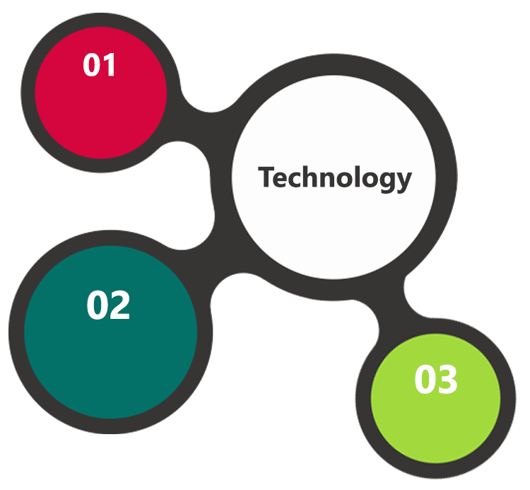

PHP7.1, Symphony

Doctrine / Broadway

HTML5 / CSS3

Java Script

Linux

NGINX

PostgreSQL

**MS SQL2012  
Windows 8/10  
Web Services**

# SYSTEM ARCHITECTURE (LOYALTY APP)

## Software Architecture

**Full Stack Symphony**

The Loyalty App is based on Symphony, which is a leading PHP framework to create web applications. Using Symfony allows developers to work better and faster by providing them with certainty of developing an application that is fully compatible with the business rules, that is structured, maintainable and upgradable, but also it allows to save time by providing generic re-usable modules.

**Doctrine**

Doctrine is a family of PHP libraries focused on providing data persistence layer. The most important are the object-relational mapper (ORM) and the database abstraction layer (DBAL). One of Doctrine’s key features is the possibility to write database queries in Doctrine Query Language (DQL) - an object-oriented dialect of SQL.

**Broadway**

Broadway is a project providing infrastructure and testing helpers for creating CQRS (Command–query separation is a principle of imperative computer programming. It states that every method should either be a command that performs an action, or a query that returns data to the caller, but not both) and event sourced applications. The project contains several loosely coupled components that can be used together to provide a full CQRSES experience.

**Admin Dashboard**

The frontend application that allows an administrator to manage the loyalty application.

**Client Dashboard**

A frontend application for end customers. It allows customers to check their profile, points, transactions history and redeem reward.

**POS Dashboard**

POS stands for Point-of-sale. It’s a physical store where you can buy stuff. This dashboard is a user interface for merchants to register a customer in loyalty program or spend points to reduce purchase amount.

**3rd party software**

Since there is clear separation between the frontend and backend any third party software can integrate with the Loyalty App and benefit from it. It’s possible to replace existing dashboards with your own solution like mobile application for end customers.

**API**

The API uses the REST approach.

**Bundles**

Bundles allow business logic from the components to be integrated with the Symphony Framework. By separating business logic from the framework, it’s easily to focus and maintain business aspects of the application and the integration with framework.

**Components**

It’s the heart of the application. It houses the business rules of the loyalty program. Components have been created with Domain Driven Design (Domain-Driven Design is a software development methodology for tackling complex software projects to deliver an end-product that meets the goals of the organization.) in mind.

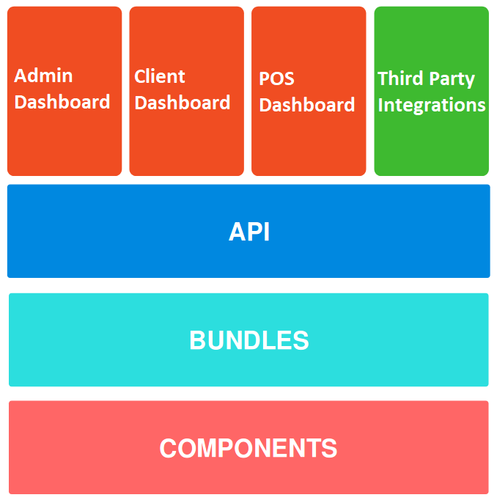

**CQRS**

CQRS stands for Command Query Responsibility Segregation. It’s a pattern that was described by Greg Young. At its heart is the notion that you can use a different model to update information than the model you use to read information.

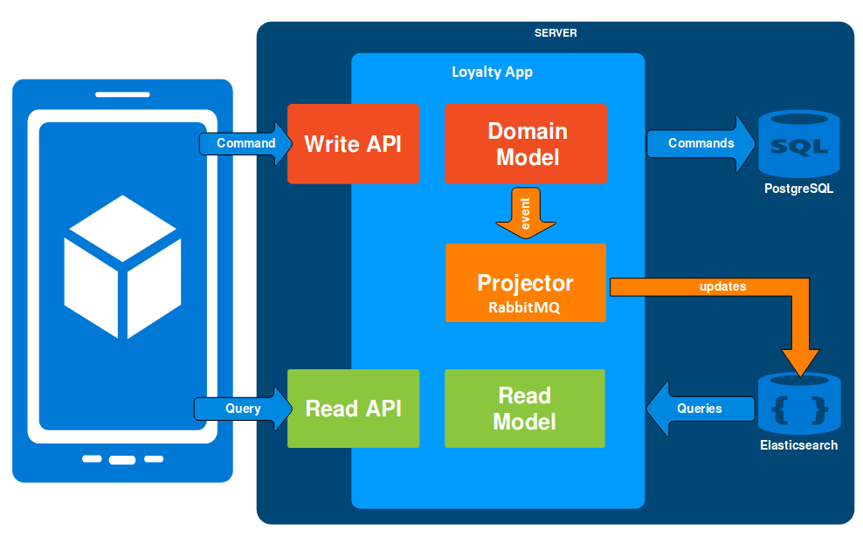

**Event Sourcing**

Event Sourcing ensures that all changes to application state are stored as a sequence of events. We can not only query these events, we can also use the event log to reconstruct past states, and use it as a foundation to automatically adjust the state to cope with retroactive changes. To implement event sourcing an external library called Broadway is used.

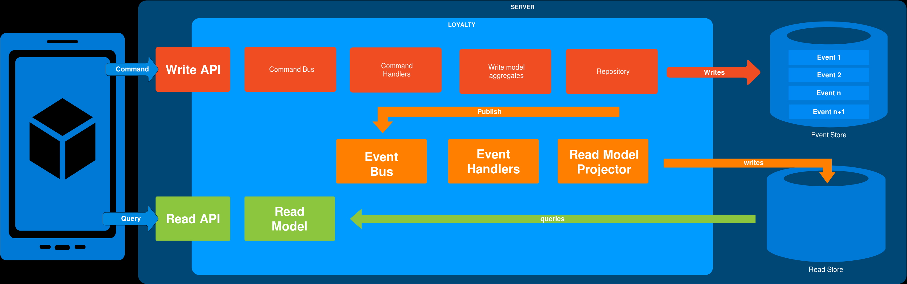

**Events**

There are three types of events dispatched in the Loyalty App, commands, events and system events.

**Commands**

It’s a user intention, it’s something that we want to happen but may be rejected for many reason, i.e. because data is not valid. To put it simply, it says “do something” to the software.

**Events**

Events have happened. It represents something that has happened and it cannot be rejected. It’s a consequence of executing a command.

**System events**

Additional type of events that are thrown during executing a command by command handler and may be used to trigger another commands. They’re also useful to separate concerns.

| **Module** | **Commands** | **Events** | **System events** |
| --- | --- | --- | --- |
| Account | * AddPoints * CancelPointsTransfer * CreateAccount * ExpirePointsTransfer * SpendPoints | * PointsWereAdded * PointsTransferHasBeenCanceled * AccountWasCreated * PointsTransferHasBeenExpired * PointsWereSpent | * AccountCreatedSystemEvent * AvailablePointsAmountChangedSystemEvent * CustomEventOccurredSystemEvent |
| Activation  Code | * CreateActivationCode | * AccountWasCreated | * ActivationCodeCreatedSystemEvent |
| Audit | * CreateAuditLog | * AuditLogWasCreated | * CreatedAuditLogSystemEvent |
| Campaign | * ChangeCampaignState * CreateCampaign * RemoveCampaignPhoto * SetCampaignPhoto * UpdateCampaign |  |  |
| Customer | * ActivateCustomer * AssignPosToCustomer * AssignSellerToCustomer * AttachCustomerToInvitation * BuyCampaign * ChangeCampaignUsage * CreateInvitation * DeactivateCustomer * InvitedCustomerMadePurchase * MoveCustomerToLevel * NewsletterSubscription * RegisterCustomer * RemoveManuallyAssignedLevel * UpdateCustomerAddress * UpdateCustomerCompanyDetails * UpdateCustomerDetails * UpdateCustomerLoyaltyCardNumber | * CustomerWasActivated * PosWasAssignedToCustomer * SellerWasAssignedToCustomer * CustomerWasAttachedToInvitation * CampaignWasBoughtByCustomer * CampaignUsageWasChanged * InvitationWasCreated * CustomerWasDeactivated * PurchaseWasMadeForThisInvitation * CustomerWasMovedToLevel * CustomerWasRegistered * CustomerAddressWasUpdated * CustomerDetailsWereUpdated * CustomerLoyaltyCardNumberWasUpdated | * CustomerActivatedSystemEvent * CustomerAgreementsUpdatedSystemEvent * CustomerAttachedToInvitationSystemEvent * CustomerDeactivatedSystemEvent * CustomerLevelChangedSystemEvent * CustomerLoggedInSystemEvent * CustomerRegisteredSystemEvent * CustomerRemovedManuallyLevelSystemEvent * CustomerUpdatedSystemEvent * NewsletterSubscriptionSystemEvent |
| EarningRule | * ActivateEarningRule * CreateEarningRule * DeactivateEarningRule * RemoveEarningRulePhoto * SetEarningRulePhoto * UpdateEarningRule * UseCustomEventEarningRule |  |  |
| Email | * CreateEmail * UpdateEmail |  | * EmailCreatedSystemEvent |
| Level | * ActivateLevel * CreateLevel * DeactivateLevel * RemoveLevelPhoto * SetLevelPhoto * UpdateLevel |  |  |
| Pos | * CreatePos * UpdatePos |  | * PosUpdatedSystemEvent |
| Segment | * ActivateSegment * CreateSegment * DeactivateSegment * DeleteSegment * UpdateSegment |  | * CustomerAddedToSegmentSystemEvent * CustomerRemovedFromSegmentSystemEvent * SegmentChangedSystemEvent |
| Seller | * ActivateSeller * DeactivateSeller * DeleteSeller * RegisterSeller * UpdateSeller | * SellerWasActivated * SellerWasDeactivated * SellerWasDeleted * SellerWasRegistered * SellerWasUpdated |  |
| Transaction | * AssignCustomerToTransaction * RegisterTransaction | * CustomerWasAssignedToTransaction * TransactionWasRegistered | * CustomerAssignedToTransactionSystemEvent * CustomerFirstTransactionSystemEvent * TransactionRegisteredEvent |
| Webhook | * DispatchWebhook |  |  |

## Technical Architecture (Loyalty App)

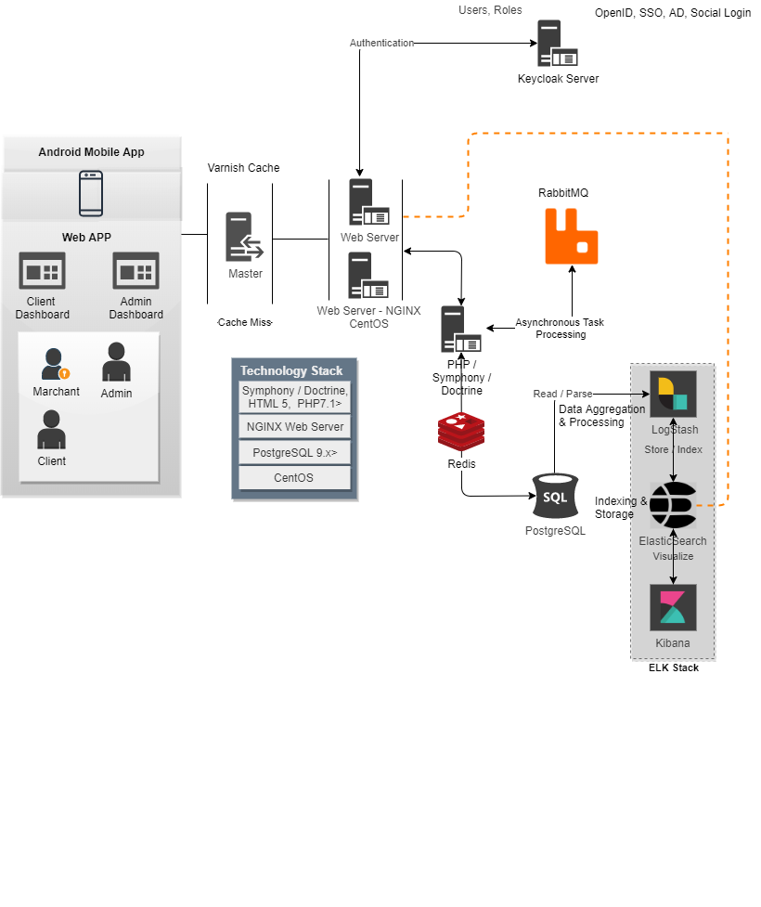

**Network Topology**

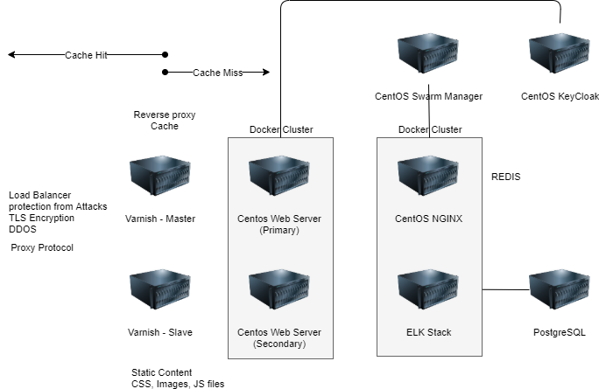

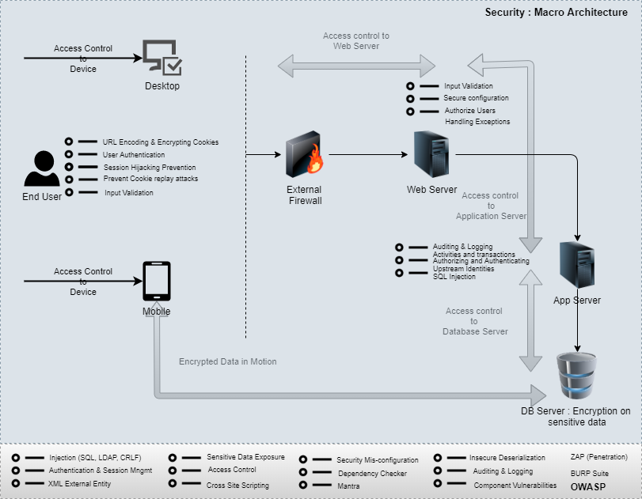**Security Architecture**

**Release and Deployment Pipeline**

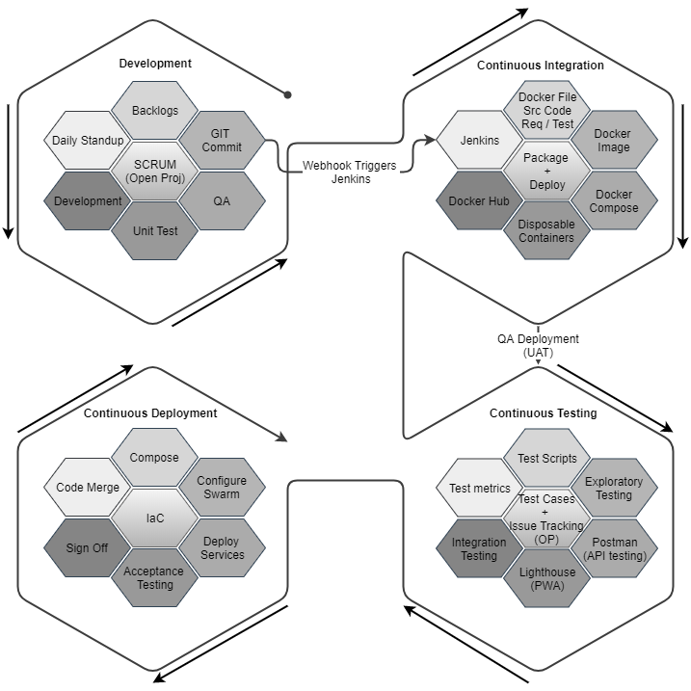

**Quality Analysis and Control**

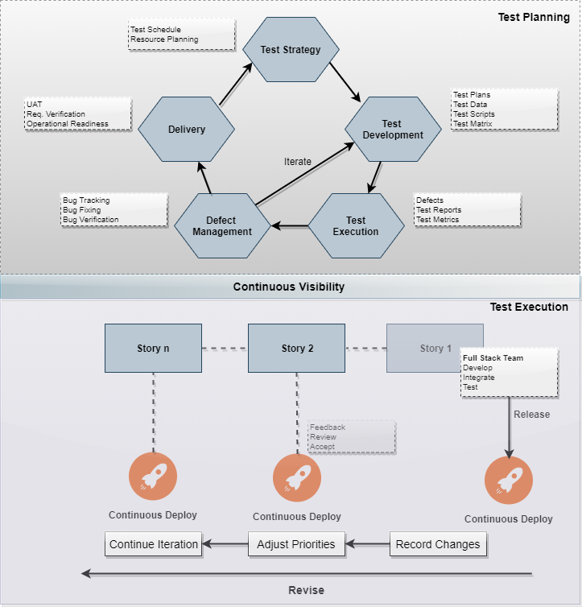

# TECHNICAL CONFIGURATIONS

## DEVELOPMENT TOOLS

* PHP 7.2, Symphony, Doctrine
* PostgreSQL, ELK Stack, RabbitMQ, Redis
* HTML5 / CSS 3
* NGINX, Docker, KAFKA, JAVA
* Web services, Ajax, JavaScript

## RECOMMENDED WEB HOSTING PACKAGE- DEDICATED HOSTING

* Operating System : CentOS
* CPU : 4 core
* Domains: Unlimited
* Disk Space: 200 GB
* Monthly Bandwidth: 50 GB
* Web site Server Software – NGINX
* Varnish Cache

## BROWSER

* Chrome version: 56
* Firefox version: 51
* Internet Explorer:11
* Safari:13

## HARDWARE

The application is reliant on hardware interfaces to provide a seamless automated user experience.

* Computer with Windows 8 or 10 OS
* Compatible Browsers as specified in section 6.2.3

## TECHNICAL STANDARDS

* Screen Resolutions

1080 x 1920, 720 x 1280, 750 x 1334, 640 x 1136

* Testing Devices
  + Android
    - Moto G( Marshmallow)
    - Alcatel (nougat)
    - Google Pixel (pie)
  + OS Version
    - KitKat and above
    - iOS 9.0+

## TECHNICAL GUIDELINES

The guidelines provide instructions and conditions that will be adhered to during the development of the mobile application.

* API will be used, as the case may be, in realizing the features and functionalities mentioned
* The client will finalize the functional requirements and UI/UX before the commencement of any development activities
* Verbat will be testing the app in the mentioned devices only. Testing on devices other than the ones mentioned under the “Technical Standards “ will have to be specified and provided by the client at the beginning of the development phase
* The client will have to provide the details of the testing devices they are using before the start of development phase.
* Client should provide the relevant Developer's Account credentials before the development phase. In case Verbat needs to create the developer id additional charges will be incurred by the client
* The apps will be developed / created within the guidelines of Android and IOS. Verbat will strictly follow the guidelines provided by the respective store. Verbat will inform the client if any of the client requirements/ request deviates from it.
* Customization of the features of the app will be susceptible to the limitation imposed by the respective platform/ store.
* OS version support will be limited to the ones mentioned under ‘Technical Configuration’, further support will have to go through change management.

# PROJECT DELIVERY

## PROJECT MANAGEMENT

The Verbat development center strictly follows industry standards on quality. The project management is process governed by the Verbat Quality Management system and is put to verification through internal audit programs that happen from time to time. Verbat will dedicate a project manager for the proposed implementation. Verbat proposes Client to identify one project manager who will be driving activities to be undertaken by Client to be the single point of contact for Verbat.

## ROLES & RESPONSIBILITIES

Verbat will assign a dedicated Project Manager/Project Lead to lead the project, who will be the first point contact for Client. He/she will be responsible for planning and managing the various activities within the project. He/she will work closely with Client Project Manager, to give periodic status updates and ensure high level of visibility and comfort on the progress of the project. The Project Manager/Project Lead will lead the co-ordination between Verbat and Client, thus enabling smooth transitioning of Client requirements to the Verbat ’ offshore delivery team, and provide visibility as well as comfort on the progress of the services to Client.

He/she will have periodic meetings with Verbat ’ s Senior Management, thus ensuring Verbat ’ Management commitment and focus on Client initiatives.

## PROJECT IMPLEMENTATION PLAN

Verbat will be providing the solution in a stand-alone fixed bid approach which ensures minimum viable solution for quick wins with core focus on the long-term business objective and outcome. Once the implementation is over, Verbat will initiate the application maintenance process (once the maintenance contract is signed) which continues to extend after the implementation.

## DELIVERABLES

* Project Plan
* Software Requirement Specification Document (SRS)
* UI/UX Design
* Functional Specification
* Testing plan and deliverables (testing scenarios and scripts)
* Source Code
* Fully Developed & Tested Application

|  |  |
| --- | --- |
| Activities | Description |
| Detailed requirement Analysis | Verbat team to conduct detailed study of requirement for the phase. If clarification is required, team will reach out to Client for more information and/or time for discussions. |
| DB Design | DB design for central and test DB. |
| Software Requirement Specification document (SRS) | Once the requirement analysis is completed, Verbat team will submit the SRS document for approval |
| UI/UX Design, Prototyping | Based on the SRS, Verbat UX/UI team will work on the UI/UX of the screens and submit for approval |
| Functional Specification Document (FS) | Once the UI/UX is approved, Verbat shall submit an FS document for approval. |
| Development | Actual system development starts based on the FS. This involves detailed design and software development of Web Application. |
| Testing | Test Planning, test plan creations, internal, integration testing and user acceptance testing. |
| Deployment | Deploying the latest built in the Verbat Test Server. |

## DELIVERY ACTIVITY SUMMARY

## ESTIMATED DELIVERY TIME

The effort estimated for delivering the application will be as below:

* 00 UAE working days for the UI/UX from the date of approval of the SRS
* 00 UAE working days for the development of the application from the Date of Approval of the FS.

| **Activity** |
| --- |
| Contract Signoff (T0) |
| Project Initiation & Initiating requirement gathering |
| Software Requirement Specification Document(SRS) |
| SRS Approval (T1) |
| System UI/UX-Complete |
| System UI/UX-Approval (T2) |
| Functional Specification (FS) |
| FS Approval (T3) |
| Development Phase-Complete |
| Perform QC (Unit Testing and Integration Testing) |
| System ready for UAT |
| UAT Acceptance on Verbat server (T4) |

* The above-mentioned timeline is in UAE Working Days
* The initiation of the UI/UX development is dependent on the confirmation of SRS. SRS will be submitted post the confirmation of the project along with LPO, signed proposal and advance payment
* The above mentioned timeline for development is post the confirmation of FS
* Documentation submitted after project initiation and system study supersedes any proposal or documentation submitted during initial requirement gathering / discussion / negotiation
* Project plan will be submitted post the confirmation of project with necessary payments
* Any delay in getting the approvals of deliverables from client will cause change in timelines and the revised timelines will be updated in weekly status reports shared with client after the project commencement
* All approvals and queries regarding the client requirement and any queries which may hinder the project advancement at any stage should be answered by the client within 24 hours from the time of initiation, failing which the time delay will get added to the actual effort and timeline which was estimated.
* On project confirmation, Verbat requires a lead time of minimum seven (07) days for resource mobilization.

## DEPLOYMENT DETAILS (AT CLIENT’S BEHEST)

* Client can opt for hosting the application at Verbat’ Server.
* If deployment is at the client’s server, responsibility of deploying the application onto the production environment after conducting the necessary acceptance testing will lie with the client unless and until Verbat ’ support is contracted for deployment.

## RELEASE PLANNING

* Client will be informed about the release date and time through email.
* Client performs the UAT

## RISK CONTINGENCY PLANNING

Verbat has identified various risk factors associated with this assignment and understands the impact of these risk factors on the project schedules. The objective of this section is to highlight for both Verbat and client, the risk factors, to analyze the impact of the risks on project execution, and to propose strategies to control and reduce the impact of the risk factor. These various risks, which could arise during the project, are tabulated below along with mitigation implementation.

| Type of risk | Impact | Risk Mitigation | Risk Handling |
| --- | --- | --- | --- |
| Scope Creep | H | Functions and features will be detailed in system requirement documents and will go through client approval. Once this document is approved, any change to requirement will go through change management review for possible impact assessment. | Proper change management procedure will be implemented. |
| Delay in customer feedback | H | The plan is prepared with enough lead-time for customer reviews and approvals.  The customer is indicated with the dates when the document is expected after review and approval. | The request for feedback will be escalated if not attended at the right time so that the schedules are not affected. Deemed acceptance criterion is set up front and will be followed. |
| Non-availability of necessary software’s, frameworks, database instances and infrastructure at client’s hosting environment(If hosting support is provided by Verbat ) | M | Client will be informed in advance on these requirements. | Possible impact to schedule. |
| Manpower attrition | L | All efforts would be made to ensure process dependence rather than being person dependent. As a risk mitigation plan Verbat will train backups. | A new person will be identified as early as possible, provided the required project-specific training and mentored by the senior members of the team to minimise impact of attrition on the project. |

*H-High, M-Medium, L-Low, NA-Not Applicable*

# PROJECT ASSUMPTIONS

The project solution and technology is created from the initial understanding of the requirement shared with Verbat through mails and meetings. The proposed solution is based on the following assumptions:

## OBJECTIVE

* The requirement is to develop Statistics web and mobile application with the functionalities as defined in ‘Functional Requirements’ section

## DESIGN

* Client to provide Verbat with the branding guidelines.
* Color theme shall be provided by the client
* Client shall provide licensed images and logos in specified size & format
* Client shall provide the text and associated images for the proposed application. Text should be provided in digital format preferably in MS Word 2013 or above
* Verbat may use template based design for the application

## DEVELOPMENT

* The proposed application front end and backend would be developed in English & Arabic
* Development Contingent upon timely feedback from client
* The client will finalize the functional requirements and UI/UX before the commencement of the development of the project
* Client shall approve the UI/UX for the web application before development work starts
* Final data needs to be entered by the client via the application
* Client will provide sample data to test the application
* Testing of web application will be done in latest versions of Google Chrome, Mozilla, Edge web browsers only
* Client will procure templates, SSL certificates (if applicable)
* Client will host and manage the application on infrastructure (server / cloud) recommended by Verbat for managing database and application backup inclusive of images
* Application and data backups are subject to the purchase of such services at an extra cost
* Internet connectivity is required for the functioning of the Web portal
* Does not support offline access or operations
* Nonparticipating shop must register to the system even if he is not participating to the program in case the data (number of voucher, voucher details, etc.) are needed to be recorded in the system
* Themes shall be enabled on the days specified by the admin. Additional design, UI /UX and development may be required to introduce new themes. It is assumed that the app will initially have a maximum of 2-3 themes. Administrators shall not be able to create new themes.
* It is assumed that Verbat shall be able to leverage the API’s used by the existing Delivery management system
* In cases where the customer is ordering food outside the country of his domicile, the customer shall be charged based on their home currency however any additional expenses like transaction fees, currency conversion etc. shall be born by the client.
* Menu items for all restaurants shall remain the same. Certain menu items for individual restaurants may become unavailable as the availability of raw ingredients
* Phase one of the app shall not be multi-lingual. English shall be the primary language
* In-App games shall be part of phase 2
* Electronic or physical gift cards may be availed by anyone who carries the cards with them
* It is assumed that the client shall provide Verbat with information on interfacing with their back end Oracle systems. It is assumed that the client is responsible for developing these interfaces
* Client is responsible for any costs associated with incorporating third part payment systems
* Payment options shall be defined across the board for the mobile app. However certain payment options may be disabled for certain countries. It shall be known that the payment options are predefined for the entire app. New payment options post development shall go through the change management process

# OUT OF SCOPE

With the ever evolving digital market, the requirement should be clear to both the parties involved, hence the importance of mentioning the out of scope details of the project. Following are considered to be out of scope while creating this proposal:

* Purchase of images, fonts
* Any language other than English & Arabic
* Migration of existing data / Database migration
* Content writing / proof reading / Data Replication / Manual data entry
* Content or image procurement or uploading or editing
* Audit Trail
* End user testing and load testing
* Developer account creation and Maintenance (Play Store)
* Adding new features to the application other than mentioned in the functional specifications. Such requests will be handled via change management. *For Change management details, please refer section titled “Change Management” in the*
* Annual Maintenance Contract (Bug fixing, debugging, enhancements) – Please refer section titled “Maintenance and Support”, unless contracted for.(refer to section 4.2)
* Hosting Infrastructure and Maintenance (web and email hosting), unless contracted for.
* Application Deployment on the server and respective stores, unless contracted for.
* Backup solution and Disaster recovery unless contracted for.
* Physical deployment onsite / installation of the application in devices and Physical connection, installation of system.
* Integration with third-party, if any, other than mentioned in the functional specifications
* Hardware Integrations / procurement and purchase
* Procurement of SMS gateway / payment gateway / email gateway
* SSL Purchase and installation, if any
* Plugin/template purchases, if any
* OS other than mentioned in the Hardware Interface
* Relevant / related software libraries
* Time and attendance is out of scope during phase 1

## CHANGE MANAGEMENT

Any addition which comes out of the project scope, upon and after the launch of the application will be considered as change management. Verbat recommends the following change management procedure for the same.

* Any change which comes out of the project scope, which was discussed, documented, and mutually approved by both the parties in the requirement stage, will be carried out only through raising a change request.
* Change request will be studied and an impact analysis on the existing work flow will be performed.
* On finalizing the impact, effort estimation for the change will be calculated and raised as additional requirement.
* Verbat will initiate the change request only after getting a formal approval from the client for the additional changes raised.
* Any change from the scope will be charged at AED 1,200.00 per man day effort and approval from the clients will be availed before commencing on any change management.

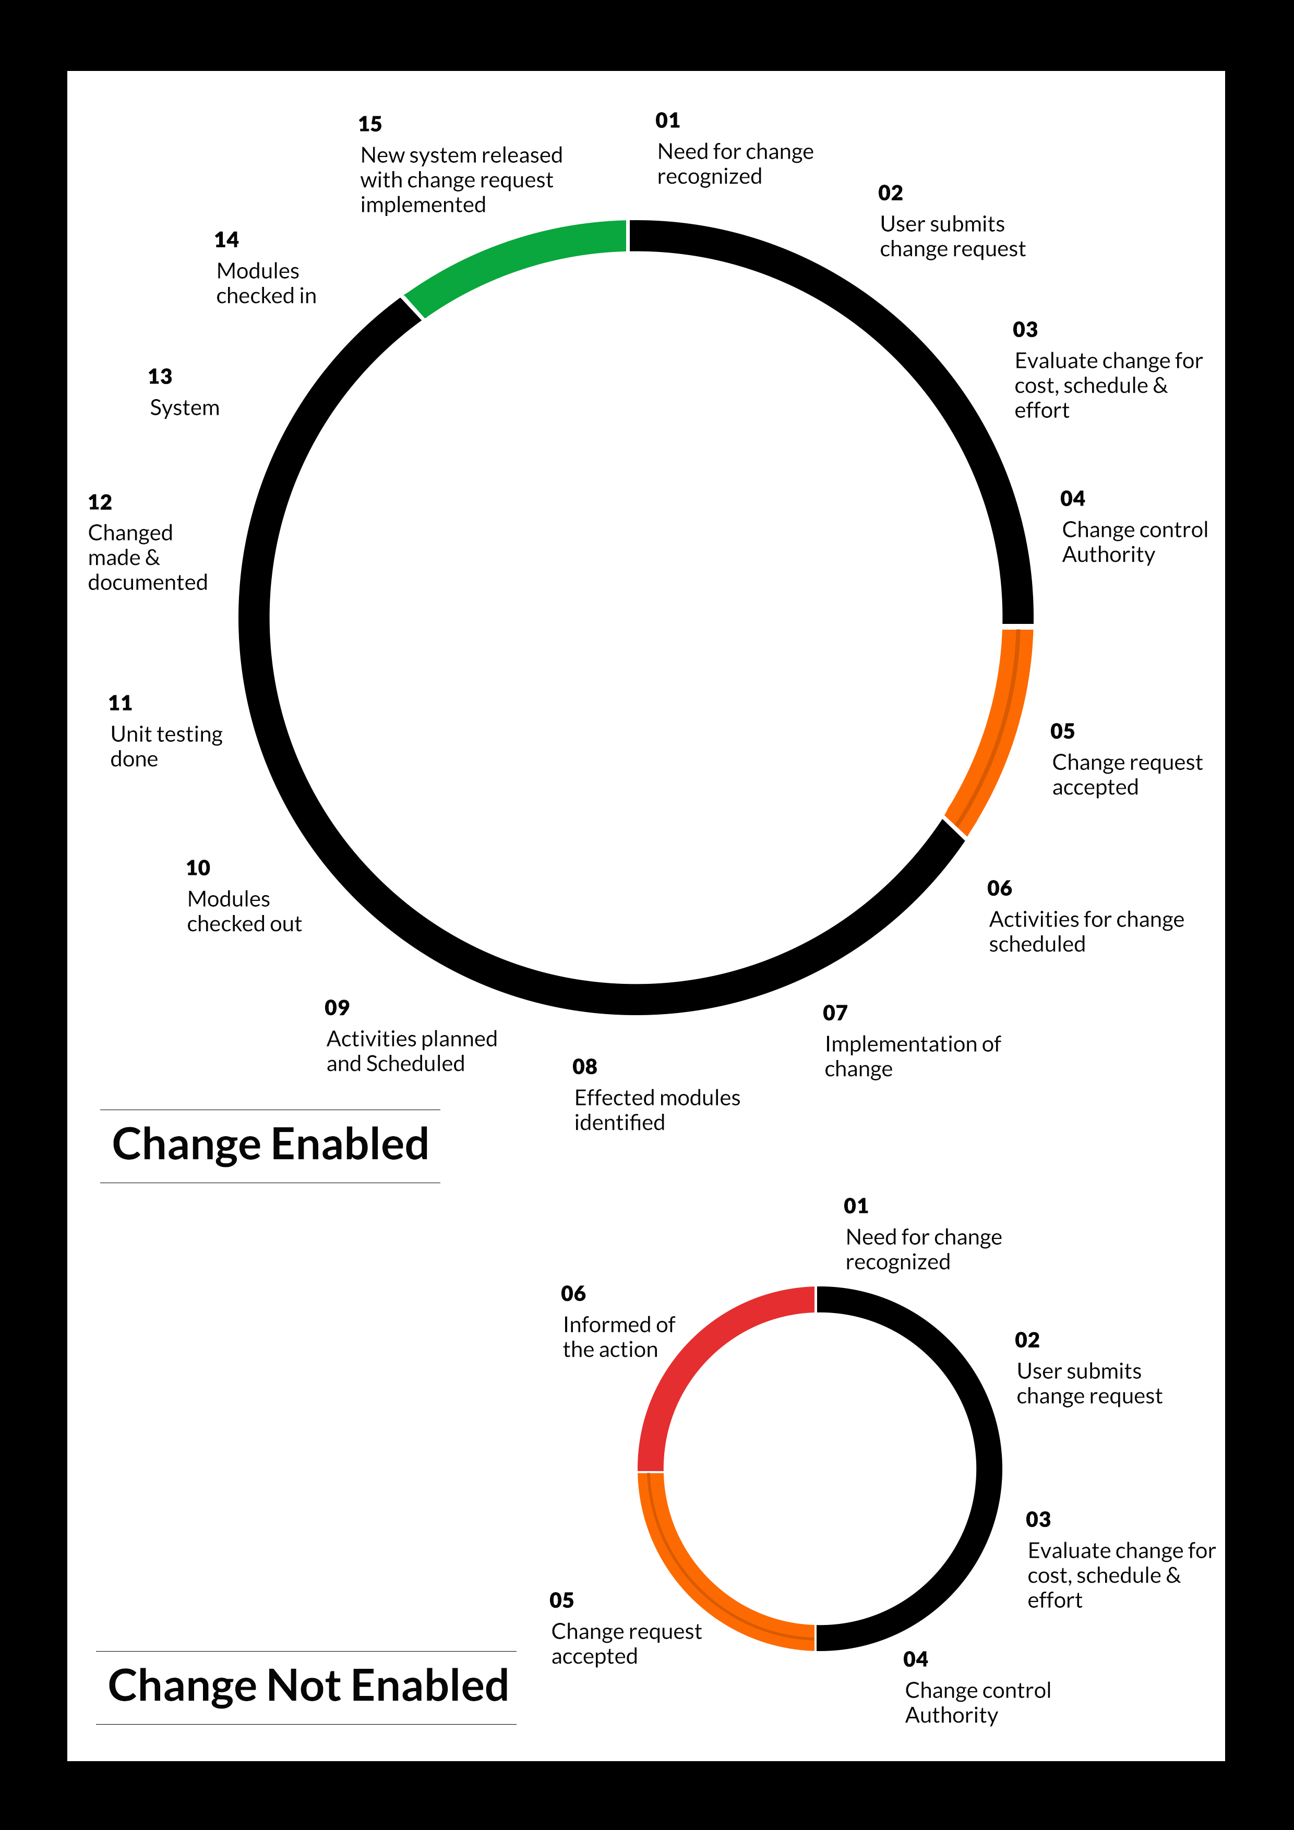

## MAINTENANCE & SUPPORT

* Maintenance contracts by default are supported as per the basic SLA terms.
* AMC with Basic SLA is charged at 25 % of the total project value. Additional Effort/change management request will be added towards Total Value of the Project to determine the AMC value.
* Maintenance support is limited to providing application support for ensuring the consistency of the look-and-feel, bug fixes and user issues i.e. maintenance and support of the existing features of the application.
* Support does not in any way cover providing technical or other support to the end users. The maintenance agreement does not include functionality changes or feature additions which are handled as change requests which will be charged AED 1,200.00 per man day. AMC does not include server support, maintenance and application deployment.
* AMC charges will cover Off-Site Support and Debugging. Support includes E-mail, Telephone and Chat unless explicitly specified. In the event, the application is hosted with the client; necessary remote desktop connectivity should beprovided for carrying out maintenance activity.
* Gap in AMC - In case if the client does not opt an AMC for a year and want to renew it after that period, 50% of the AMC amount for the year for which AMC is not taken will also be payable if the client wishes to renew the AMC contract.

*Note:*

* *Please note that the AMC support shall start only after all the necessary sign-offs (AMC Document) to this effect have been given.*
* *It is not mandatory that the client should opt for an AMC (replace with perhaps: It is mandatory that the client opts for an AMC). The client will still be supported on an ad-hoc basis on an agreed man-day rate.*
* *AMC Payment Terms: 100% to be paid as advance.*

## SERVICE LEVEL AGREEMENT (SLA)

|  |  |  |  |  |
| --- | --- | --- | --- | --- |
| **SLA Type** | **Max Response Time** | | **Max Resolution Time** | **Target** |
| Basic | 1  working day | 3 working days | | Request / incident / problem tickets |
| Advanced | 5 Business Hours | 12 Business Hours | | Request / incident / problem tickets |
| Priority | 3 Business Hours | 5 Business Hours | | Request / incident / problem tickets |

*Note:*

* *We provide Basic SLA as standard with AMC while Advanced and Priority SLAs attract additional charges.*
* *Time zone applicable (8:00 am to 5.00 pm, Sunday to Thursday)*

AMC Option:

Client can opt for time and material based Annual Maintenance, the details of which will be shared post the completion of project.

# TERMS & CONDITIONS

## ACCEPTANCE CRITERIA

* UAT (User Acceptance Test) sign off should happen within 07 Days from the first release of the application and the acceptance confirmation needs to be mailed to Verbat failing which Verbat will consider the project as approved by the client.
* Any comments or reason for rejection need to be documented and the same needs to be sent as an email from the official mail id of client to Verbat on or before 07 days from the first release.
* Timeframe for acceptance for any further release will be mutually agreed and finalized between client and Verbat depending on the UAT Comments

## WARRANTY

* Verbat shall provide a bug ﬁx warranty at no additional cost for 30 days from the date of acceptance of the project, for correction of any errors in the developed application that may be attributed to Verbat.
* However, this does not cover modifications by Client, or use of the application on an environment other than the proposed environment, or other circumstances outside Verbat’s reasonable control. In such a case Verbat reserves the right to charge for its services.
* All error corrections will be executed at Verbat India office. In the event of any need for on-site work, all expenses incurred for such trips will be payable to Verbat by Client.

## SOURCE CODE & INTELLECTUAL PROPERTY RIGHTS

* Upon completion of the Project and 100% completion of the payment, client will have access to the source code except for propriety codes, developer tools and third party applications etc.
* The solution offered will be the intellectual property of the client and will be made available to the client on an “unlimited license” basis.
* Modifications by third party/person: No person or organization, other than Verbat or any person authorized by Verbat in writing, has any permission to modify/change the software Solution to be eligible to get continued support from Verbat as per the support terms defined under this document.
* Liabilities/Damages: Verbat accepts no liability or damages of any kind arising out of use or non-use of the software delivered. The responsibility of testing of software lies with Client.

## GENERAL TERMS AND CONDITIONS

* Offer Valid for 30 calendar days from the date of submission of the Proposal.
* An average of 20 working days are assumed in a month.
* All the projects activities will be carried out from our off-shore development center in India
* All the documentation will be provided in English.
* Third party components may be used to develop this application.
* The scope of the project is to develop the Application as detailed in the scope of the project and mentioned in this proposal. Any changes or additions will have to go through change management.
* This proposal would have been derived or concluded from either the RFQ /RFP/data shared via email / information transferred during an initial requirement analysis meeting / tele-conversation. Verbat reserves the right to change the terms of this proposal as the final terms (including the costing), features & functionalities and timeline could change during the course of the project. Hence any fees quoted / timeline committed in this proposal may not be considered as final unless agreed and signed by both parties.
* Web Application will be best viewed only in the environment mentioned in the section Browser Compatibility
* All Source Codes and other project artefacts would adhere to the Verbat document templates and internal coding standards.
* The documents delivered to the client includes the ones mentioned under ‘Deliverables’ and these will adhere to Verbat’s internal document standards.
* Acceptance criteria shall be based on the clauses which were mutually discussed between Verbat and client at the Requirement Analysis phase and the same will be documented and approved by both parties through official emails
* In case Client requires any extension of the proposed acceptance schedule, the associated effort and cost of such extension can be mutually reviewed.
* For any circumstances if project needs to be put on Hold / Stop it requires minimum request notice period of 1 week along with duration for which request will be addressed by management and final decision on the request will be based on that
* If deployment is done in client’s server, Verbat cannot be held responsible for any performance issues arising due to hardware malfunctions.
* Client is responsible for data backup in case the application is not hosted on Verbat server.
* Source code will only be delivered or uploaded on the Production Server once the due payments are made.

## GENERAL ADMINISTRATIVE, TECHNICAL & FUNCTIONAL ASSUMPTIONS

* Detailed system study is required before the start of the project.
* During the requirement gathering phase, authorized personnel from the Client’s side is expected to be available for discussion and finalizing the HLD (High Level Design), before development commences.
* Type of reports and formats, if under the scope of the project, needs to be specified by Client before project sign off.
* Workflows if under the scope of the project, need to be specified/ confirmed by client before project signoff.
* Verbat assumes that all sign-offs from Client will be provided within agreed and specified timeframe.
* Client will provide all the necessary contents, both text and image, before starting the project in the format suggested by Verbat (if any).
* The client should provide the relevant information and data well in time for the execution of a related activity. Non- availability of this information or data may lead to an interruption of work which may result in a delay in delivery as well as additional costs to the client.
* Client should have/possess server with technical specifications as suggested by Verbat for the proposed application.
* Client will be provided with one time training (train the trainer) on how to use the application via video conference (maximum of 4 hours). Additional training requests will be charged.

# FINANCIALS

## WEB AND MOBILE APPLICATION DEVELOPMENT

|  |  |  |
| --- | --- | --- |
| **No** | **Description** | **Amount (AED)** |
| 01. | Development of:   * Web Application |  |
|  | **Total Project Cost** |  |

*Note:*

* *The above cost is exclusive of VAT applicable in UAE*
* *The above cost is based on the initial understanding of the requirement grounded on the details shared by client. Any further changes in the scope or complexity if encountered during detailed system study/ analysis will call in for additional effort and time.*
* *The above cost does not include Application hosting, integration with any other third-party systems, deployment unless explicitly mentioned in this proposal.*
* *For feature additions, please refer section titled “Change Management “.*
* *LPO to be raised in the name of “Verbanet Technologies LLC” for project initiation*
* *Refer section 7.3 for ‘Mode of Payment’.*

### **PAYMENT TERMS**

* 30% () of total project value to be paid as advance along with the Purchase Order
* 40% () of total project value to be paid on confirmation of the UI/UX
* 30% () of the total project value to be paid on completion of Development and UAT on Verbat test server

*Note:*

*Payment should be made within 7 days from the date of invoice.*

## WINDOWS DEDICATED HOSTING – OPTIONAL

ITEM NO. DECSRIPTION AMOUNT (AED)

1. Windows Dedicated Hosting

TOTAL PROJECT COST

*Note:*

* *The above cost is exclusive of VAT applicable in UAE*
* *Refer “Windows Dedicated Hosting Proposal” for detailed Server specifications.*
* *Refer section 7.3 for ‘Mode of Payment’.*
* *LPO to be raised in the name of “Verbanet Technologies LLC” for project initiation*

### **PAYMENT TERMS**

* 100% advance payment along with Purchase Order to initiate Server purchase

*Note:*

*Payment should be made within 7 days from the date of invoice.*

### **MODE OF PAYMENT**

By Cheque to Verbanet Technologies LLC

OR

Wire transfer to our bank account

Bank Name : Emirates NBD

Account Name : Verbanet Technologies LLC

Account Number : 1011492858201

IBAN Number : AE61 0260 0010 1149 2858 201

Swift Code : EBILAEAD

Bank Address : Mamzar Branch, Dubai

*Note:*

* *Bank charges incurred during wire transfer to be borne by the client.*
* *Any local taxes / VAT applicable to be borne by the client*
* *Client invoices will include VAT charges in addition to the application cost*

# CLIENT REFERENCES

Education

Transportation

**Client Name – Ministry of Education (MOE)**

Project Name: Open Educational Resource Platform (OERP)

Location: Dubai, U.A.E

Ministry of Education has requested Verbat to develop a UAE- Open educational resource platform (OERP). The aim of this platform is to provide a centralized online platform where UAE and others can view, share and contribute their contents. Furthermore, this portal will allow UAE-MOE to track and monitor the progress through a dashboard. All information related to OER such as issue date, source, current state, future state, release dates along with best practices shall be captured.

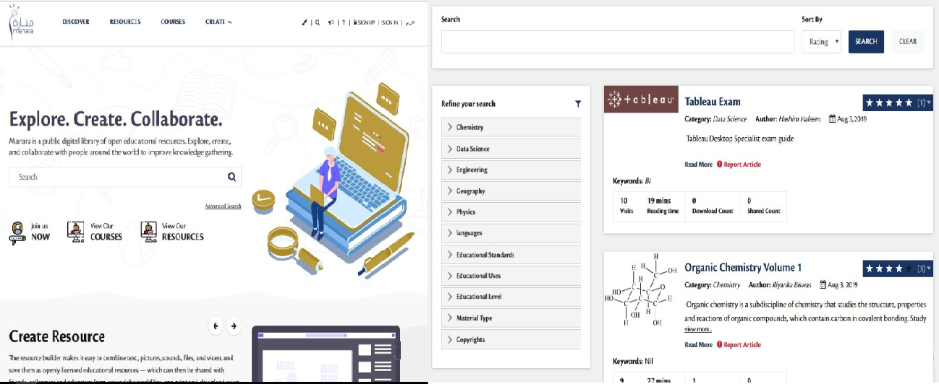

**Client Name – Sharjah Commerce and Tourism Development Authority (Government of Sharjah)**

Project Name: Permit Issuance and Inspection System

Contract Type: Fixed Bid

Location: Sharjah, U.A.E

Established in 1996, the Sharjah Commerce and Tourism Development Authority (SCTDA) is tasked with promoting commercial and tourism activities in the emirate of Sharjah. Sharjah intends to provide a sustainable tourism product with a unique and distinct tourism experience in the desert areas of the emirate. This is geared towards attracting the interest of various tourism companies, specifically tour operators, to focus on Sharjah when organizing desert trips and desert adventures activities within these areas. Consequently, this would be beneficial to the tourism sector and will contribute further to Sharjah’s economy. Hence, the Sharjah government has decided to organize desert tourism activities through this project; the issuance of permits to all tour vehicles entering the desert areas of Sharjah for desert safari activities owned or operated by tour operators along with the day to day inspection tasks carried by inspectors who can issue fines and attach evidences for further actions.

Sharjah Tourism resource deployment model comprises of Offsite resource (Verbat Resource) and Onsite Project Manager (from client’s side)

**Client Name – MBC**

Project Name: Security Inspection System

Contract Type: Fixed Bid

Location: Dubai, U.A.E

Smart Security System facilitates a sophisticated and structured approach to execute the daily security checklist to be used by the security patrol users. In addition to the ability of recording concern/issues as well to be viewed at any time as reports.  The application includes different users like Super Admin, Branch Admin, Inspector, Resolver and Viewer. The Inspector user reports patrol issues and concern issues using android mobile application. Branch admin assign the patrol issues to the resolver. Viewer will be able to see the issues and concerns related to the particular branch.

**Client Name – Carrefour Hybrid Project**

Project Name: Software Quality Assurance Managed Services

Contract Type: Time & Material

Resource Deployment Model: Hybrid (Onsite + Offsite)

Founded in 1992, Majid Al Futtaim is the leading shopping mall, retail and leisure pioneer across the Middle East and North Africa (MENA).

A remarkable business success story, Majid Al Futtaim started from one man’s vision to transform the face of shopping, entertainment and leisure to ‘create great moments for everyone, every day’. It has since grown into one of the United Arab Emirates’ most respected and successful businesses spanning 13 international markets, employing over 27,000 people, and achieving the highest credit rating (BBB) among privately-held corporates in the Middle East.

Carrefour testing team comprised of 20 resources inclusive of Onsite Project Manager, Onsite Test lead and Offsite Test Engineers

**Client Name – Ministry of Foreign Affairs**

Project Name: VISA Scheduling System

Contract Type: Fixed Bid

Location: Dubai, U.A.E

A web based application for the visa applicants and respected sponsors to schedule appointment for the security verifications. The system allows online payment facility. The application features include option for the sponsor to schedule appointments, option for the super admin to manage country and sites, manage other admin users and set e-mail/SMS notifications

# ABOUT US

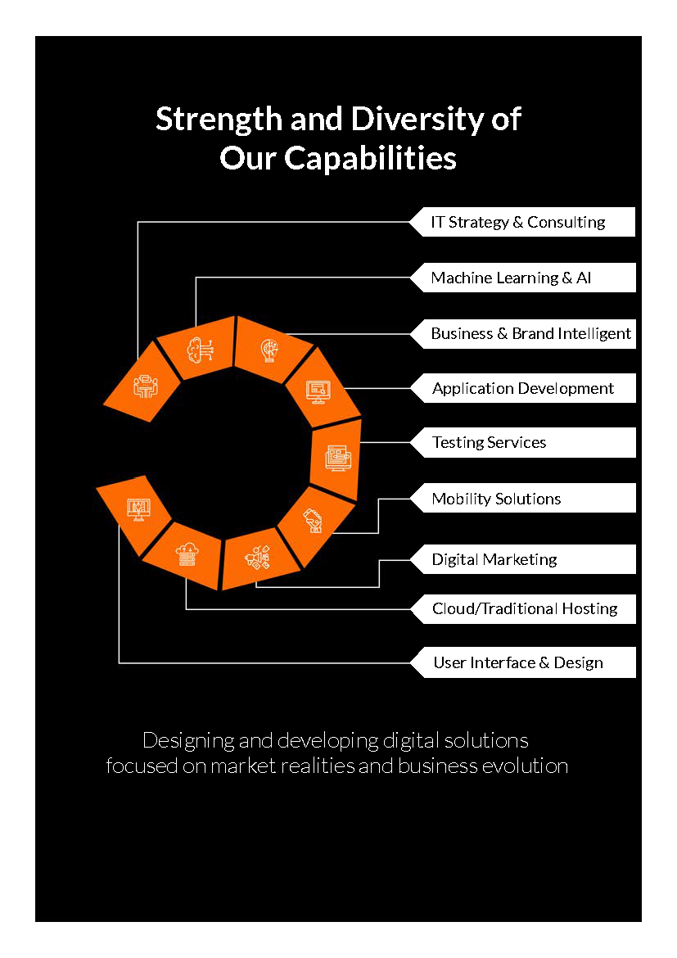

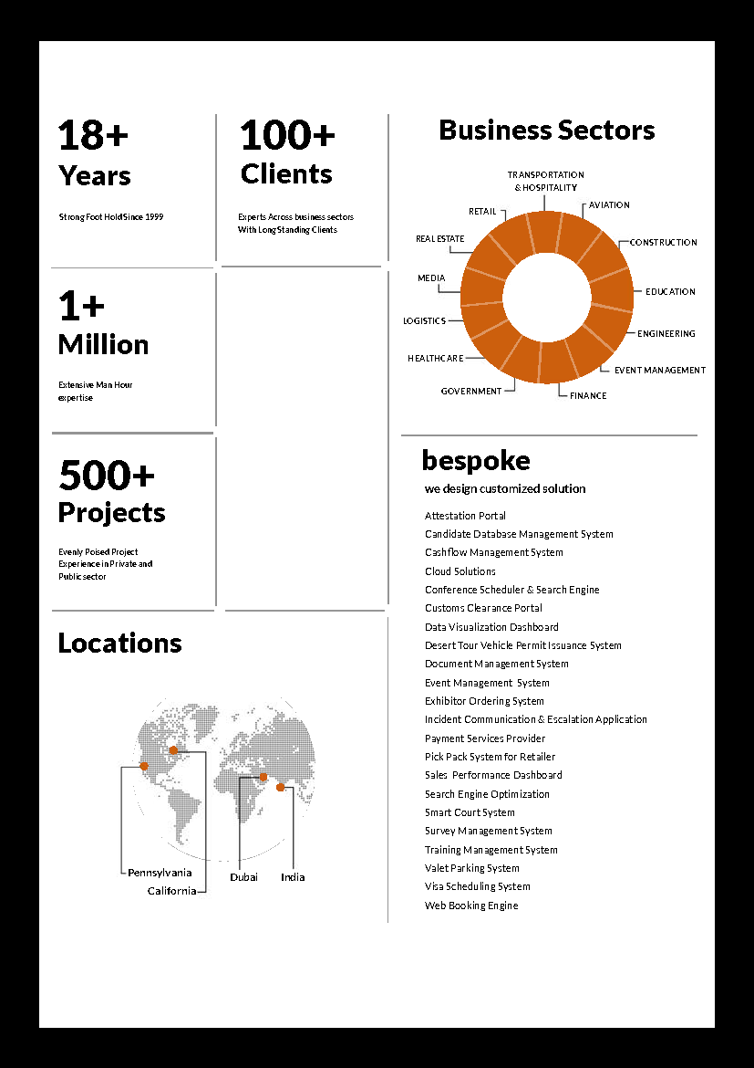



**Conﬁdentiality Notice:**

**This Proposal is conﬁdential and contains proprietary information and intellectual property of Verbanet Technologies LLC. Neither this proposal nor any of the information contained herein may be reproduced or disclosed under any circumstances without the express written permission of Verbanet Technologies L.L.C (hereby known under its brand name of Verbat in the United Arab Emirates). 2018. All rights Reserved**